**Exploring the Demographic and Socioeconomic Factors Related to COVID-19 Cases/Deaths for Citizens of the United States of America**

by

Christopher S Flach

A Capstone Project Paper Submitted in Partial Fulfillment of the Requirements for the Degree of

Master of Science

in Data Science

University of Wisconsin – La Crosse



La Crosse, WI

May 1, 2022

**Abstract**

This study explored the relationships between COVID-19 incidence with demographic and socioeconomic variables within the United States of America. These variables were collected from publicly available data sets and aggregated at the county level. Data science techniques such as correlation analysis and machine learning via XGBoost were used to determine important topics to explore. First, mental and physical health showed strong correlations with COVID-19 infection and death. Second, research has shown that Area Deprivation Indices (ADI) generally have a positive correlation with COVID-19 incidence. Third, policy measures have been implemented to impact mobility with the objective of mitigating transmission rates. The goal of this paper is to then identify relationships within each of the previously mentioned topics where strong correlations with COVID-19 incidence exist to inform research, practice, and policy development related to the continued efforts to address the pandemic status of this disease.

**Table of Contents**

List of Tables 5

List of Figures 6

Introduction 8

Literature Review 11

Introduction 11

Mental Health 12

Physical Health 15

Area Deprivation Indices / Social Determinants of Health 16

Government Policy Measures / Public Mobility 17

Conclusion 19

Methodology 20

Introduction 20

Research Design 20

Research Topics 20

Population 21

Instrumentation 21

Data Collection 21

Data Analysis 24

Conclusion 41

Results 42

Introduction 42

Mental / Physical Health 44

Area Deprivation Indices / Social Determinants of Health 61

Governmental Policy Measures / Mobility 75

Conclusion 84

Summary 85

Introduction 85

Findings 85

Conclusions by Research Questions 85

Discussion 86

Suggestions for Future Research 86

Conclusion 87

References 88

Appendix 94

**List of Tables**

1. Mental Health Disorder & Odds of COVID-19 Infection 14
2. Mental Health Disorder & Odds of COVID-19 Infection (Demographic Breakout) 15
3. Odds Ratios for Cases / Hospitalizations / Testing by Level of Deprivation 17
4. Mean Change in Destination Visits by State 18
5. National COVID-19 Cases - Metrics (Initial Model) 35
6. National COVID-19 Cases – Metrics (Final Model) 37
7. National COVID-19 Deaths – Metrics (Final Model) 39
8. Bayes Factor Significance Table 44
9. Mental / Physical Health Summary Statistics 60
10. ADI / SDoH Economic Stability Summary Statistics 64
11. Temperature, High School Graduation Rate, & COVID-19 Cases 66
12. ADI / SDoH Health Care Summary Statistics 69
13. ADI / SDoH Neighborhood Summary Statistics 72
14. ADI / SDoH Social Summary Statistics 74
15. School Closing Index by Month 80
16. Gathering Restrictions Index by Month 82
17. Monthly Change by Restrictiveness 84

**List of Figures**

1. Cumulative COVID-19 Cases/Deaths in the USA 8
2. Correlation: Cases & Day-Level Variables 25
3. Correlation: Deaths & Day-Level Variables 26
4. COVID-19 Cases by Fully Vaccinated Quartiles 27
5. COVID-19 Deaths by Fully Vaccinated Quartiles 28
6. Correlation: Cases / Deaths & Weather Variables 29
7. Correlation: Cases & Static Variables 30
8. Correlation: Deaths & Static Variables 31
9. SIR Model Equation 32
10. Model Fit (Bias & Variance) 33
11. National COVID-19 Cases – Actual vs Prediction (Initial Model) 34
12. National COVID-19 Cases – XGBoost Model Training 36
13. National COVID-19 Cases – Actual vs Prediction (Final Model) 37
14. National COVID-19 Deaths – Actual vs Prediction (Final Model) 38
15. National COVID-19 Cases – Variable Importance (Final Model) 40
16. National COVID-19 Deaths – Variable Importance (Final Model) 40
17. Health and Lifestyle Changes due to COVID-19 45
18. COVID-19 Cases and Mental Health 46
19. COVID-19 Deaths and Mental Health 47
20. COVID-19 Cases by Mental Health Quartiles Over Time 48
21. COVID-19 Deaths by Mental Health Quartiles Over Time 49
22. COVID-19 Cases and Physical Health 50
23. COVID-19 Deaths and Physical Health 51
24. COVID-19 Cases by Physical Health Quartiles Over Time 52
25. COVID-19 Deaths by Physical Health Quartiles Over Time 53
26. Average Number of Physically / Mentally Unhealthy Days by County 54
27. Mental Health Correlations 55
28. Physical Health Correlations 56
29. Predicted Probability of Health Problems 57
30. Silhouette Method – Mental/Physical Health 58
31. Mental / Physical Health Clustering – Deaths 59
32. Mental / Physical Health Clustering – Cases 60
33. Silhouette Method – ADI/SDoH Economic Stability 63
34. ADI / SDoH Economic Stability Clustering 64
35. 2021 COVID-19 Cases by High School Graduation Rate 65
36. Silhouette Method – ADI/SDoH Health Care Access & Quality 68
37. ADI / SDoH Health Care Clustering – Deaths 69
38. ADI / SDoH Neighborhood Clustering – Deaths 71
39. ADI / SDoH Neighborhood Clustering – Cases 72
40. ADI / SDoH Neighborhood – COVID-19 Deaths & Cigarette Tax / Usage 73
41. ADI / SDoH Social Clustering 74
42. Policy Measures & Mobility 77
43. Apple Walking Model – SHAP Values 78
44. Google Residential Model – SHAP Values 78
45. Monthly Change in COVID-19 Cases by Stringency Index 80
46. Monthly Change in COVID-19 Cases by School Closing Policy 82
47. Monthly Change in COVID-19 Cases by Gathering Restrictions 84

**Introduction**

**Background**

In December 2019, the first cases were being reported in Wuhan, China of what would eventually be referred to as COVID-19, a respiratory disease that spreads rapidly between humans. Some of the common side effects include fever, dry cough, and fatigue. Symptoms generally begin 2-14 days after exposure with the average recovery time being approximately 16 days (Kandola, 2021). While most people have mild cases and fully recover, many have been hospitalized, have long term side effects, or have died after contracting COVID-19.

On January 21, 2020, the United States of America confirmed its first case in Snohomish County, Washington. On March 11, 2020, the World Health Organization (WHO) declared the outbreak of COVID-19 a global pandemic. As of January 1, 2022, confirmed cases in the US had accumulated to approximately 55 million and the total number of deaths associated with COVID-19 had risen to over 800,000.

**Figure 1**

*Cumulative COVID-19 Cases / Deaths in the USA*

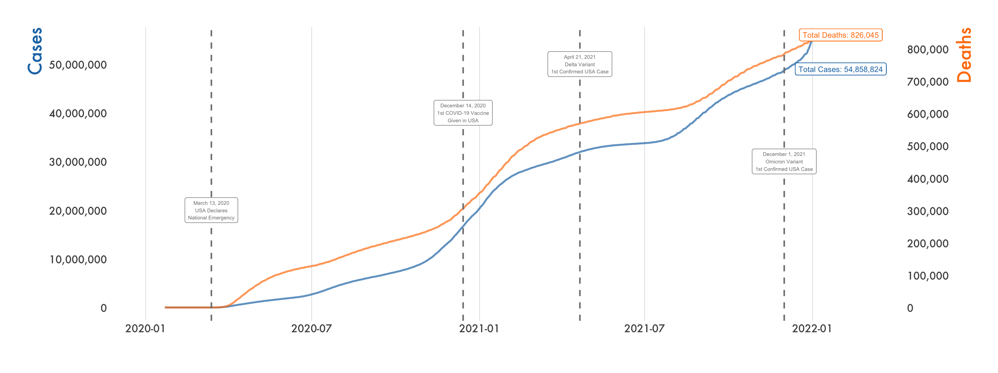

*Note.* This figurecontains cumulative COVID-19 cases (blue) and deaths (orange) from January 1, 2020 through December 31, 2021 using Johns Hopkins University (2022) data.

**Problem Statement**

After two years since the first confirmed case in the state of Washington, nearly everyone (if not everyone) in the US has been impacted by COVID-19 in some fashion. However, it hasn’t been uniform across the nation. Some groups are more vulnerable and thus require more resources. Therefore, it is necessary to better understand which cohorts are more disadvantaged to be proactive against this coronavirus and its various mutations.

**Purpose of the Study**

The following topics have been the subjects of research to better understand how to mitigate the detrimental effects of COVID-19:

* Mental and physical health have strong correlations with COVID-19 cases and deaths.
* Area Deprivation Indices (ADI) generally have a positive correlation with COVID-19 incidence.
* Policy measures such as masking and event cancellations are drawn up to reduce mobility.

The goal of this paper is to identify further factors with strong correlation to COVID-19 to inform research, practice, and policy development related to the continued efforts to address the pandemic status of the disease.

**Significance of the Study**

COVID-19 and the response to it has caused considerable damage to the following aspects of our lives. Many have lost loved ones. Many have caught the disease and are struggling with long term side effects. Hospitals have had capacity issues which has led to overworked medical staff and patients not receiving necessary care. The economy has suffered, and people have had to make the difficult choice to close their businesses. The Christian church body which was already struggling with declining attendance saw in-person rates drop more rapidly with the onset of COVID-19. Mental health issues such as anxiety and depression have increased from 11% (2019) to 41% (2021) for adults in the United States (Panchal et al., 2021). There are also many other areas of our lives and in our society that have been detrimentally impacted since its inception. Maximizing an objective understanding of how to minimize incidence rates is of critical importance.

To further understand significant relationships with COVID-19 incidence, a variety of data sets were combined. The features included consisted of demographic and socioeconomic information, survey data, mobility indices, and COVID-19 cases, deaths, and testing. After joining the data at the county and date level, two data science techniques were chosen to form the questions above in the Purpose of the Study. First, correlation analysis was performed amongst all the variables to see where there were strong (positive and negative) relationships with COVID-19 cases and deaths. Second, modeling via the XGBoost algorithm was utilized to see which independent variables best predicted COVID-19 incidence 30 days from the current date.[1] Lastly, the results of these analyses were used to create multiple cohorts and determine if their differences were statistically significant.

**Literature Review**

**Introduction**

Many businesses and organizations benefit highly from understanding the demographic and socioeconomic makeup of their clients. Retailers use this information to understand which products to stock and how to target promotions. Social media websites utilize personal data to minimize customer acquisition costs for businesses. Government agencies value having this knowledge as it allows them to understand how best to allocate their resources and promote a strong community.

Regarding COVID-19, many researchers have concluded that this virus can affect different cohorts of people disproportionately. “In the United States, for example, minority and poor populations reflect disproportionately high rates of infectious disease [such as COVID-19] and other health disparities.” (McNeely et al., 2020). Boserup et al. (2020) also concludes that “all major racial and ethnic minority groups have been disproportionally impacted by the COVID-19 pandemic.” Therefore, maintaining datasets that accurately reflect the population at appropriate concentrations is necessary for a society to respond effectively during a time of crisis.

While there are numerous ways to explore how COVID-19 has disproportionately affected citizens of the USA, the following were reviewed:

* How have those with mental health issues experienced further struggles during this time?
* How do those with and without underlying physical health conditions respond to COVID-19 infections?
* How do Area Deprivation Indices (ADI) / Social Determinants of Health (SDoH) correlate with COVID-19 cases / deaths?
* What are the interactions between mobility trends, government restrictions, and COVID-19?

**Mental Health**

According to the Centers for Disease Control and Prevention (CDC) (2021), “Mental health includes our emotional, psychological, and social well-being. It affects how we think, feel, and act. It also helps determine how we handle stress, relate to others, and make healthy choices. Mental health is important at every stage of life, from childhood and adolescence through adulthood.” A major struggle surrounding mental health is that it can be difficult to objectively measure. It’s not something as simple as blood pressure or body temperature. Thus, optimal treatment plans may not be easily recognizable. Mental health illnesses and disorders can increase the likelihood of physical health problems which can then further complicate care management strategies.

Social support programs that promote stability, community, activity, etc. are effective in combatting mental health issues. However, the onset of a major disruptive event (such as COVID-19) often leads to increased rates of mental disorders in a society. An analysis by Lu et al. (2021) concluded the following.

1. The pandemic has led to increased economic uncertainty, increased unemployment and underemployment pressure, increased income uncertainty, and different degrees of employment pressure and economic difficulties.
2. These difficulties have stimulated different levels of mental health problems, ranging from perceived insecurity (environmental, food safety, etc.), worry, fear, to stress, anxiety, depression, etc., and the mental health deterioration varies across different groups, while [*sic*] the symptoms of psychological distress are more obvious among disadvantageous groups.
3. Mental health problems have caused behavior changes and various stress behaviors such as protective behaviors and resistive behaviors.

Wang et al. (2020) performed a study around the impact of mental disorders and the risk of COVID-19 infection. Table 1 shows the adjusted odds ratio[2] of contracting COVID-19 for someone with ADHD, bipolar disorder, depression, or schizophrenia versus an individual with the same comorbidities and similar demographics but without a mental health condition. Clearly, the odds of COVID-19 infection increase substantially for those with mental health disorders. Table 2 looks at these same exposures and includes gender, age, and ethnicity breakouts. That analysis shows that females, seniors, and African Americans are at increased risk compared to males, adults, and Caucasians respectively.[3] The magnitude by which mental health increases COVID-19 infection rates according to this study should encourage proactive mitigation strategies for this and other public health matters.

**Table 1**

*Mental Health Disorder & Odds of COVID-19 Infection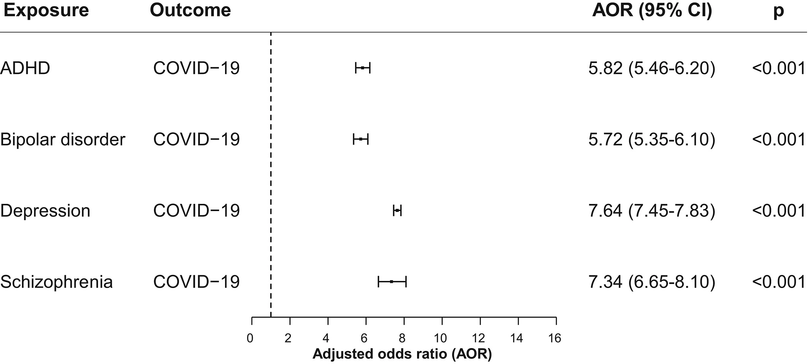Note.* This figure shows the association of recent (within past year) diagnosis of a mental disorder and COVID-19 infection after adjusting for age, gender, ethnicity, and medical comorbidities[4] (Wang et al., 2020).

**Table 2**

*Mental Health Disorder & Odds of COVID-19 Infection (Demographic Breakout)*

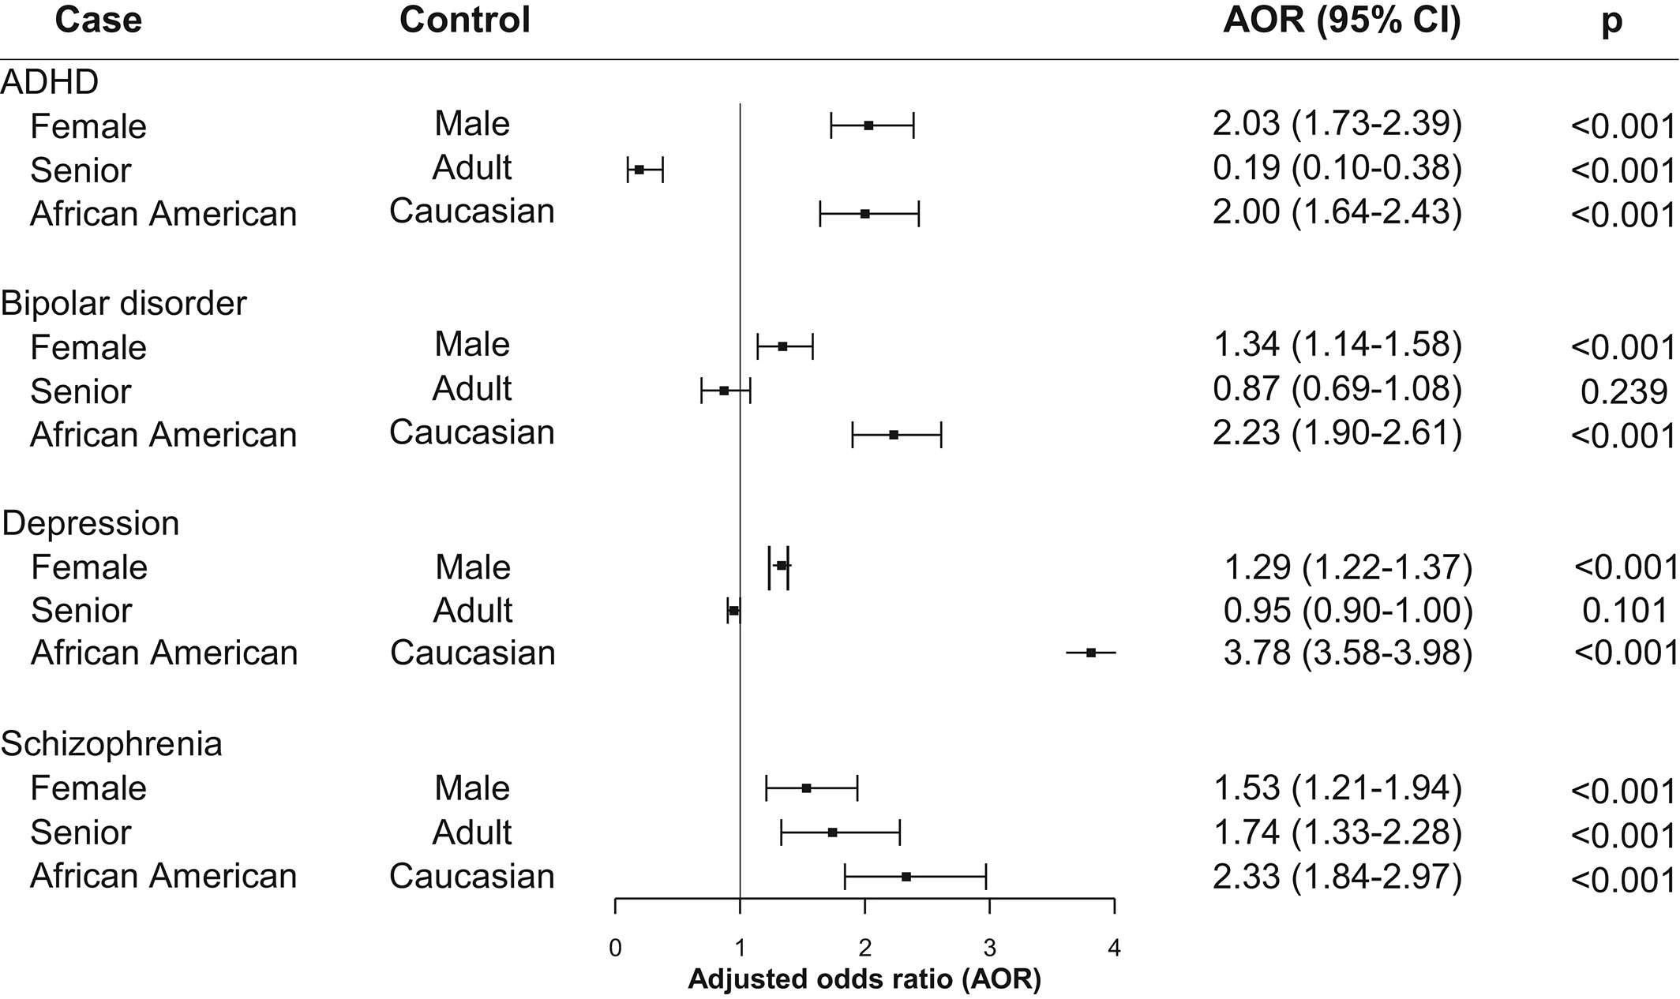

*Note.* This figure shows the effects of demographics on odds of COVID-19 infection among patients with a recently diagnosed mental disorder after adjusting for medical comorbidities (Wang et al., 2020).

**Physical Health**

Unlike mental health, physical health can often be easier to objectively measure. We can look at blood sugar levels, monitor heart rates, ensure that organs are functioning properly, etc. Within the physical health space, chronic illnesses are often flagged because they increase the probability of a lower quality of life and higher health care spending if not properly managed. Thus, it is valuable for patients, providers, and payers to address these conditions. Some of the most common and costly chronic illnesses include cancer, diabetes, and heart disease.

Alyammahi et al. (2021) states “patients are more susceptible to COVID-19 and have higher mortality rates compared to patients with no comorbid conditions.” Additionally, they mentioned “COVID-19 can induce chronic diseases in previously healthy patients.” The combination of COVID-19 and comorbidities ultimately leads to a higher risk of a more severe case of COVID-19.

Furthermore, COVID-19 has increased complications for those with chronic illnesses even if they don’t contract this virus because medical staff have been diverted to assist with urgent COVID-19 cases. According to Nunez et al. (2021), “The pandemic has further affected those seeking care for chronic conditions in areas without well-established telemedicine. Telemedicine helps provide routine care for patients with chronic diseases who are at increased risk of severe illness if exposed to the virus. COVID-19 has made facility-based care for chronic conditions a major challenge.”

**Area Deprivation Indices / Social Determinants of Health**

Area Deprivation Index (ADI) values provide a ranking from 1 to 100 to indicate how disadvantaged a region is based on Social Determinants of Health (SDoH) such as income, education, employment, and housing quality. “Living in a disadvantaged neighborhood has been linked to a number of healthcare outcomes, including higher rates of diabetes and cardiovascular disease, increased utilization of health services, and earlier death.” (Kind et al., 2018). Though higher ADI values have been shown to be correlated with higher COVID-19 incidence rates, Kitchen et al. (2021) states that this correlation is stronger in urban counties and weaker in rural areas. Additionally, the results of a study by Lewis et al. (2020) in Table 3 below illustrate the magnitude by which higher ADI values contribute to higher COVID-19 incidence.

**Table 3**

*Odds Ratios for Cases / Hospitalizations / Testing by Level of Deprivation*

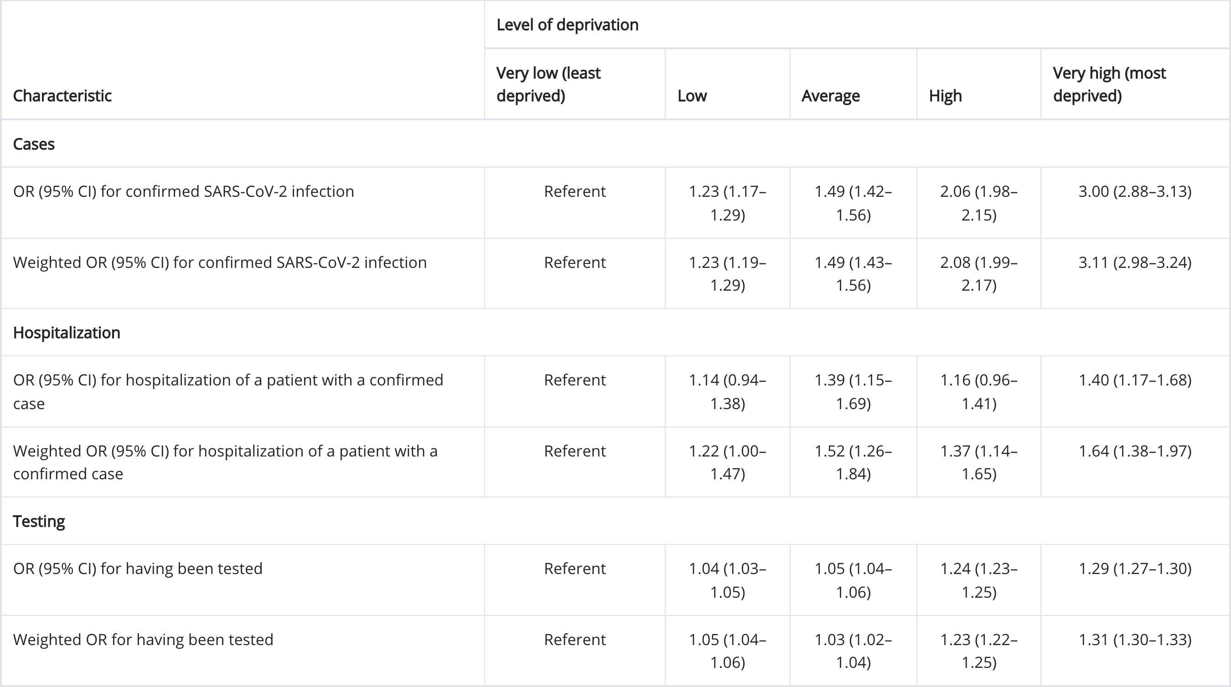

*Note.* This table contains unadjusted odds ratios (ORs), weighted ORs, and 95% confidence intervals (CIs) for COVID-19 infection, hospitalization, and testing by quintiles of health improvement index areas – Utah, March 3–July 9, 2020 (Lewis et al., 2020).

**Government Policy Measures / Public Mobility**

Mobility is commonly tracked through personal devices such as cell phones or applications such as Google Maps. This data can be used to inform how people are traveling and where to. As COVID-19 is a transmissible disease, it is understandable to presume that increases in mobility may lead to increases in infection rates.

In order to discourage mobility, governments have implemented stay-at-home orders and other restrictive policy measures. Jacobsen (2020) looked to study the impact of government intervention regarding mobility. States without stay-at-home orders were compared against those with stay-at-home orders. They confirmed that those mandating lockdowns were effective in reducing mobility (Table 4).

**Table 4**

*Mean Change in Destination Visits by State*

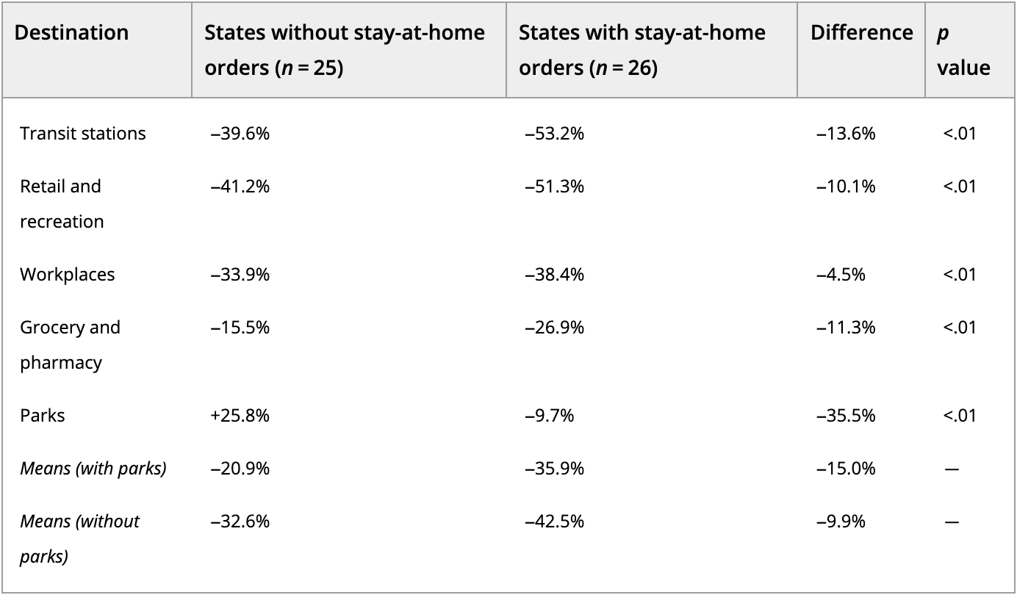

*Note.* This table contains the mean change in visits to various destinations by state between mid-February and March 29, 2020 based on whether a statewide stay-at-home order was or was not in effect as of March 29 (Jacobsen, 2020).

Given that mobility can be effectively reduced through public policy measures, it’s important to confirm that reduced mobility then leads to lower COVID-19 incidence. Gottumukkala et al. (2021) explored the relationship between mobility and COVID-19 infection rates for the second peak in the United States through a phase-wise association approach by using a Logistic Growth Model (LGM). The four phases chosen based on confirmed cases were early growth (I), fast growth (II), fast growth to steady-state (III), and steady-state (IV). Their analysis showed that it was difficult to find correlations between changes in mobility and in the number of the cases outside of Phase-II. Therefore, they concluded that it is not productive to associate mobility with cases beyond the first peak. Lastly, their study did not consider approaches such as facial covering requirements and government regulations which may be strong contributors.

**Conclusion**

The relationships between COVID-19 incidence and the topics covered in this literature review (mental / physical health, ADI / SDoH, and government policy measures / mobility) have been the subject of much research. There are many variables to study from a demographic / socioeconomic perspective, but these were chosen due to being highly correlated with COVID-19 in 2021 and / or important predictors when modeling COVID-19 incidence. Studies have concluded that there are statistically significant differences in cohorts when looking at mental / physical health as well as ADI / SDoH. However, while restrictive policies have been effective in reducing mobility, it is not decisive that reduced mobility has been effective in minimizing COVID-19 incidence.

**Methodology**

**Introduction**

Much research has been performed comparing a specific variable (such as race, gender, mental health status, underlying physical conditions, etc.) against COVID-19 cases and deaths. The goal of this study was to understand the magnitude of which variables have the highest correlation with COVID-19 incidence. To do so, this paper used a holistic approach of including a variety of publicly available datasets to let modeling and statistically sound best practices determine which features were most important and thus required the most attention to combat this coronavirus through the allocation of resources.

**Research Design**

A quantitative methodology with multiple types of research designs was covered in this case study. A quasi-experimental approach was applied via an XGBoost model. The objective of the model was to measure the effect that the independent variables had on the dependent variables (cases and deaths). Correlation was utilized to test how strongly variables were related. The data for some of the variables changed daily and therefore included a time component. Other variables were static and thus were measured against aggregate cases and deaths by county. The last type of design included was descriptive. Cases, deaths, and other variables were analyzed to gain a high-level exploratory understanding of various summary statistics.

**Research Topics**

The following topics were studied to identify further factors that correlate with COVID-19:

* Mental / Physical Health
* ADI / SDoH
* Government Policy Measures / Public Mobility

**Population**

For this case study, the goal was to determine which factors correlate with COVID-19 cases / deaths in the United States of America. To do so, it seemed reasonable to gather data at the county level. More granular data would have been difficult to obtain, and less granular data would likely have lead to fewer insights. The data included for variables that could be acquired at a daily / monthly level range from January 2020 through January 2022. Static variables such as political affiliation or gender percentages consisted of the latest available information. More detail regarding variable specific time frames is found in the Data Collection section below.

**Instrumentation**

Integrated development environment (IDE) RStudio was used with the open-source statistical software R for data preparation, modeling, and visualization. While R’s base functionality includes many fundamental statistical functions, it can be expanded with packages via the Comprehensive R Archive Network (CRAN). Some of the primary packages utilized in this report were dplyr, xgboost, and ggplot (see Appendix for full list).

**Data Collection**

Data for cases and deaths were collected from the COVID-19 Data Repository by the Center for Systems Science and Engineering (CSSE) at Johns Hopkins University (JHU). The US data sources are the health departments at the state or county / city level. This dataset contains data from January 2020 and is updated daily (Dong et al., 2020).

JHU also provides daily data regarding COVID-19 testing at the state level. “The Johns Hopkins Coronavirus Resource Center began providing COVID-19 testing data for the United States from publicly reported sources since March 7, 2021 when The Atlantic’s COVID Tracking Project end its year-long collection effort.” (Johns Hopkins University, 2022). Therefore, each county within a state used the same testing values. From this dataset, a few features were engineered. Population data was joined to calculate tests per 100,000. Lag variables were created that calculate the change in testing per 100,000 people by 7, 14, 21, and 28 days.

Much research has been done regarding Social Determinants of Health and Area Deprivation Indices. Those in less fortunate areas with fewer resources seem to have more health complications. Therefore, the [Neighborhood Atlas](https://www.neighborhoodatlas.medicine.wisc.edu/) data provided by the University of Wisconsin was included in this analysis (Kind et al., 2018). As of the development of this study, the latest ADI values that were available and thus included were for 2019.

Next, the County Health Rankings dataset was included as it is contains many factors that influence health. This is a program of the University of Wisconsin Population Health Institute that works towards equal opportunities for everyone to be as healthy as possible. Their goal is to build awareness on health disparities and empower community leaders to create sustainable change (*County Health Rankings*, 2021). The latest data available at the time of this writing and thus included were for 2021.

The CDC provides daily vaccination data at the county level. “Data represents all vaccine partners including jurisdictional partner clinics, retail pharmacies, long-term care facilities, dialysis centers, Federal Emergency Management Agency and Health Resources and Services Administration partner sites, and federal entity facilities.” (*Centers for Disease Control and Prevention*, 2022). The features in this data include how many people have received at least one dose and how many are fully vaccinated. These values are also broken out by age thresholds.

“Socioeconomic indicators like poverty rates, population change, unemployment rates, and education levels vary geographically across U.S. States and counties. [Economic Research Service (ERS)] compiles the latest data on these measures and provides maps and data display / download for states and counties.” (U.S. Department of Agriculture, 2021). The data source for education, poverty, population, and median income is the U.S. Census Bureau. Unemployment data is provided by the Bureau of Labor Statistics (BLS). The data sourced here is a five-year average between 2015 and 2019.

From the United States Census Bureau, the American Community Survey (ACS) data was collected. This data contains the most popular social, economic, housing, and demographic data at various geographic levels for 2017. It is often utilized to help local officials, community leaders, and businesses understand the changes taking place in their communities (*United States Census Bureau*, 2020).

As COVID-19 is a transmissible disease, Google and Apple daily mobility reports were included in the data. “These Community Mobility Reports aim to provide insights into what has changed in response to policies aimed at combating COVID-19. The [Google] reports chart movement trends over time by geography, across different categories of places such as retail and recreation, groceries and pharmacies, parks, transit stations, workplaces, and residential.” (Ramachandran, A., 2020 & *Google* *COVID-19 Community Mobility Reports*, 2021). The Apple reports track daily changes in requests for directions by transportation type for walking, driving, and public transit (*Apple Maps*, 2021).

Harvard Dataverse contains a presidential election returns database (MIT Election Data and Science Lab, 2021). The 2020 results were used to estimate political affiliation at the county level. This data was included as the political parties of the United States continue to disagree on the best course of action against COVID-19.

Lastly, average temperature and total precipitation data was included from the National Oceanic and Atmospheric Administration (NOAA, 2022). This dataset is aggregated at the monthly level by county. Virus transmission rates are known to be impacted by climate. Therefore, understanding how weather interacts with other variables and their relationship with COVID-19 incidence should be worthwhile.

**Data Analysis**

After combining the variety of data sources previously mentioned at the date and county level, calculating correlations and building a predictive model was advantageous to determine which variables may be the most worthwhile to study. Correlations were calculated at daily, monthly, and annual levels (depending on the dataset) as well as by county using both parametric and non-parametric measures based on the underlying distribution and assumptions of the variables involved. The methods of choice are Pearson and Spearman correlation coefficients respectively.

Figure 2 below shows the correlations for the seven-day averages of cases per 100,000 people and the day-level variables. Figure 3 shows the correlations for the seven-day averages of deaths per 100,000 people and the day-level variables. The relatively high positive correlations between cases, tests, and deaths is expected. Mobility features such as driving (apple_driving) and visiting parks (parks_percent_change_from_baseline) have an inverse relationship with both cases and deaths.

**Figure 2**

*Correlation: Cases & Day-Level Variables*

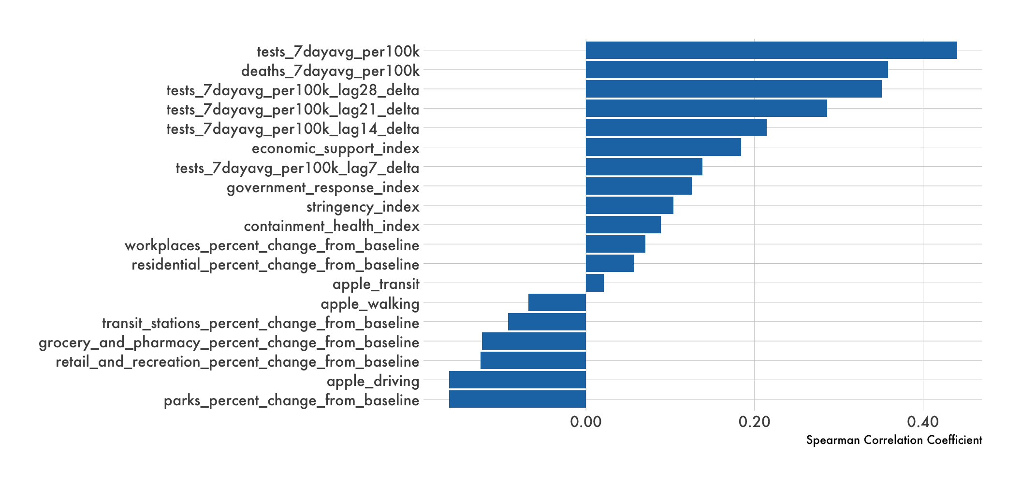

*Note.* This figure shows the correlation between the seven-day average of COVID-19 cases per 100,000 people and day-level variables for 2021. See the Data Dictionary in the Appendix for variable descriptions and sources.

**Figure 3**

*Correlation: Deaths & Day-Level Variables*

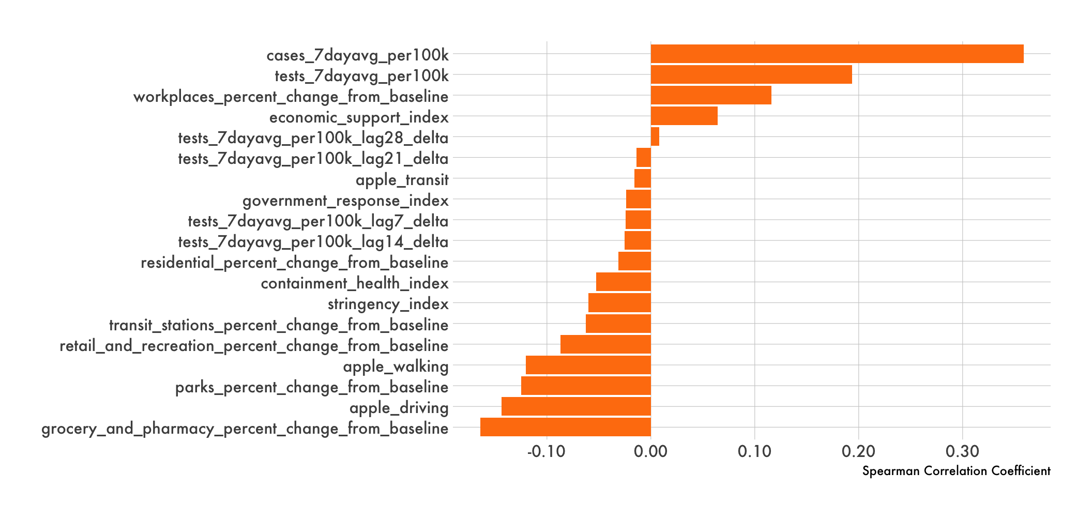

*Note.* This figure shows the correlation between the seven-day average of COVID-19 deaths per 100,000 people and day-level variables for 2021. See the Data Dictionary in the Appendix for variable descriptions and sources.

Vaccination data is also provided at the day-level by the CDC. However, it was excluded from Figures 2 and 3 as it is reported as a cumulative value. Figures 4 and 5 below illustrate daily COVID-19 cases and deaths respectively per 100,000 people by quartile where the blue or orange line respectively focuses on a specific bucket. The gray lines represent the other quartiles for comparison. Counties are bucketed based on the maximum reported value of the percent of people fully vaccinated in 2021. Interestingly, counties with ultimately the fewest fully vaccinated people [0,45.4] saw the largest spike in cases around September 2021, but counties with the most fully vaccinated people (60.2,100] by the end of 2021 had the highest spike in cases in December. Regarding COVID-19 deaths however, counties with more fully vaccinated people consistently had fewer deaths per 100,000 people throughout 2021.

**Figure 4**

*COVID-19 Cases by Fully Vaccinated Quartiles*

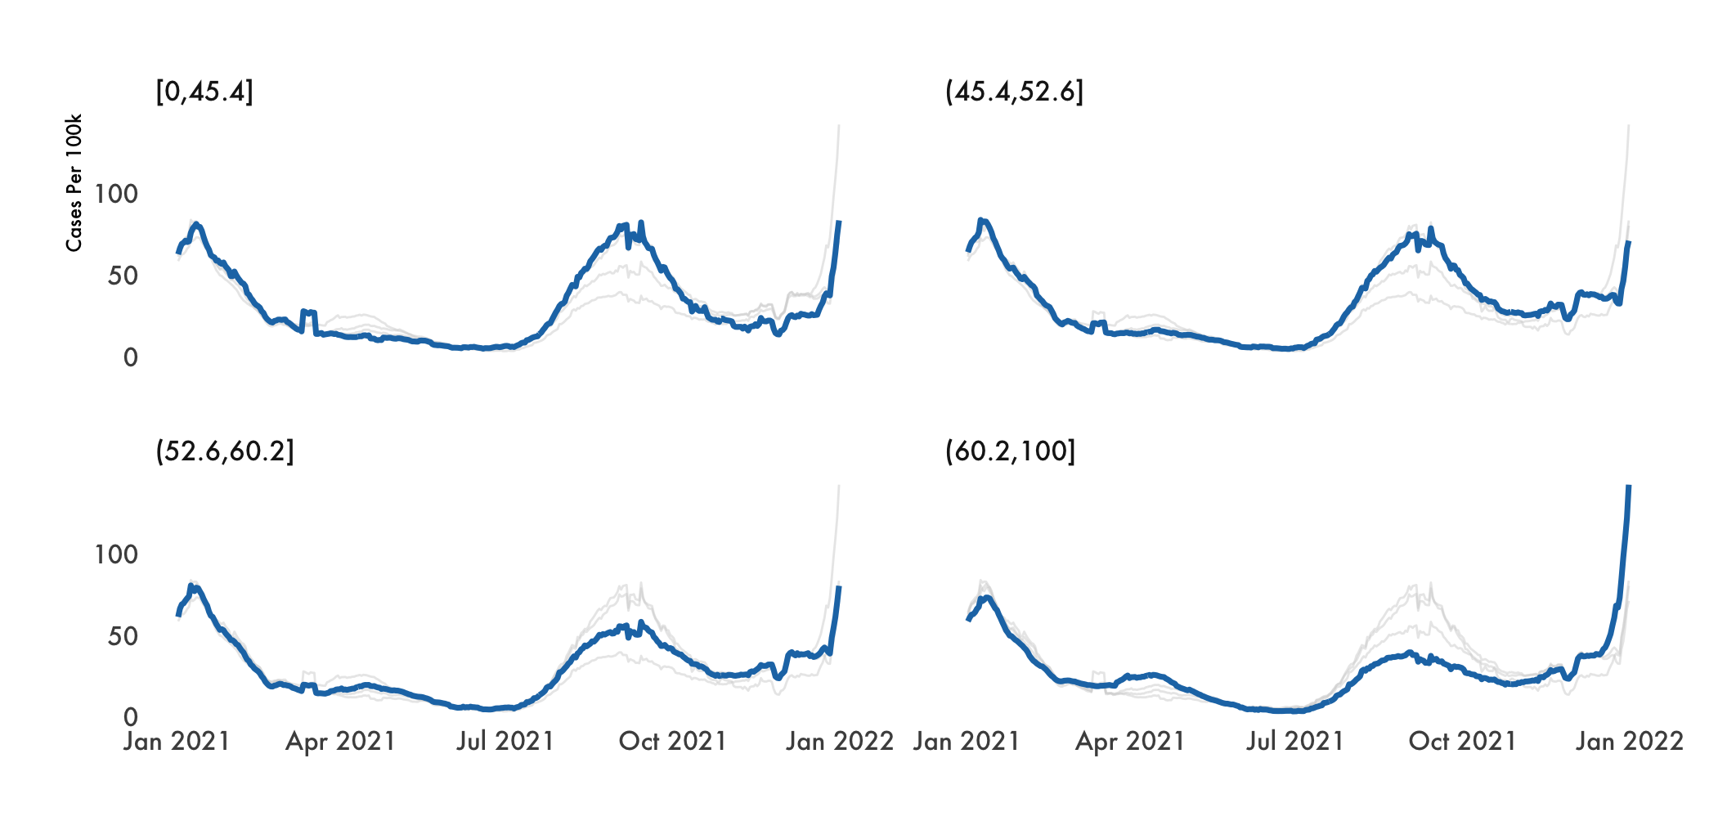

*Note.* This figure illustrates daily cases per 100,000 (Johns Hopkins University, 2022) where counties are grouped into quartiles based on the maximum reported value of the percent of people fully vaccinated (*Centers for Disease Control and Prevention*, 2022) in 2021.

**Figure 5**

*COVID-19 Deaths by Fully Vaccinated Quartiles*

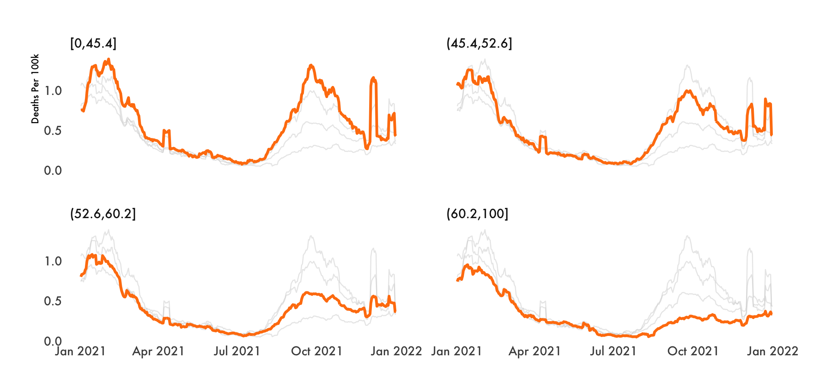

*Note.* This figure illustrates daily deaths per 100,000 (Johns Hopkins University, 2022) where counties are grouped into quartiles based on the maximum reported value of the percent of people fully vaccinated (*Centers for Disease Control and Prevention*, 2022) in 2021.

The weather data correlation shown in Figure 6 was aggregated at the monthly level. There was a small negative relationship between COVID-19 incidence and precipitation, and a slightly larger negative correlation with temperature. Therefore, this suggests that warmer and wetter areas may experience few COVID-19 cases and deaths.

**Figure 6**

*Correlation: Cases / Deaths & Weather Variables*

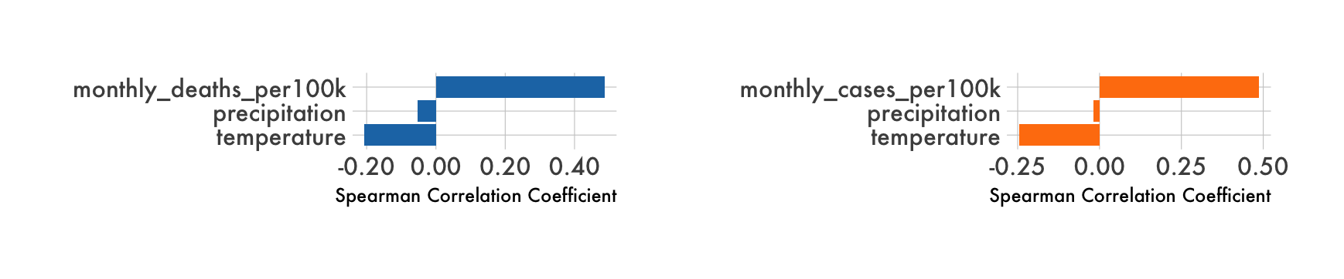

*Note.* This figure shows the correlation between monthly COVID-19 cases and deaths per 100,000 people and month-level weather variables. See the Data Dictionary in the Appendix for variable descriptions and sources.

Figures 7 and 8 below show the top and bottom 25 variables most correlated (positively and negatively) with COVID-19 cases and deaths respectively. From these visuals, there appears to be a few key topics which helped shape the purpose of this study.

* Mental Health (Variables: average_number_of_mentally_unhealthy_days, percent_frequent_mental_distress, etc.)
* Physical Health (Variables: average_number_of_physically_unhealthy_days, percent_fair_or_poor_health, etc.)
* ADI/SDoH (Variables: college, adi, median_household_income, etc.)

**Figure 7**

*Correlation: Cases & Static Variables*

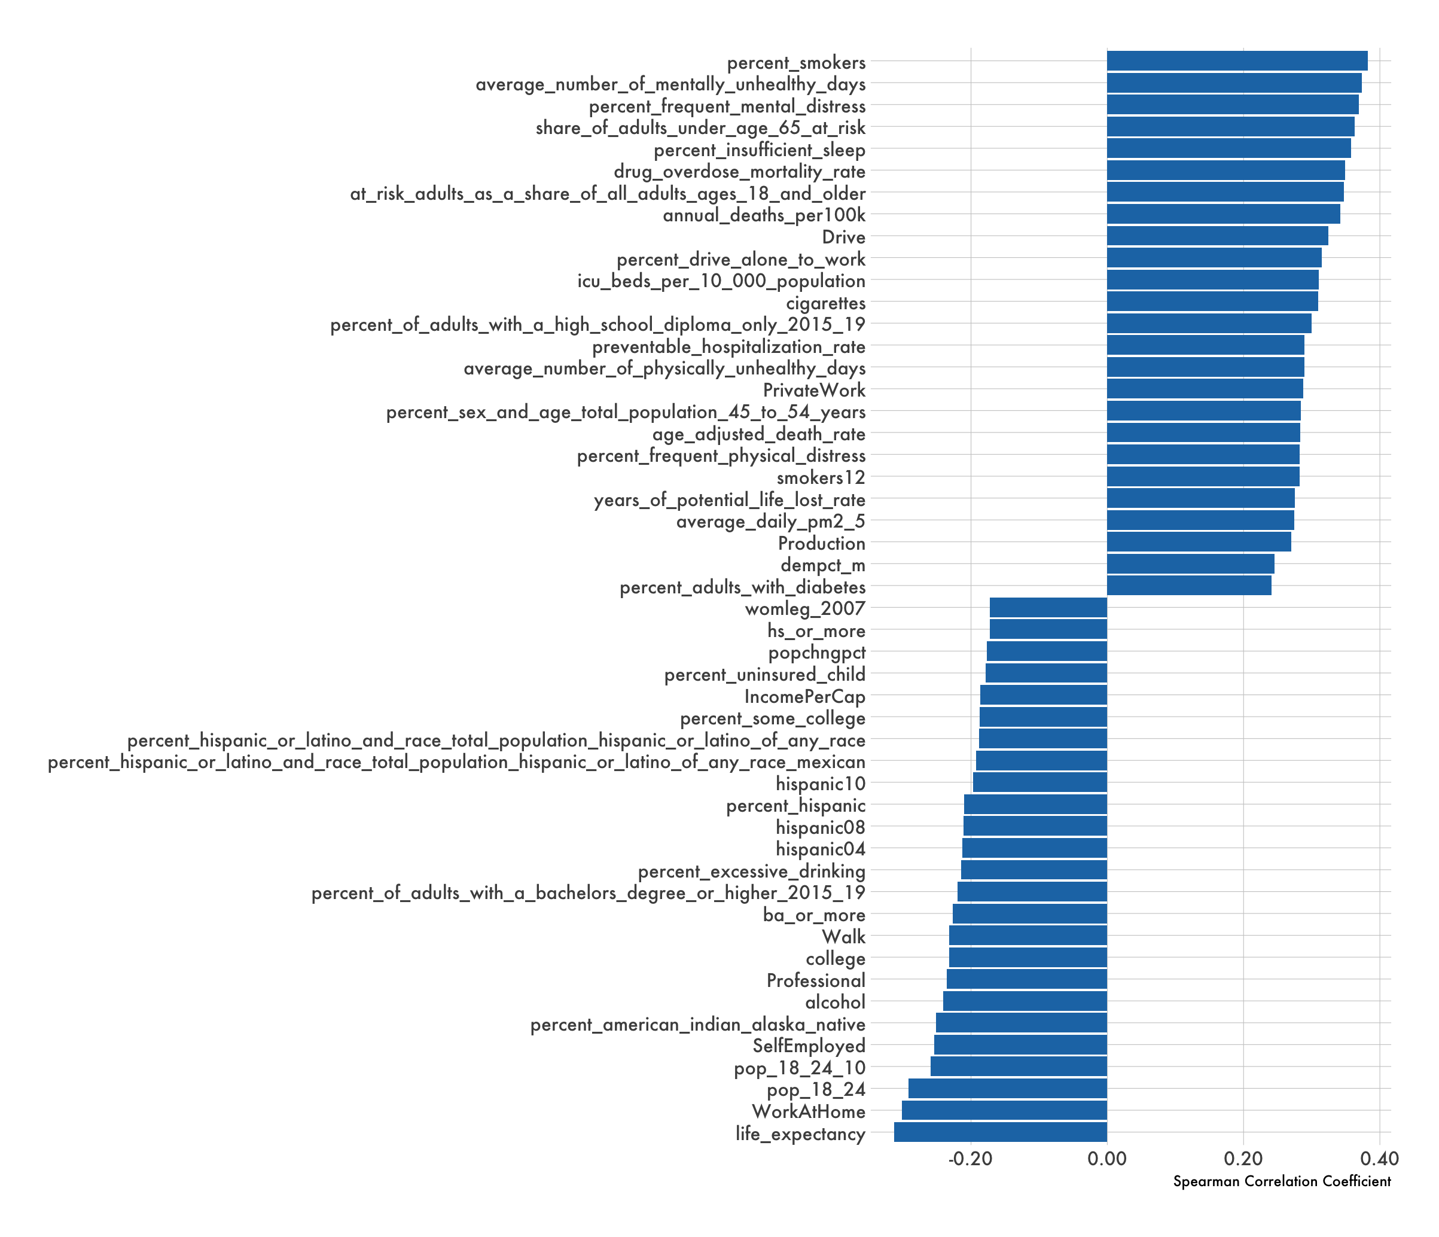

*Note.* This figure shows the correlation between annual COVID-19 cases per 100,000 people and static variables for 2021. See the Data Dictionary in the Appendix for variable descriptions and sources.

**Figure 8**

*Correlation: Deaths & Static Variables*

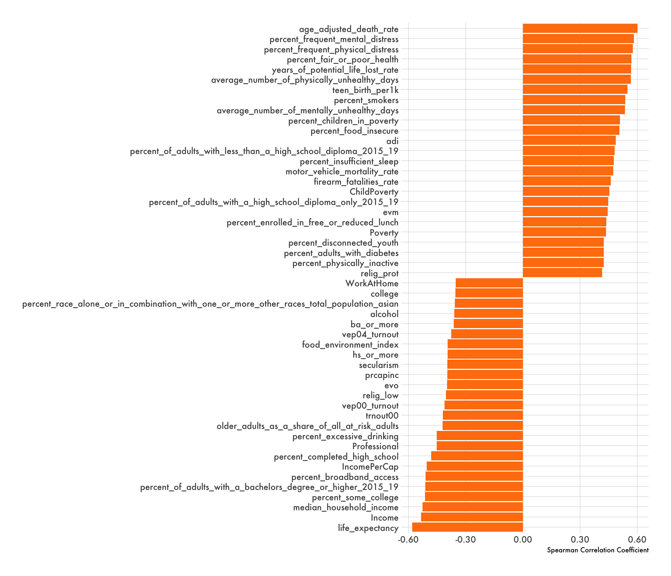

*Note.* This figure shows the correlation between annual COVID-19 deaths per 100,000 people and static variables for 2021. See the Data Dictionary in the Appendix for variable descriptions and sources.

In modeling COVID-19 cases and deaths, a common approach has been to use an SIR model as illustrated in Figure 9. This type of model compartmentalizes people into one of three categories: S-susceptible, I-infectious, and R-recovered/removed. Susceptible people become infected at a rate equal to the product of an infectious contact rate β and the number of infectious I. Infectious people recover at a rate γ (Choisy, 2018). These types of models have been expanded upon to include spatial features, vaccination rates, loss of immunity, etc. However, an SIR model is outside the scope of this study as its goal is to model the spread of infectious diseases within a population. This paper applied a machine learning algorithm for the purpose of extracting feature importance and model interactions to better understand the demographic and socioeconomic makeup of those already impacted by COVID-19.

**Figure 9**

*SIR Model Equation*

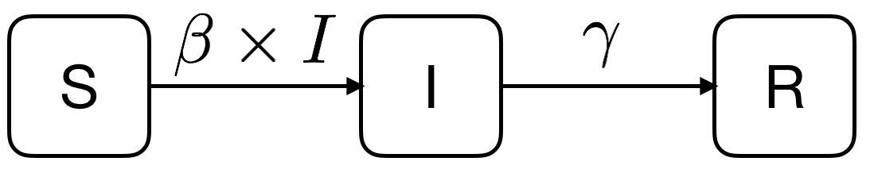

*Note.* This figure shows a basic SIR (Susceptible, Infectious, Recovered/Removed) model equation (Choisy, 2018).

XGBoost (eXtreme Gradient Boosting) was selected to build regression models for predicting cases and deaths per 100,000 people 30 days from the current date. While the goal of this study was not forecasting, these models were used to extract important information regarding the variables that are most indicative of future COVID-19 incidence as well as strong interactions amongst the variables.

XGBoost is a machine learning algorithm that can be used for regression and classification. The general idea behind gradient boosting is that combining weak learners will ultimately produce a more accurate model. A weak learner is a simple decision tree that is constructed based on purity scores[5]. Gradient boosting aims to combine multiple decision trees to lower the model error. This algorithm has been successfully utilized many times on competition platforms such as Kaggle because of its ability to implement state-of-the-art results quickly (Radecic, 2021).

The development of a machine learning model requires considerations for several preprocessing steps. One of these steps includes how best to split the data into a training set and a testing set. The training set contains the data that will be used by the algorithm to build the model for future predictions. The testing set is a mutually exclusive dataset by which the model can be tested for overfitting or underfitting. Figure 10 below illustrates the importance of optimally fitting a model to the training and testing data sets.

**Figure 10**

*Model Fit*

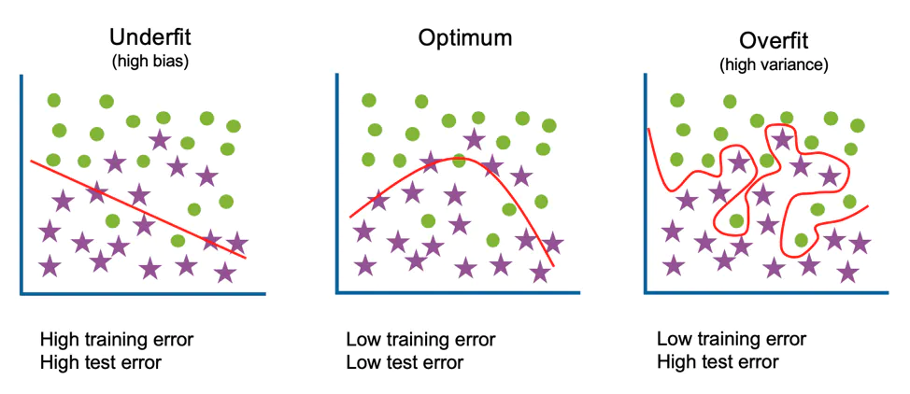

*Note.* This figure illustrates the importance of properly fitting a model so that both the training and testing data sets have minimal error (IBM Cloud Education, 2021).

Splitting the data between training and testing sets is often done randomly. For this project however, the training data was manually selected to range from July 1, 2020 through August 31, 2021. The testing data ranges from September 1, 2021 through November 30, 2021. Because of the time component within the data, this approach seemed reasonable as the dependent variable is a future target.

Figure 11 below illustrates total COVID-19 cases by day at the national level. The blue line represents actual values, and the gray line is the predicted values. Based on this visual, the model appears to be overfit. The lines prior to September 1, 2021 (training data) are very close together. Beginning September 1, 2021 (testing data), they start to drift apart. Calculating a few common statistical metrics confirms that the model is overfit. Table 5 contains the following metrics:

* Root Mean Square Error (RMSE): This value is the standard deviation of the residuals (prediction errors). Thus, a lower value indicates a more accurate fit.
* Mean Absolute Error (MAE): This refers to the average of the absolute differences between actual and predicted values. Again, a lower value indicates a more accurate fit.
* Coefficient of Determination (R^2): This equals the squared value of the correlation between the actual and predicted values (in our scenario). This value can range from 0 to 1, and a value of 1 indicates a perfect fit.

**Figure 11**

*National COVID-19 Cases: Actual vs Prediction (Initial Model)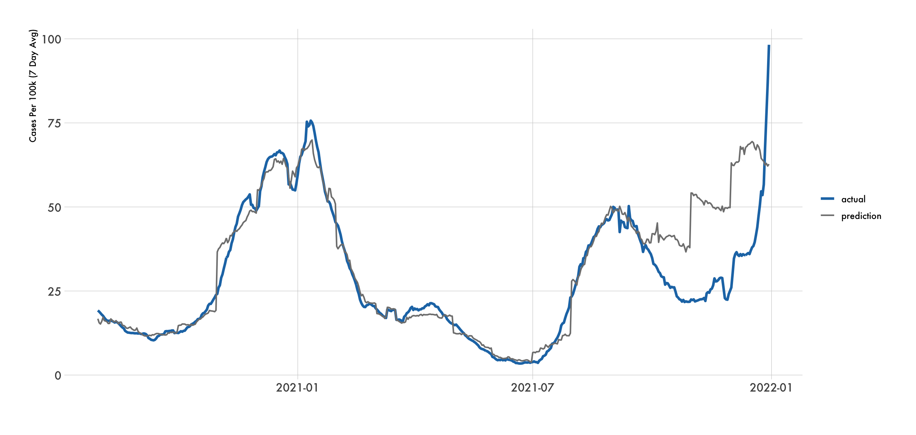Note.* This figure shows the seven-day moving average of cases per 100,000 people in the United States using Johns Hopkins University (2022) data. The blue line represents actual values. The gray line represents predictions from the initial XGBoost model.

**Table 5**

*National COVID-19 Cases – Metrics (Initial Model)*

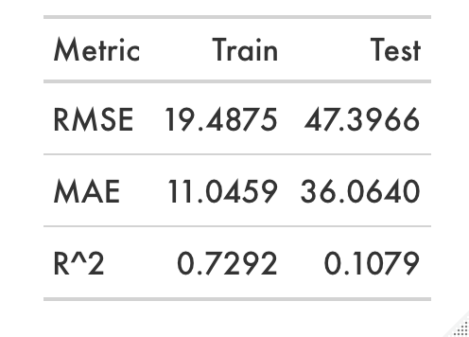

*Note.* This table shows the metrics for the training and testing data sets of the initial COVID-19 cases model.

Table 5 also indicates that the model is overfit as the Test metrics show poor performance when compared to the Train values. Additionally, the values in the Train and Test columns in Table 5 should be relatively similar. Therefore, the xgb.train function within the xgboost package was used which accepts both the training and testing datasets as input for constructing a model. Because boosting is a sequential process (information from a previously grown tree is used to build the next tree), the model attempts to improve its predictions over subsequent iterations. The goal is to identify the iteration where the Test RMSE is minimal and use that to finalize the model. Figure x below indicates that iteration 19 (dashed orange line) is recommended in constructing the final model.

**Figure 12**

*National COVID-19 Cases – XGBoost Model Training*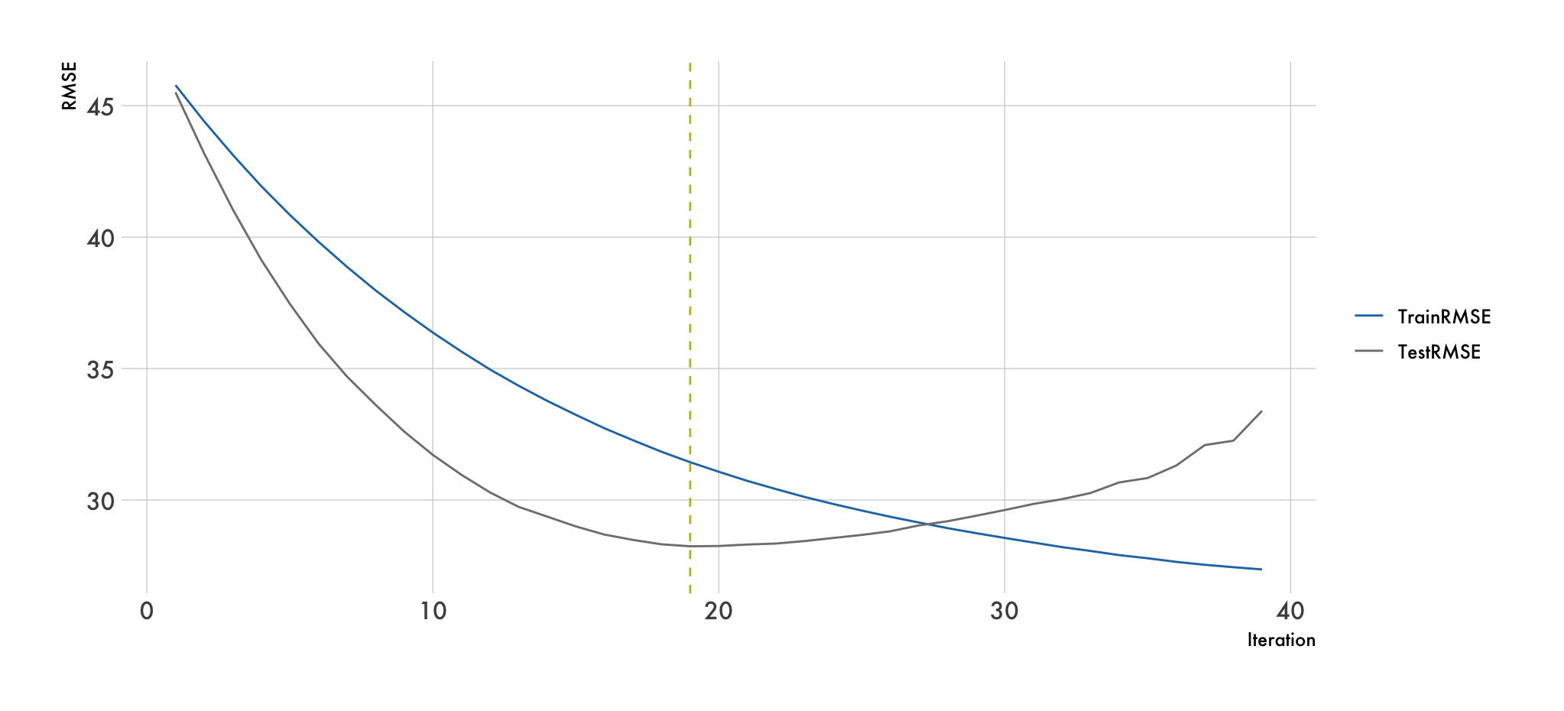

*Note.* This figure shows the RMSE values for the training and testing data sets at each iteration during the model training.

Figure 13 below shows the results of the final model. Visually, it’s apparent that the model doesn’t fit the training set as well. However, the testing data appears to have a better fit up until the spike at the end of 2021. Additionally, Table 6 affirms this as the metrics for the Train column have worsened, but the Test column values have improved compared to the initial model. The metrics are more similar than they were in Table 5 which addresses the issue of overfitting. Therefore, this final model has been improved to better handle new data. While this model may not be ideal for forecasting, it was effectively used in this paper for exploring the interaction between variables and their association with COVID-19 cases.

**Figure 13**

*National COVID-19 Cases – Actual vs Prediction (Final Model)*

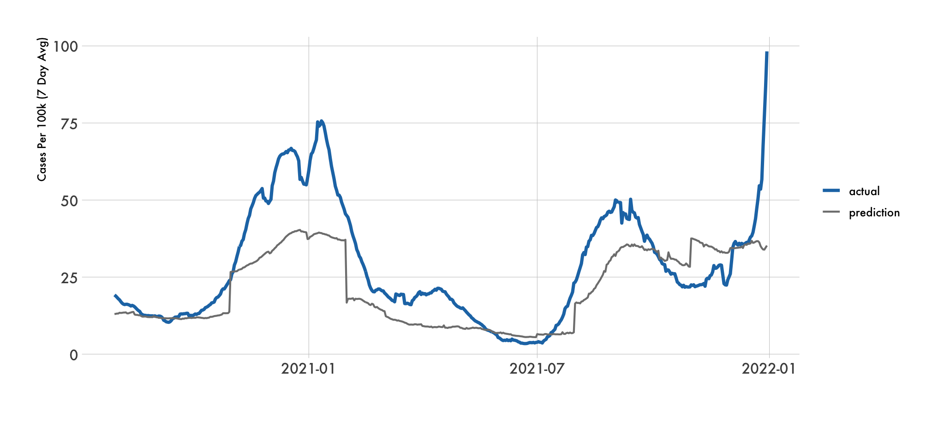

*Note.* This figure shows the seven-day moving average of cases per 100,000 people in the United States using Johns Hopkins University (2022) data. The blue line represents actual values. The gray line represents predictions from the final XGBoost model.

**Table 6**

*National COVID-19 Cases – Metrics (Final Model)*

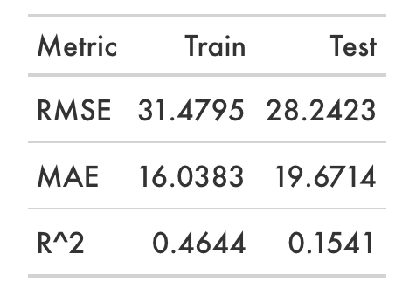

*Note.* This table shows the metrics for the training and testing data sets of the final COVID-19 cases model.

Modeling (including tuning) for COVID-19 deaths was performed in a similar fashion. The chart with actuals and predictions as well as the metrics table for the final model are shown below in Figure 14 and Table 7 respectively. From these models, variable importance was extracted, and model interactions were explored to compare groups for statistically significant differences and uncover interactions between features. One thing to note is that the Omicron variant is more contagious but less deadly. That can be seen in Figure 13 as the blue line increases sharply heading into January 2022, yet the orange line in Figure 14 remains below the gray prediction line towards the end of 2021. Similar to the model for COVID-19 cases, this model may not be reliable in accurately forecasting COVID-19 deaths. However, it proved valuable in the discovery of important features to explore.

**Figure 14**

*National COVID-19 Deaths – Actual vs Prediction (Final Model)*

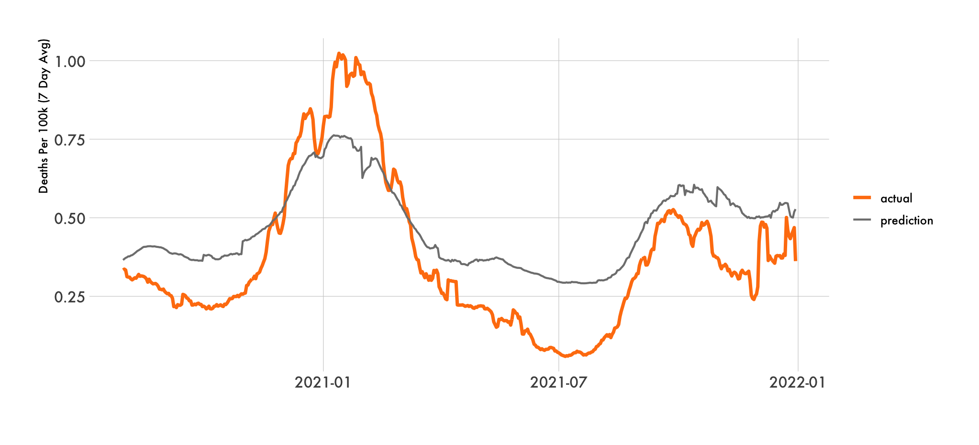

*Note.* This figure shows the seven-day moving average of deaths per 100,000 people in the United States using Johns Hopkins University (2022) data. The orange line represents actual values. The gray line represents predictions from the final XGBoost model.

**Table 7**

*National COVID-19 Deaths – Metrics (Final Model)*

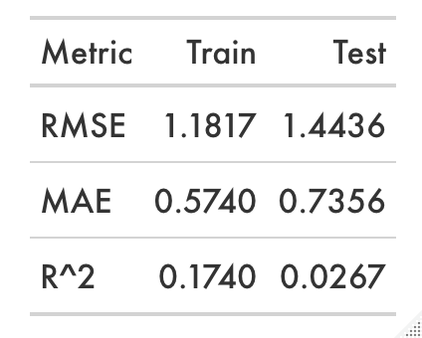

*Note.* This table shows the metrics for the training and testing data sets of the final COVID-19 deaths model.

From the finalized models, Figures 15 and 16 contain the top 25 variables by importance in predicting cases and deaths respectively. Brownlee (2016) states, “Importance provides a score that indicates how useful or valuable each feature was in the construction of the boosted decision trees within the model. The more an attribute is used to make key decisions with decision trees, the higher its relative importance.”

Some of the key variables seen below which assisted in further exploration as the objective of this paper include stringency_index, government_response_index, and gathering_restrictions regarding government policy measures and mobility. Other variables such as adi, hs_or_more, and cig_tax were useful in comparing various Social Determinants of Health. Interestingly, mental and physical health variables don’t seem to have a high importance for the models although their correlations were relatively strong compared to other features.

**Figure 15**

*National COVID-19 Cases – Variable Importance (Final Model)*

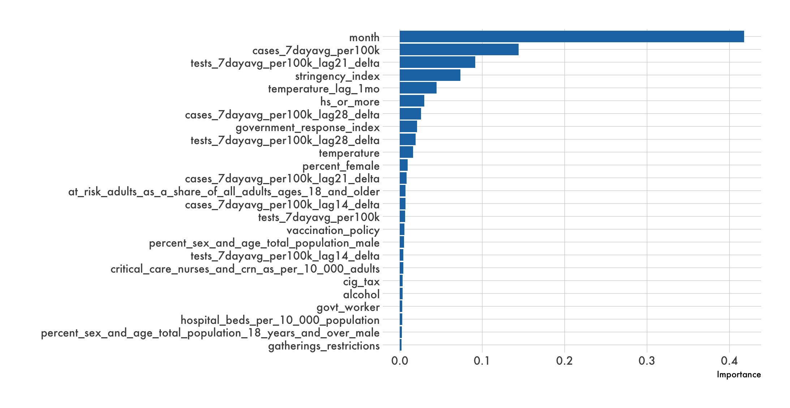

*Note.* This figure shows the variable importance from the final cases model.

**Figure 16**

*National COVID-19 Deaths – Variable Importance (Final Model)*

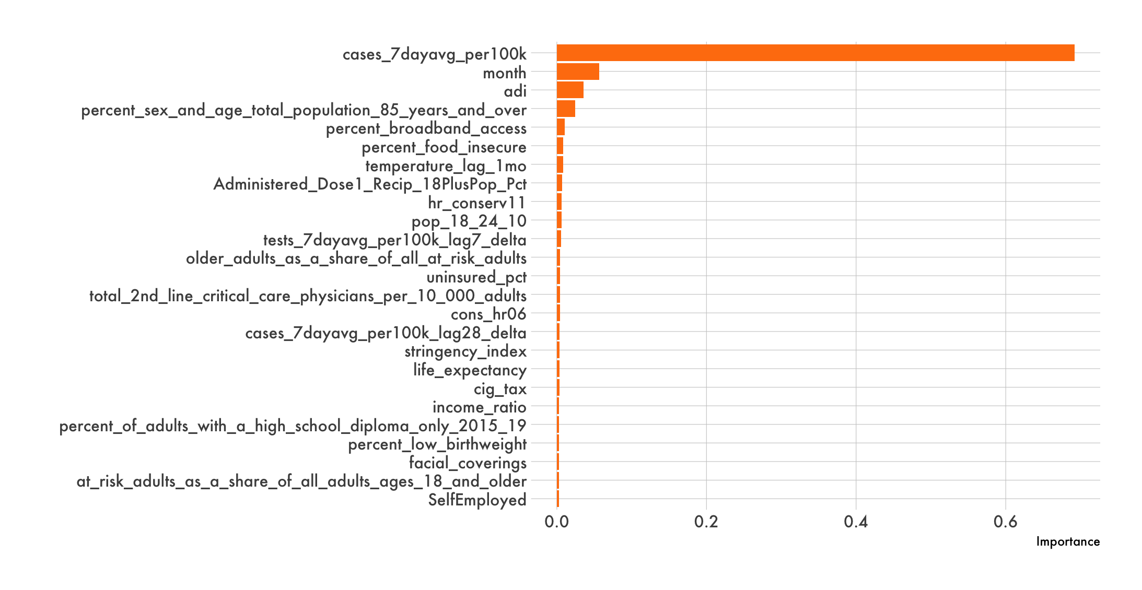

*Note.* This figure shows the variable importance from the final deaths model.

**Conclusion**

Correlation analysis and predictive modeling are commonly used data science methods. This case study used these approaches to uncover relationships between the research topics, other independent variables, and COVID-19 incidence. The methods discussed above applied a data driven approach of determining which topics may be the most valuable to study as they had high correlations and / or were strong predictors. The goal of these approaches was to objectively determine which cohorts to focus on in order to minimize COVID-19 incidence. The upcoming section determines statistically significant differences between cohorts through correlation and clustering analyses.

**Results**

**Introduction**

When examining the results of an analysis, it’s important to consider the actionability of the output. For example, it’s difficult to develop a health improvement initiative without understanding what drives mental / physical health issues. Likewise, ADI values are composed of many components that require individual attention.

Additionally, there must be no ambiguity in the action plan. Those impacted by leadership decisions should feel confident that adjustments will lead to a net overall benefit. Decisions that are backed by sound data science principles will generally instill confidence. Regarding policy measures and mobility, restrictive strategies should be significantly effective or abandoned.

This section explores variable interactions with COVID-19 incidence for each topic of this paper to better understand actionable issues:

* Mental and physical health were compared against poverty and education because of their high correlation.
* Features that tie to the five domains within SDoH were explored based on the variable interaction output from the COVID-19 cases and deaths models.
  + The Economic Stability section looked at the relationship amongst political and income features.
  + The Education Access & Quality section looked at education levels and temperature.
  + The Health Care Access & Quality section focused on teen births and percentage of births with low birthweight.
  + The Neighborhood & Built Environment section clustered ADI, government response index, cigarette smoking, and cigarette taxes.
  + The Social & Community Context section covered access to (healthy) food and ADI.
* School closings, gathering restrictions, and overall stringency were evaluated for effectiveness based on SHAP values output from mobility models dependent upon restrictive policy measures.

A variety of plots are used throughout this section. Some of which are annotated with measures to determine statistical significance. Below is a list of the statistics applied in this section along with how they are to be interpreted:

* $t_{Student}$ informs how significant the differences are between groups.
* $t_{Welch}$ informs how significant the differences are between groups.[6]
* is used to determine if a statistically significant difference exists between three or more independent groups by comparing their means.
* ${\hat{g}}_{Hedges}$ measures the size of the difference between groups where 0.2 is considered small, 0.5 is medium, and 0.8 is large.
* $p$ is used to determine statistical significance. Generally, a value less than 0.05 is sufficient for rejecting the null hypothesis.
* ${\hat{r}}_{Pearson}$ indicates the correlation between variables using the Pearson method.
* ${\hat{ρ}}_{Spearman}$ indicates the correlation between variables using the Spearman method.
* $\log_{e}({BF}_{01})$ indicates evidence for the null or alternative hypothesis as seen in Table 8.

**Table 8**

*Bayes Factor Significance Table*

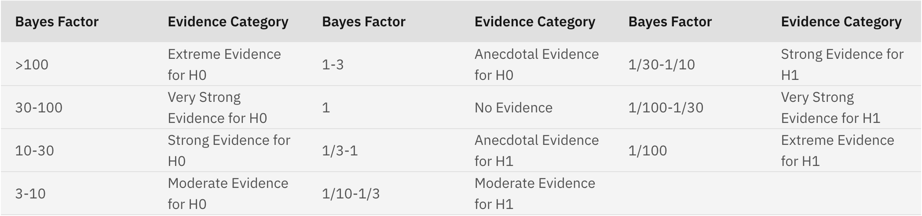

*Note.* This table contains commonly used thresholds to define significance of evidence (IBM, 2021).

**Mental / Physical Health**

CVS Health (2021) states in their study that the COVID-19 pandemic had a significant impact on people’s health. Stress levels rose significantly, and the coronavirus impacted people’s health and lifestyles in a variety of ways. Figure 17 below highlights some notable changes.

**Figure 17**

*Health and Lifestyle Changes due to COVID-19*

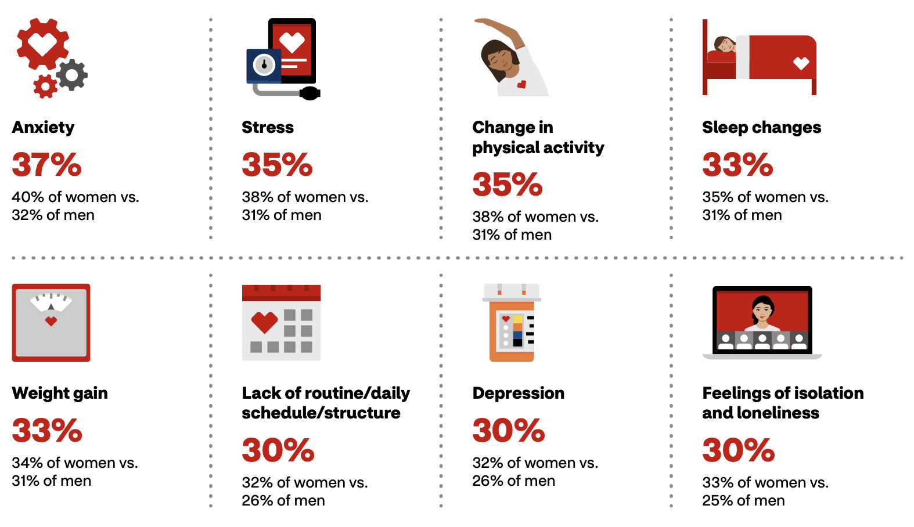

*Note.* This figure shows how the pandemic impacted people’s health and lifestyle (CVS Health, 2021).

From the correlation analysis performed with COVID-19 cases, one of the top variables was average_number_of_mentally_unhealthy_days with a Pearson correlation coefficient of 0.38. Figure 18 below illustrates the positive sloping relationship between annual cases per 100,000 people and the average number of mentally unhealthy days at the county level. The near zero p score indicates that the null hypothesis of no correlation can be rejected. Lastly, the Bayes Factor suggests extreme evidence for the alternative hypothesis according to Table 8.

**Figure 18**

*COVID-19 Cases and Mental Health*

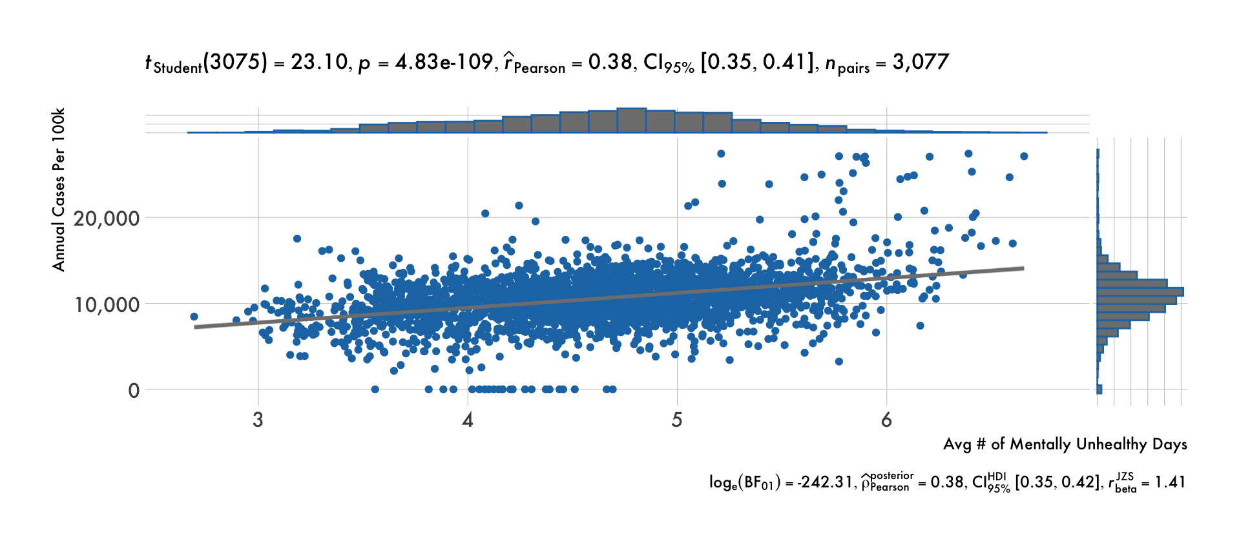

*Note.* This figure shows a correlation between 2021 COVID-19 cases per 100,000 people (Johns Hopkins University, 2022) and the average number of mentally unhealthy days (*County Health Rankings*, 2021) by county.

The variable average_number_of_mentally_unhealthy_days has an even stronger correlation with total COVID-19 deaths in 2021 at the county level in Figure 19. The Pearson correlation coefficient for this comparison is 0.52 with a 95% confidence interval of [0.49, 0.54]. The near zero p value indicates that the null hypothesis of no correlation can be rejected. There is again extreme evidence for the alternative hypothesis based on the Bayes Factor of -475.46.

**Figure 19**

*COVID-19 Deaths and Mental Health*

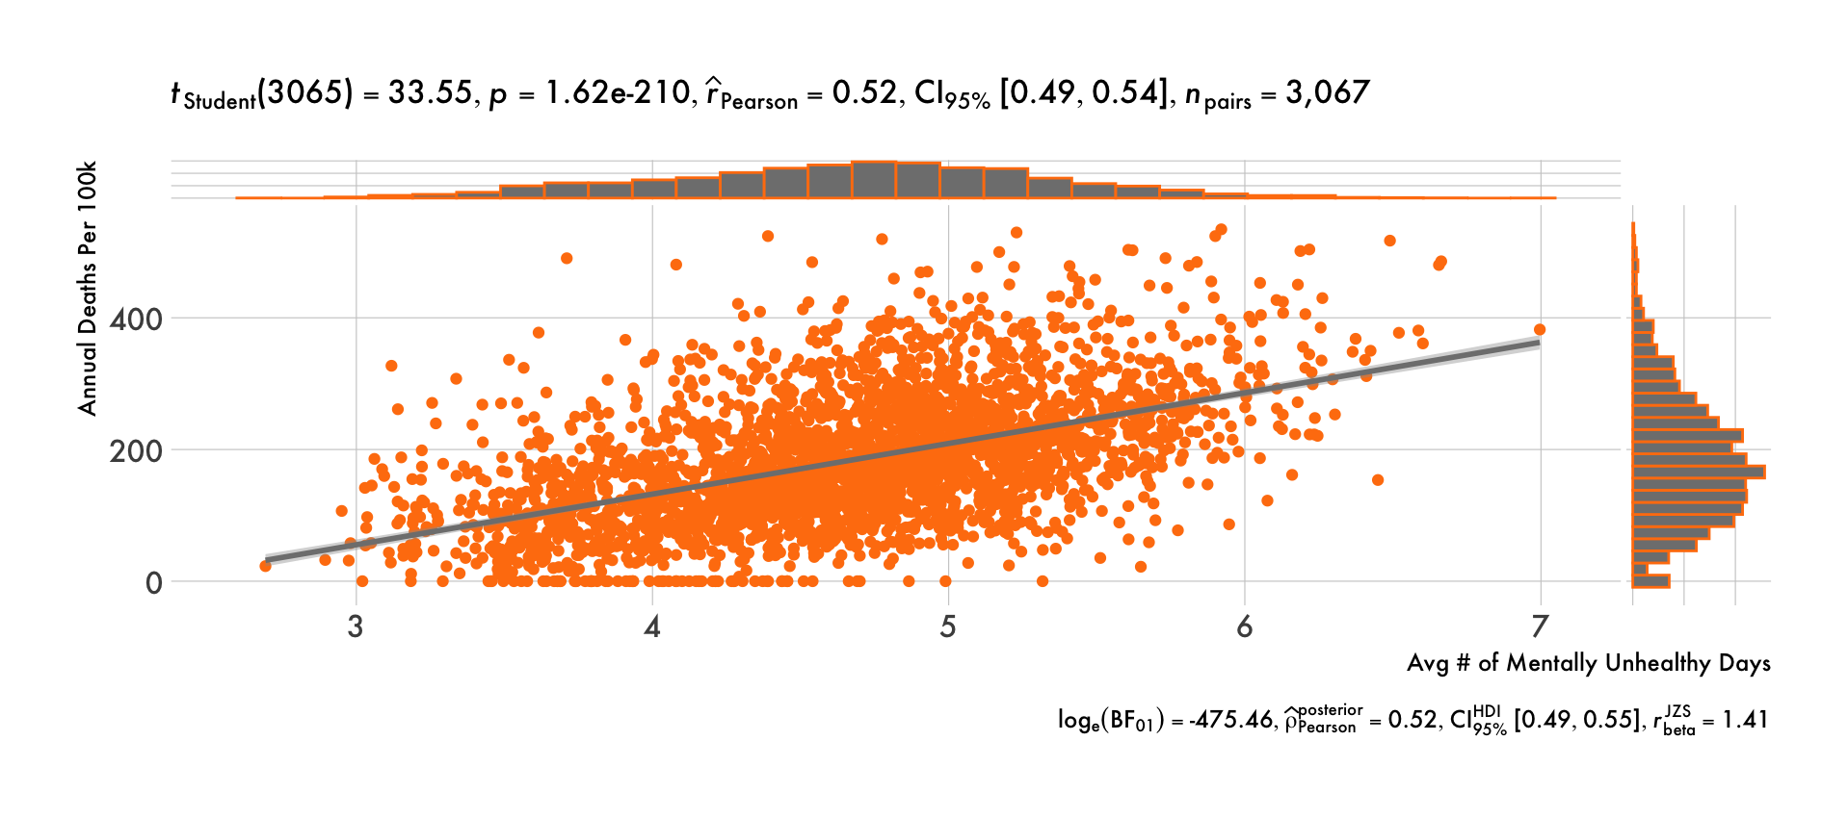

*Note.* This figure shows a correlation between 2021 COVID-19 deaths per 100,000 people (Johns Hopkins University, 2022) and the average number of mentally unhealthy days (*County Health Rankings*, 2021) by county.

The figures above illustrated the correlation between mental health and aggregate COVID-19 incidence for 2021. Comparing how groups were affected over time helped to reinforce the importance of a healthy state of mind. Four buckets were created based on the average number of mentally unhealthy days. The cohorts in the 0%-25% bucket include the bottom 25% of counties with the lowest average number of mentally unhealthy days, and those in the 75%-100% bucket were in the top 25%.

Figure 20 compares one quartile in blue against the others colored in gray. This visual shows how cases in the bottom 25% were relatively flat around September 2021 but peaked in the top 25% (75%-100%). Then, December 2021 shows the bottom 25% being the most severe regarding case count and the top 25% having the fewest cases. When looking at the COVID-19 deaths by mental health quartiles in Figure 21 however, there is not a similar reversal heading into the end of 2021. Deaths remain relatively low for the bottom 25% and relatively high for the top 25% throughout the year.

**Figure 20**

*COVID-19 Cases by Mental Health Quartiles Over Time*

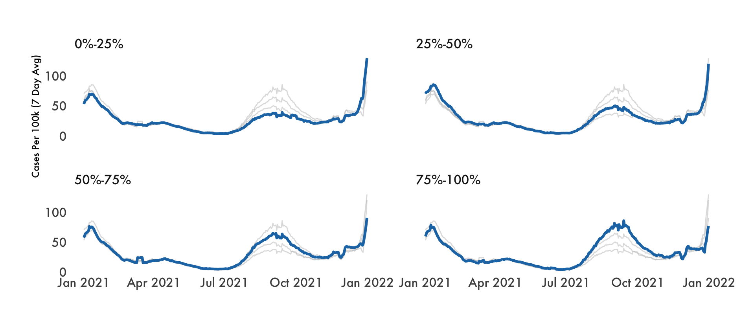

*Note.* This figure shows 2021 COVID-19 cases per 100,000 people (Johns Hopkins University, 2022) over time by quartiles of average number of mentally unhealthy days (*County Health Rankings*, 2021).

**Figure 21**

*COVID-19 Deaths by Mental Health Quartiles Over Time*

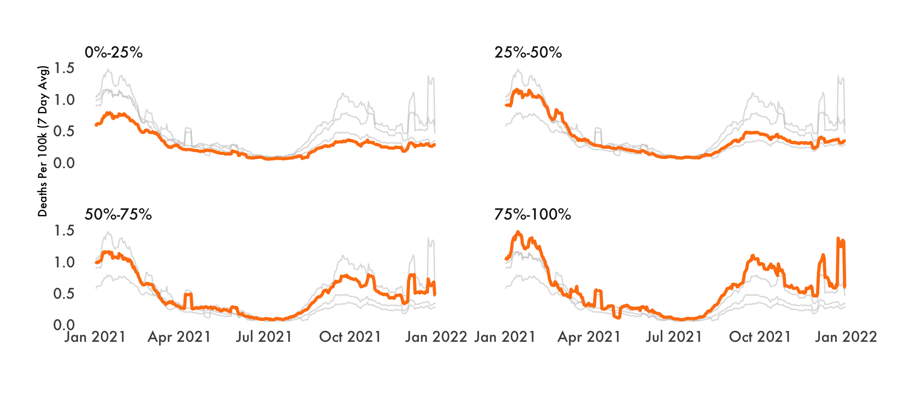

*Note.* This figure shows 2021 COVID-19 deaths per 100,000 people (Johns Hopkins University, 2022) over time by quartiles of average number of mentally unhealthy days (*County Health Rankings*, 2021).

Regarding physical well-being, Harvard Medical School has published a few articles regarding COVID severity. First, Tello (2021) states, “…people who were consistently inactive had a significantly higher risk of hospitalization, ICU admission, and death after getting COVID-19 than those who were active for at least 150 minutes per week.” Second, a study was performed on 593,000 adults where their diet was tracked from February 2020 through September 2020. “Scientists found that people who reported eating the most fruits, vegetables, and legumes had a 9% lower risk of getting COVID and a 41% lower risk of developing severe COVID during the study period, compared with people who reported eating the least fruits and vegetables.” (Godman, 2021).

The variable average_number_of_physically_unhealthy_days had positive statistically significant correlations with 2021 COVID-19 cases and deaths as well; deaths also being slightly stronger. The quartiles over time followed a similar pattern as the mental health graphics. Figures 22-25 below for physical health contain similar visualizations, statistical measures, and results as above for mental health.

**Figure 22**

*COVID-19 Cases and Physical Health*

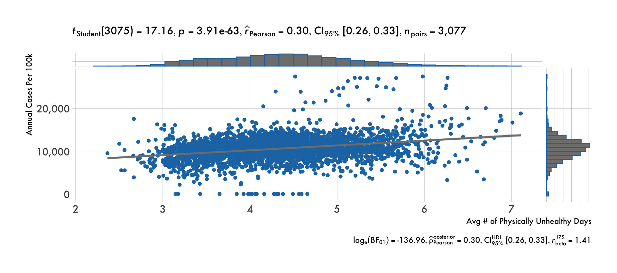

*Note.* This figure shows a correlation between 2021 COVID-19 cases per 100,000 people (Johns Hopkins University, 2022) and the average number of physically unhealthy days (*County Health Rankings*, 2021) by county.

**Figure 23**

*COVID-19 Deaths and Physical Health*

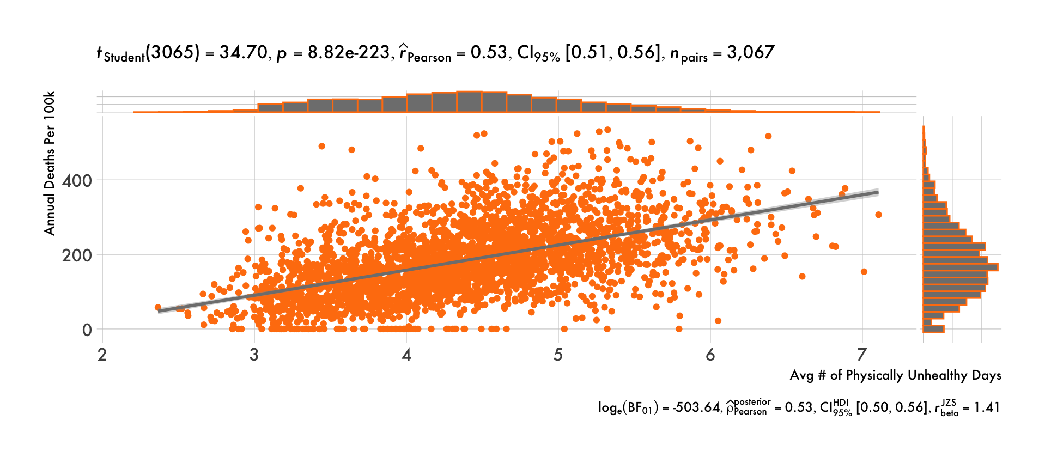

*Note.* This figure shows a correlation between 2021 COVID-19 deaths per 100,000 people (Johns Hopkins University, 2022) and the average number of physically unhealthy days (*County Health Rankings*, 2021) by county.

**Figure 24**

*COVID-19 Cases by Physical Health Quartiles Over Time*

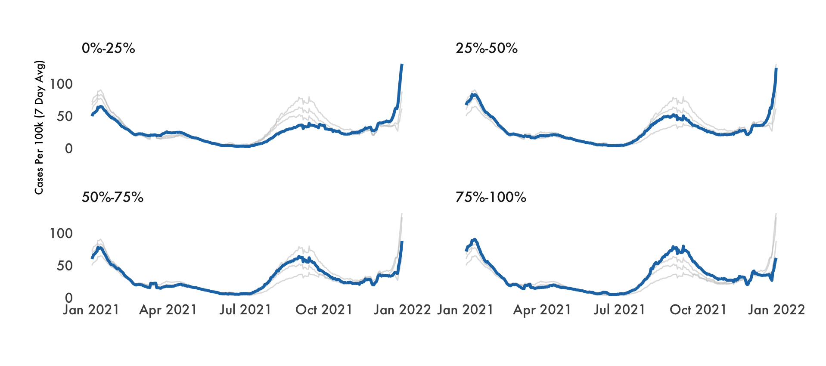

*Note.* This figure shows 2021 COVID-19 cases per 100,000 people (Johns Hopkins University, 2022) over time by quartiles of average number of physically unhealthy days (*County Health Rankings*, 2021).

**Figure 25**

*COVID-19 Deaths by Physical Health Quartiles Over Time*

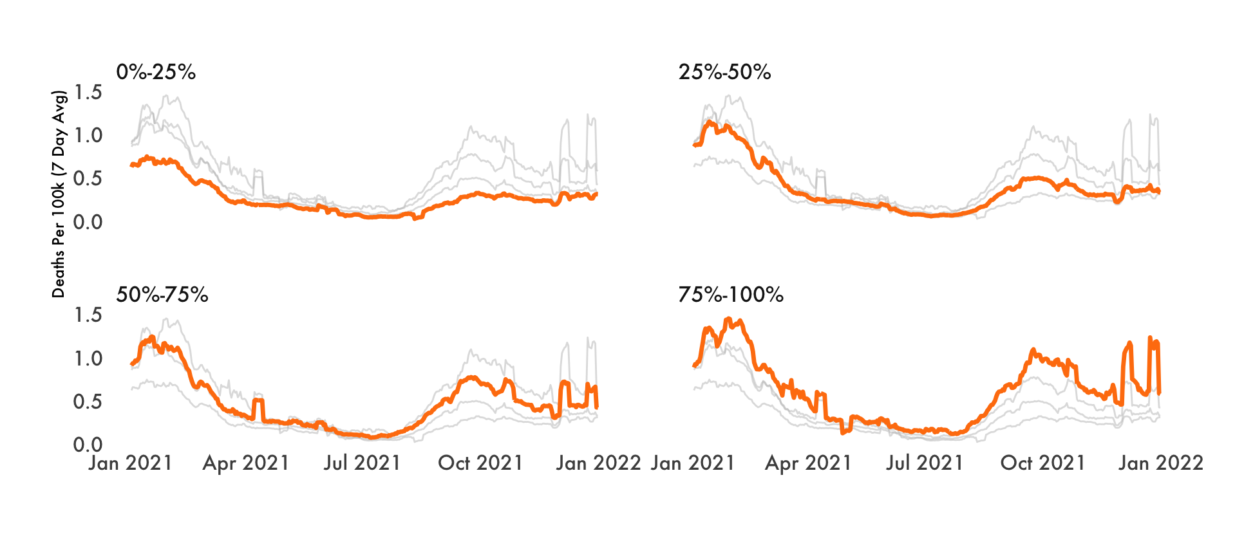

*Note.* This figure shows 2021 COVID-19 deaths per 100,000 people (Johns Hopkins University, 2022) over time by quartiles of average number of physically unhealthy days (*County Health Rankings*, 2021).

The analyses above show that those with poorer mental and physical health are impacted by COVID-19 to a greater magnitude. “Mental health is as important as physical health when caring for your overall well-being during the COVID-19 pandemic. Your mental health determines how you think, feel, and act — and it affects your physical health, too.” (Anthem, 2021). Figure 26 reinforces Anthem’s statement regarding the interaction between mental and physical health. Therefore, holistic health care (addressing mental and physical well-being) should be encouraged to best protect against COVID-19 and support quick recoveries.

**Figure 26**

*Average Number of Physically / Mentally Unhealthy Days by County*

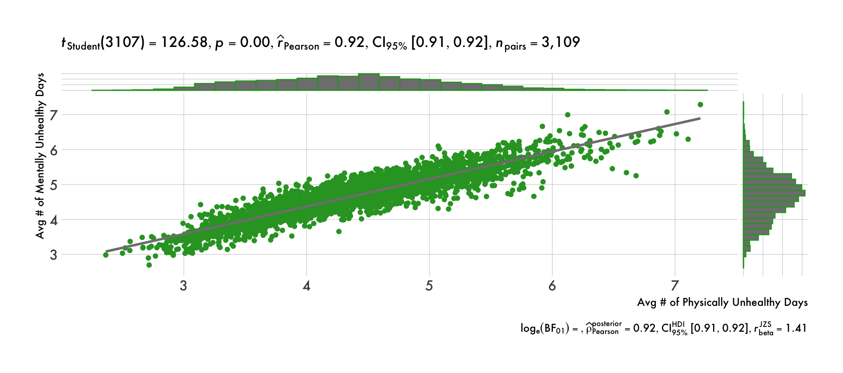

*Note.* This figure shows the correlation between average number of mentally unhealthy days and average number of physically unhealthy days (*County Health Rankings*, 2021) by county.

Next, there are a few strong correlations to point out between mental / physical health and SDoH as seen in Figures 27 and 28. Some of the variables that fall into the SDoH domain of Economic Stability show a clear relationship; child poverty is positively correlated, and income is negatively correlated. Modius Health (2019) suggests that the key to physical health and monetary wealth requires maintaining a healthy mental state.

**Figure 27**

*Mental Health Correlations*

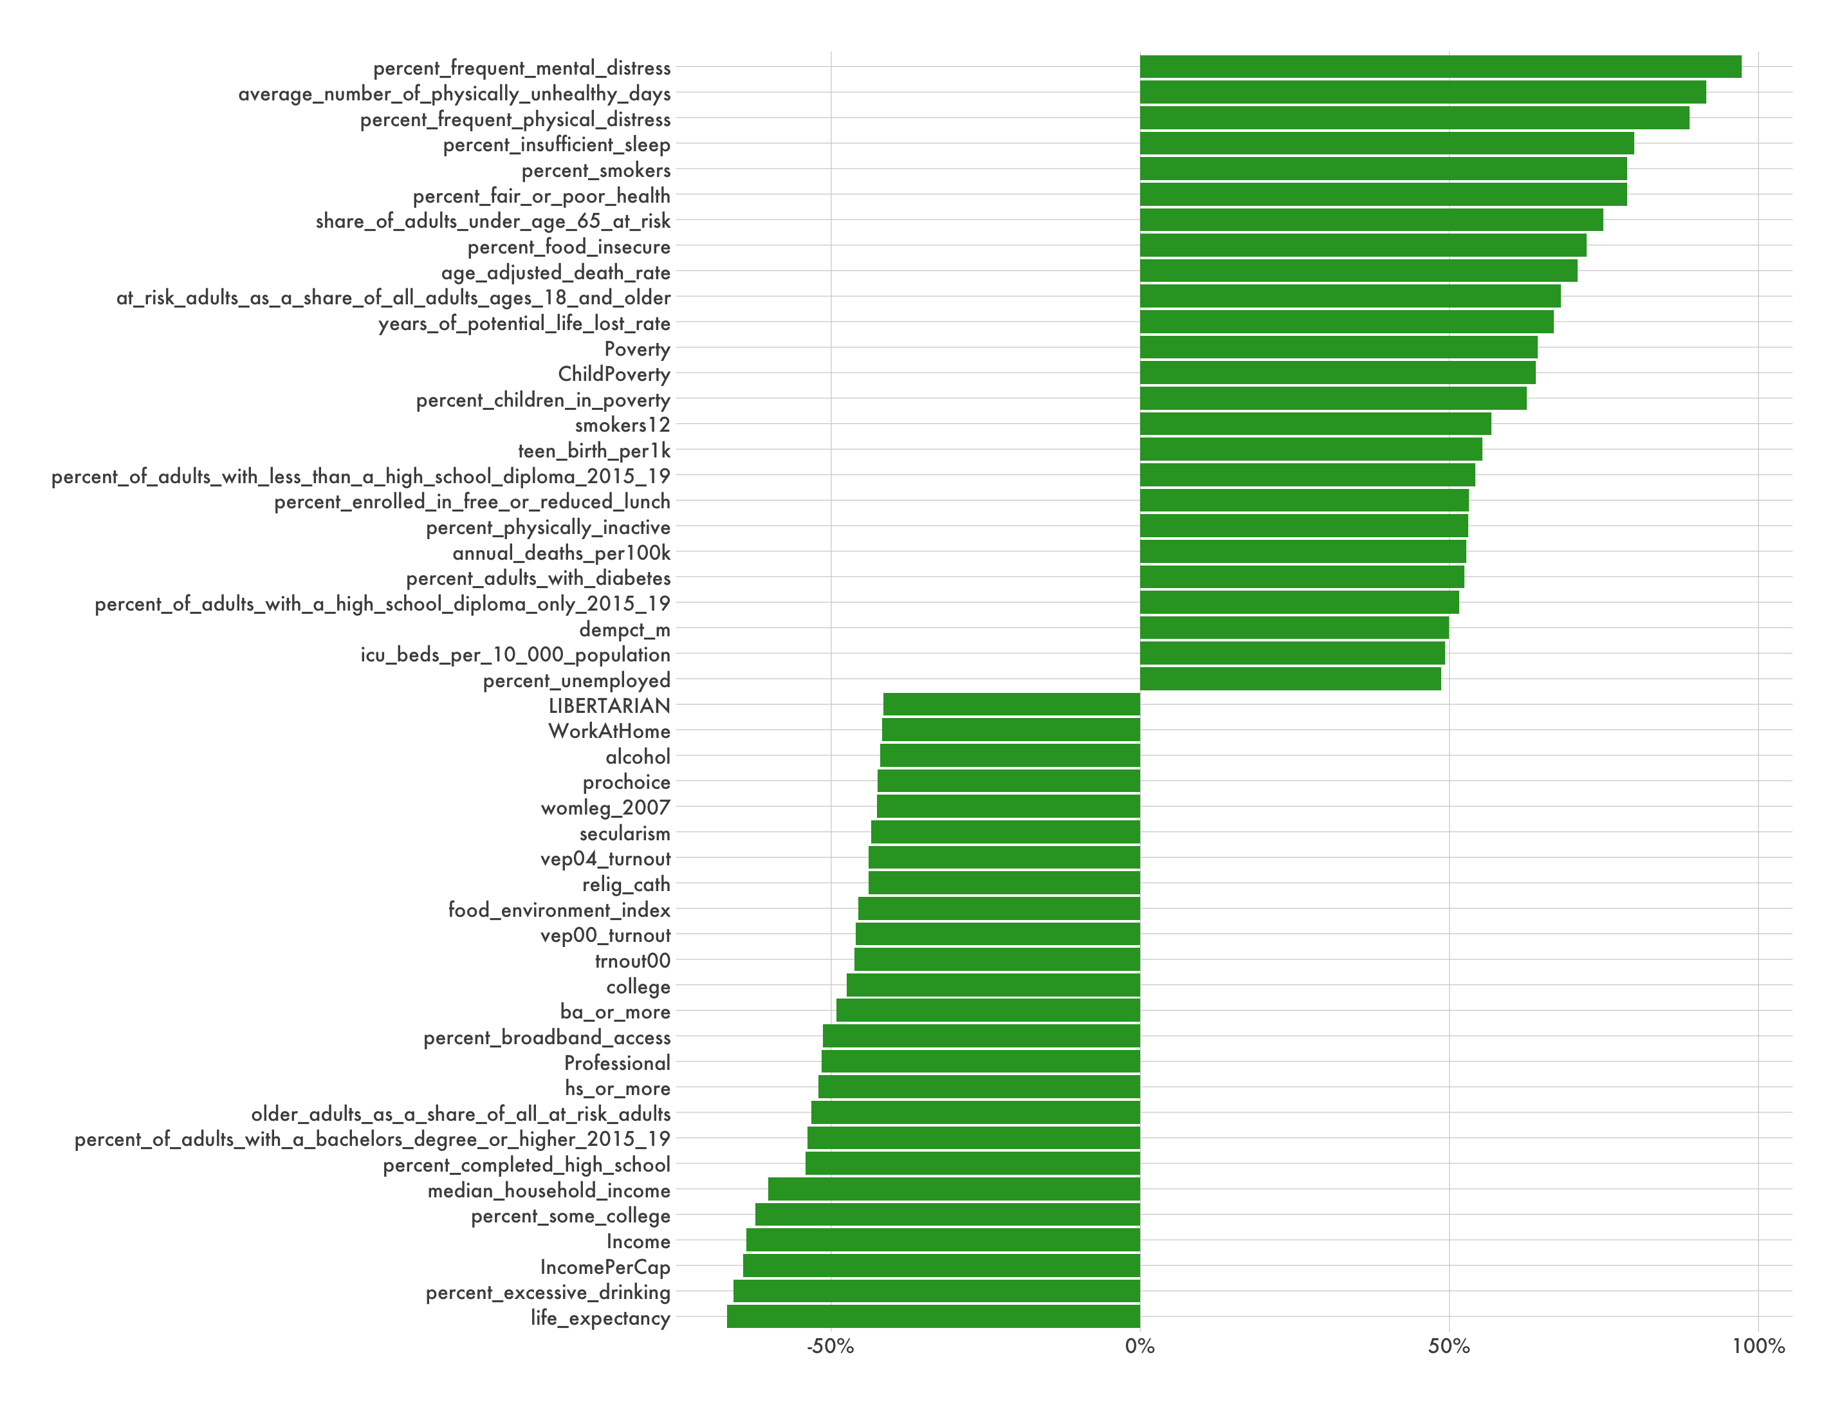

*Note.* This figure shows the correlation between the average number of mentally unhealthy days and static variables for 2021. See the Data Dictionary in the Appendix for variable descriptions and sources.

**Figure 28**

*Physical Health Correlations*

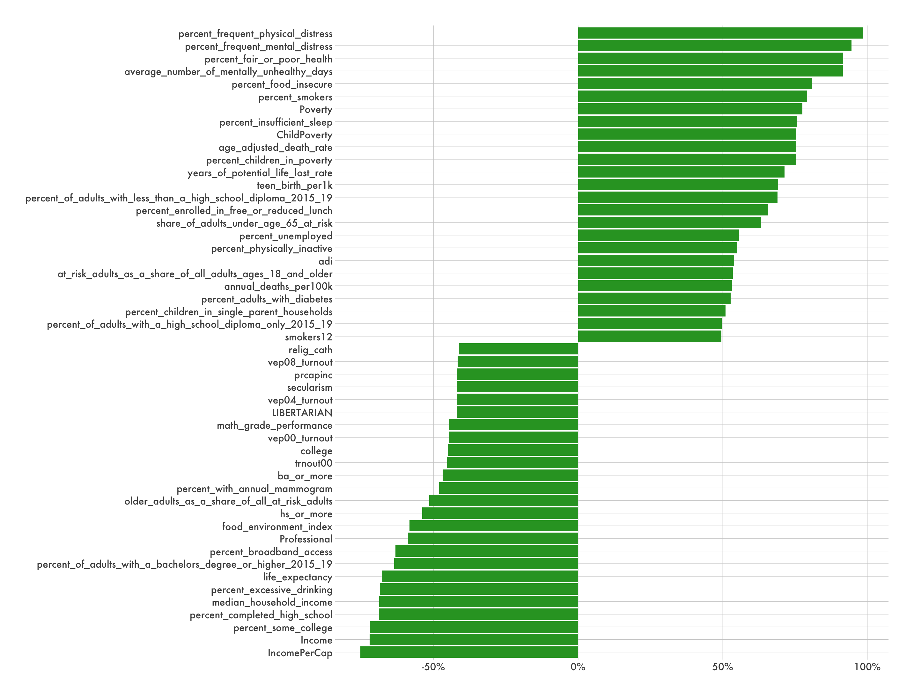

*Note.* This figure shows the correlation between the average number of physically unhealthy days and static variables for 2021. See the Data Dictionary in the Appendix for variable descriptions and sources.

Variables related to advanced learning are negatively correlated while cohorts with a high school diploma or less have a positive association with mental/physical health issues. Zajacova et al. (2018) stresses that there is not merely a correlation between education and health, but a causal impact. They discuss how numerous natural experiments and twin designs confirm that years of schooling generally lead to better physical and mental health as shown in Figure 29.

**Figure 29**

*Predicted Probability of Health Problems*

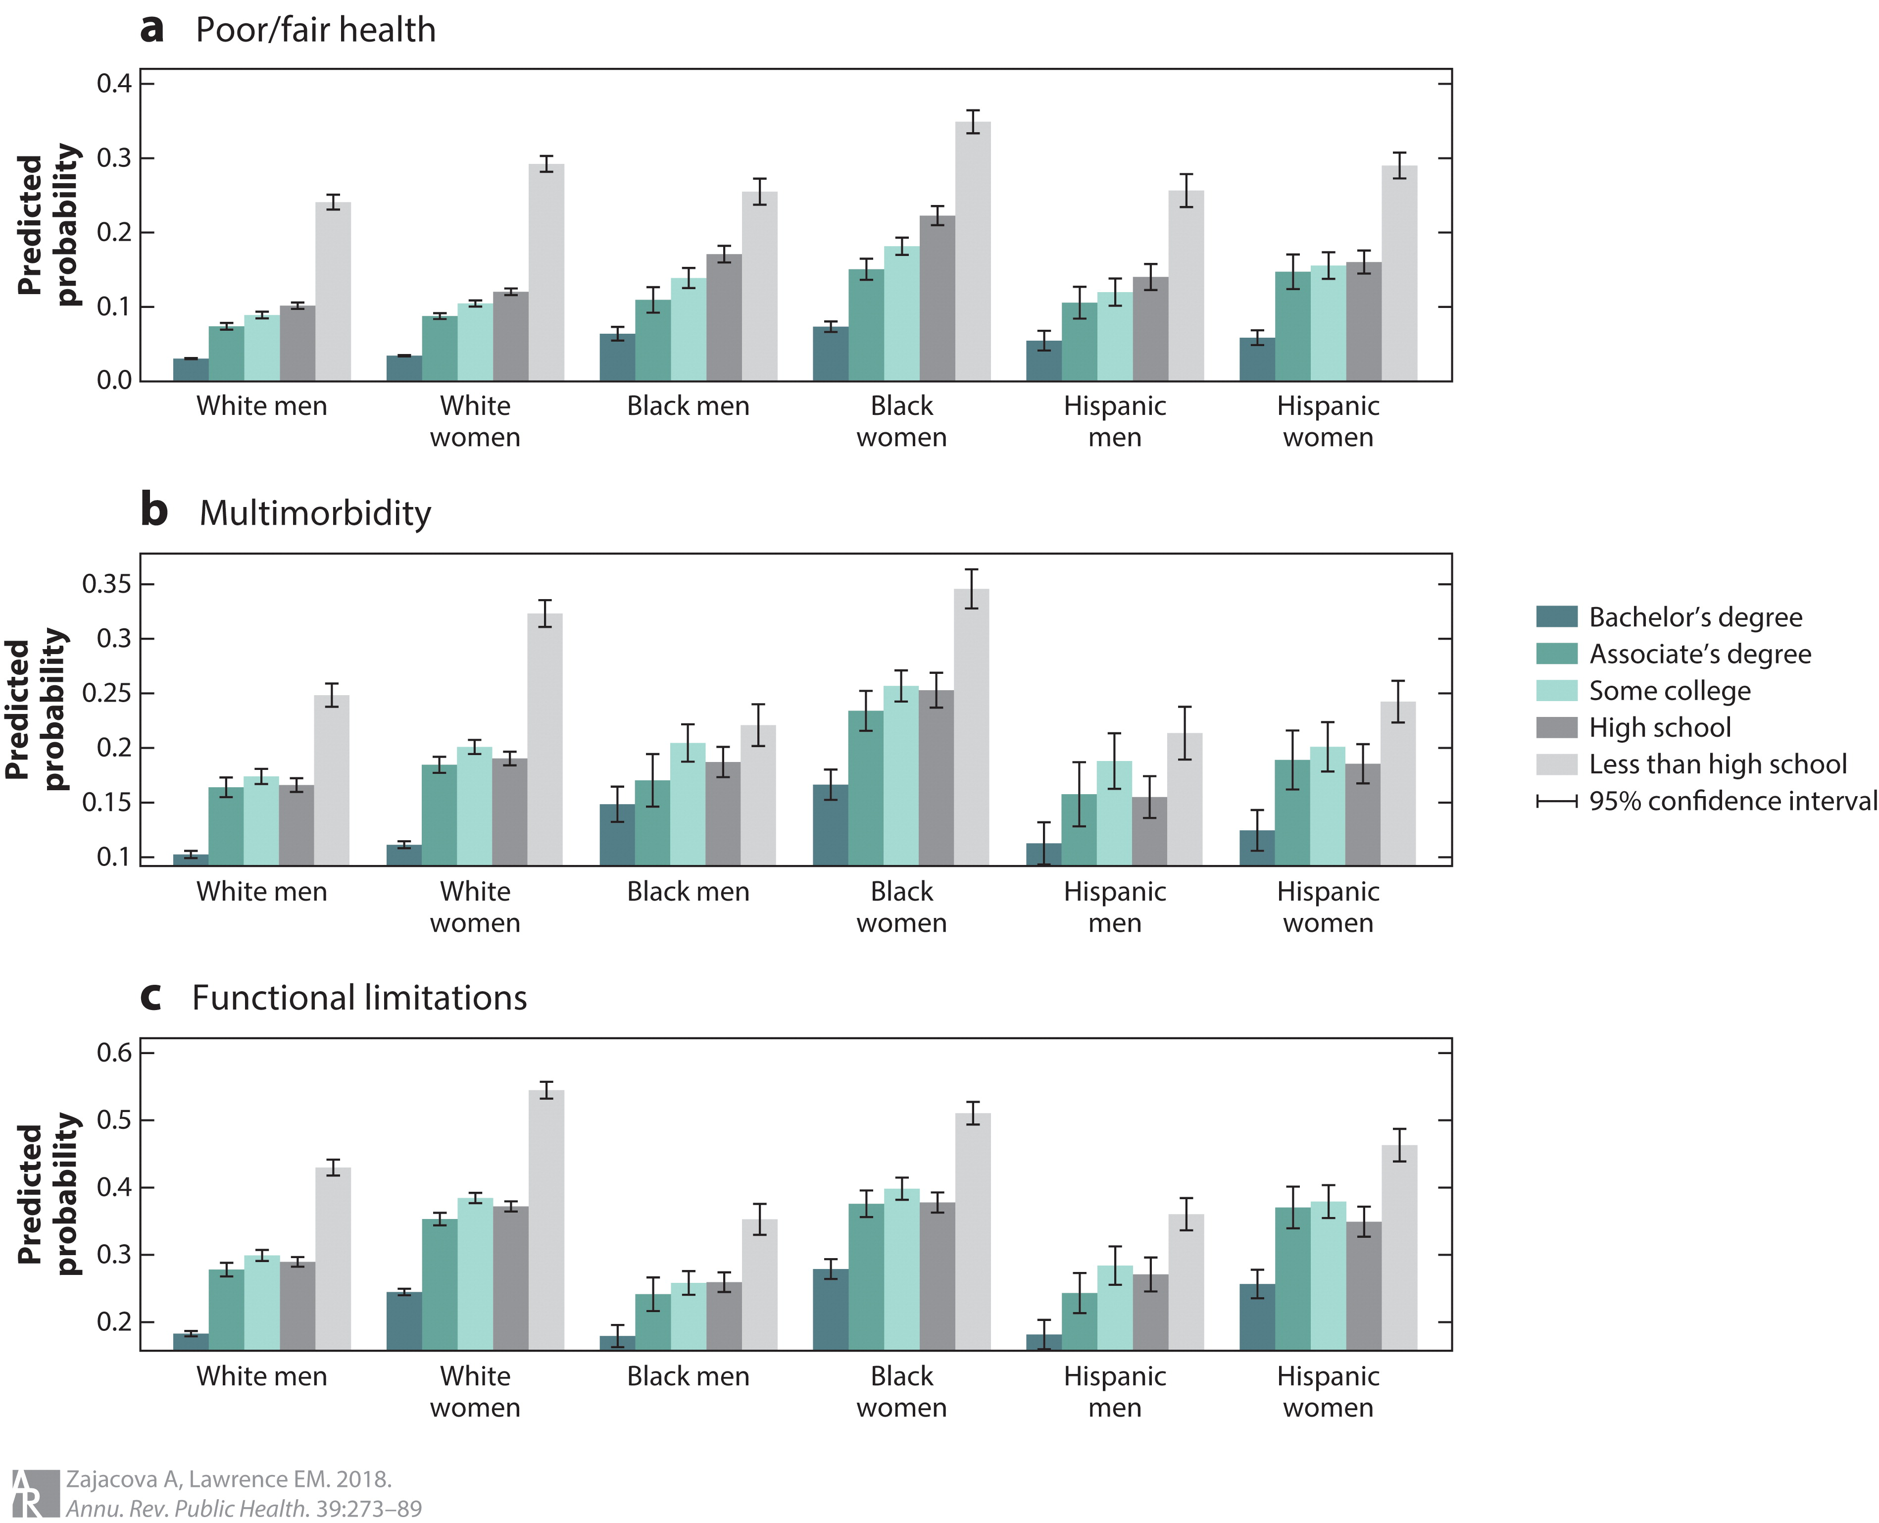

*Note.* This figure shows the levels of three health outcomes across educational attainment levels in six major demographic groups (Zajacova et al., 2018).

Lastly, clustering was performed amongst COVID-19 cases, COVID-19 deaths, mental health, physical health, population, density, (child) poverty, and income. Clustering is an unsupervised approach used to form meaningful groupings and structure to identify similarities and differences.

A few methods can be applied to first determine the optimal number of clusters to use. The silhouette method was utilized in Figure 30 which measures the quality of a clustering and determines how well each point lies within its cluster (Soetewey, 2020). Based on its output, two clusters will be used to partition the data.

**Figure 30**

*Silhouette Method – Mental / Physical Health*

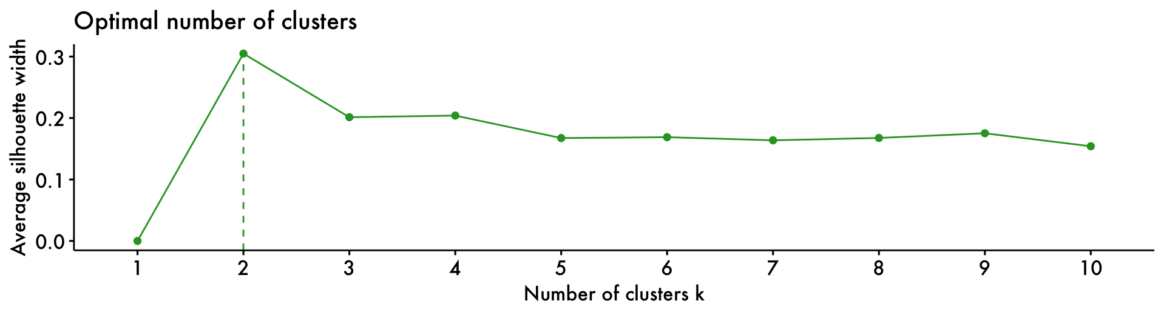

*Note.* This figure illustrates clustering performed on COVID-19 incidence, mental health, physical health, population, density, (child) poverty, education, and income. Table 9 shows the specific variables included. See the Data Dictionary in the Appendix for variable descriptions and sources.

Figures 31 and 32 below indicate that these clusters are statistically significantly different. The p values are essentially zero. The Bayes Factors indicate extreme evidence for the null hypothesis. While Hedge’s g implies that the size of the difference is large for the deaths cluster, the cases cluster has a score of 0.5 indicating a medium size difference.

**Figure 31**

*Mental / Physical Health Clustering - Deaths*

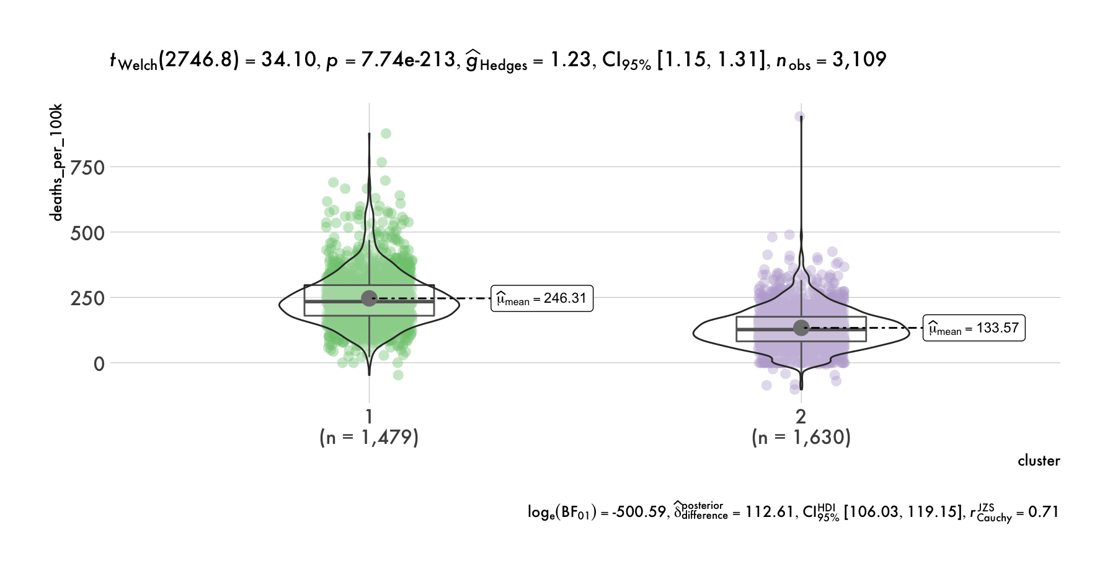

*Note.* This figure illustrates the statistically significant difference between the two clusters. Table 9 shows the specific variables included. See the Data Dictionary in the Appendix for variable descriptions and sources.

**Figure 32**

*Mental / Physical Health Clustering - Cases*

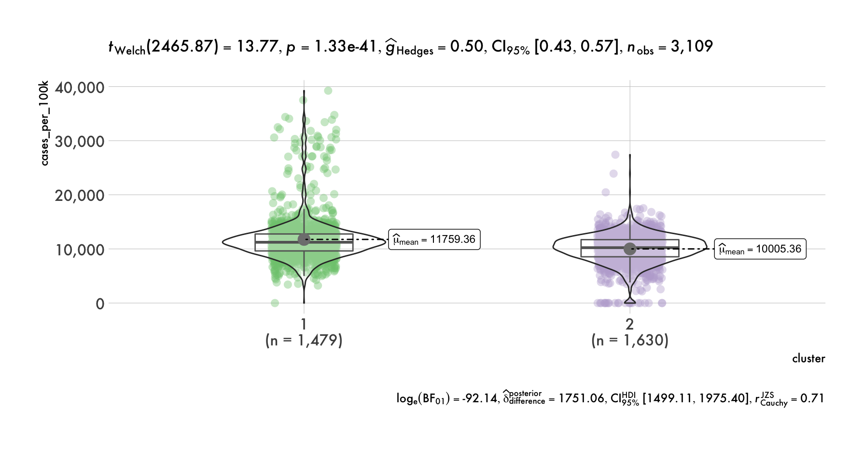

*Note.* This figure illustrates the statistically significant difference between the two clusters. Table 9 shows the specific variables included. See the Data Dictionary in the Appendix for variable descriptions and sources.

Table 9 below shows two approximately evenly sized clusters. Most of the variables have no overlap between the two clusters when looking at the interquartile ranges (IQR)[7]. Cluster 1 includes counties with higher average numbers of physically and mentally unhealthy days, higher poverty rates, poorer education levels, and lower income values. Additionally, COVID-19 deaths and cases per 100,000 people are generally higher in Cluster 1.

**Table 9**

*Mental / Physical Health Summary Statistics*

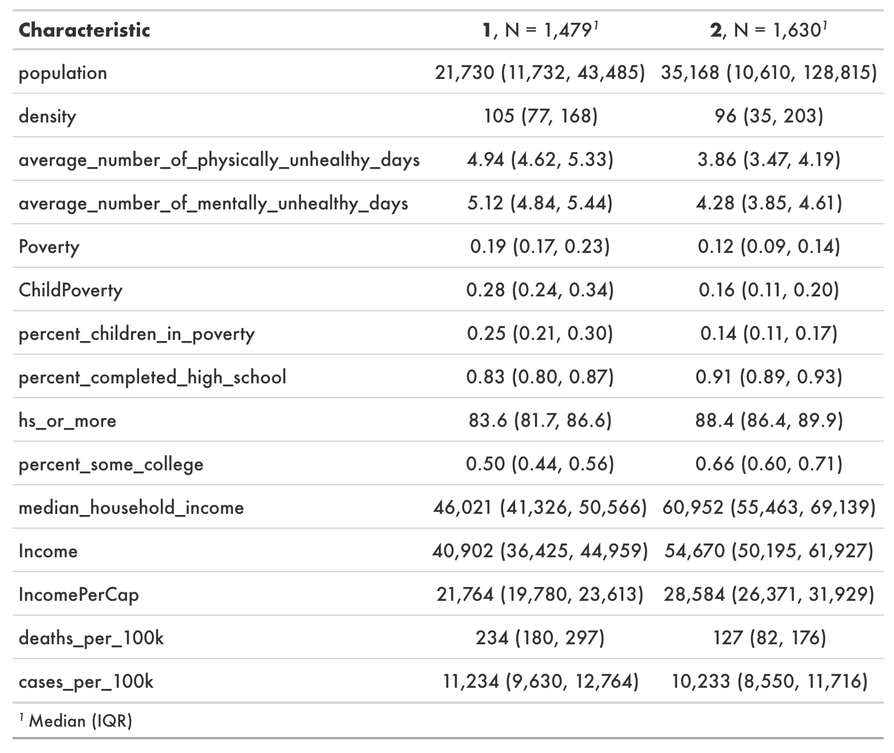

*Note.* This table includes the variables used for Mental / Physical Health Clustering. See the Data Dictionary in the Appendix for variable descriptions and sources.

**Area Deprivation Indices / Social Determinants of Health**

Social Determinants of Health impact the health, well-being, and quality of life for people. They contribute to wide health disparities and inequities. One of the goals of Healthy People 2030 is directly related to SDoH; “Create social, physical, and economic environments that promote attaining the full potential for health and well-being for all.” SDoH are generally categorized into five domains:

* Economic Stability
* Education Access & Quality
* Health Care Access & Quality
* Neighborhood & Built Environment
* Social & Community Context

From the models created to predict cases and deaths, the EIX package for R was used to find pairs and interactions amongst variables. Pairs can be merely cooccurrences, but interactions are identified when the child node has a higher gain than the parent node. A node which is divided into sub-nodes is called a parent node, whereas sub-nodes are the child of a parent node (Gurung, 2022). The latter approach is recommended as it’s difficult to determine if a real interaction exists when the parent node is larger. Second, gain is essentially the sum of a feature’s contribution in each tree of the model. The larger the gain for a variable, the more important it is in generating a prediction.[8]

Recall that the COVID-19 deaths model listed ADI as one of the most important variables. However, ADI is merely an aggregated score based on a variety of socioeconomic measures. Utilizing the model interactions output allows for unique variable associations to be explored that may not be intuitive. Combinations were chosen such that each SDoH domain is represented in a pair of variables with a relatively large gain.

***Economic Stability***

First, for economic stability, income (specifically the variable income_ratio) appeared once as a parent node in the model interactions output with cases as the child node. To uncover a potential relationship with another feature, the model pairs output was reviewed. One of the pairs the rose to the list from the deaths model consisted of income_ratio as the child node and hr_conserv11 as the parent node. Multiple political affiliation and income variables were gathered for clustering analysis. Based on the silhouette chart in Figure 33, two clusters will be used to partition the data.

**Figure 33**

*Silhouette Method – ADI / SDoH Economic Stability*

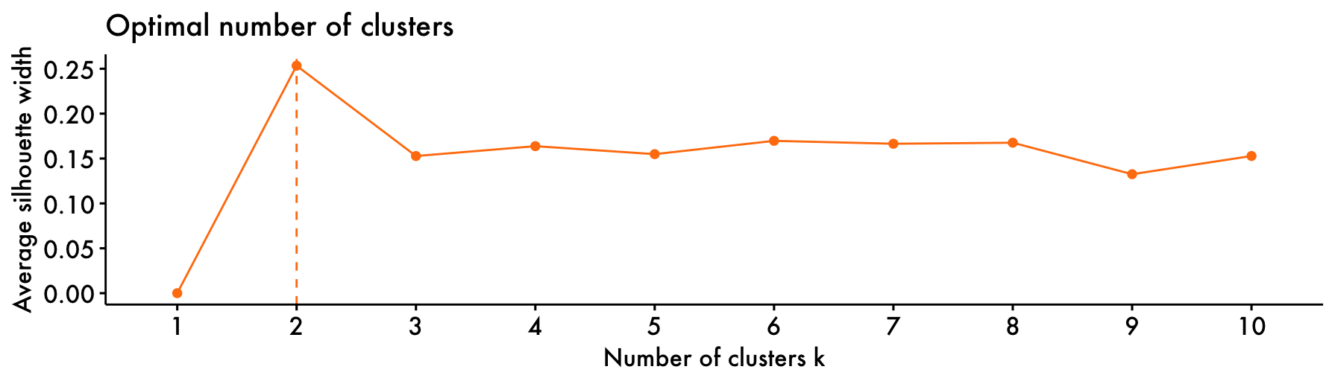

*Note.* This figure illustrates clustering performed on political affiliation, income variables, population density, and COVID-19 deaths. Table 10 shows the specific variables included. See the Data Dictionary in the Appendix for variable descriptions and sources.

Figure 34 illustrates a distribution of deaths per 100,000 people at the county level by cluster. Based on Welch’s t test and the near zero p value, the null hypothesis can be rejected. Hedge’s g value indicates a large difference. The Bayes Factor implies extreme evidence for the alternative hypothesis. Therefore, these cohorts are considered statistically significantly different. Table 10 includes a breakdown of the features involved. The non-overlapping IQR amongst most of the political party features, Income / IncomePerCap, and deaths_per_100k further support the difference between the clusters.

**Figure 34**

*ADI / SDoH Economic Stability Clustering*

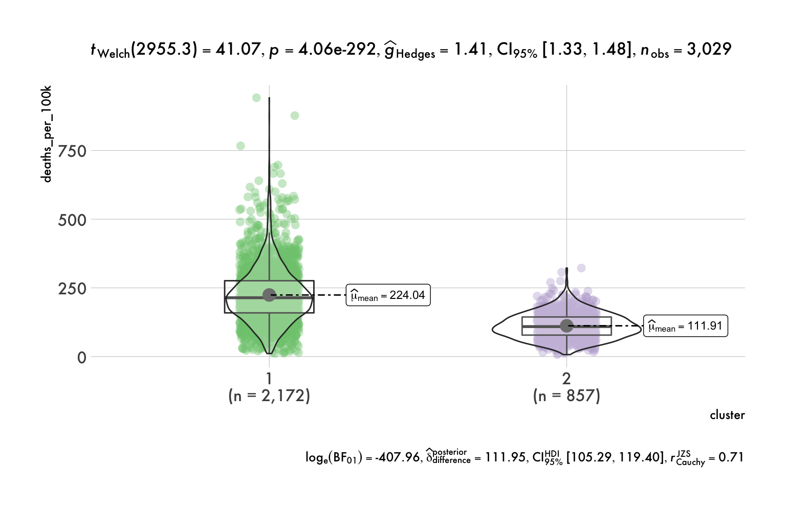

*Note.* This figure illustrates the statistically significant difference between the two clusters. Table 10 shows the specific variables included. See the Data Dictionary in the Appendix for variable descriptions and sources.

**Table 10**

*ADI / SDoH Economic Stability Summary Statistics*

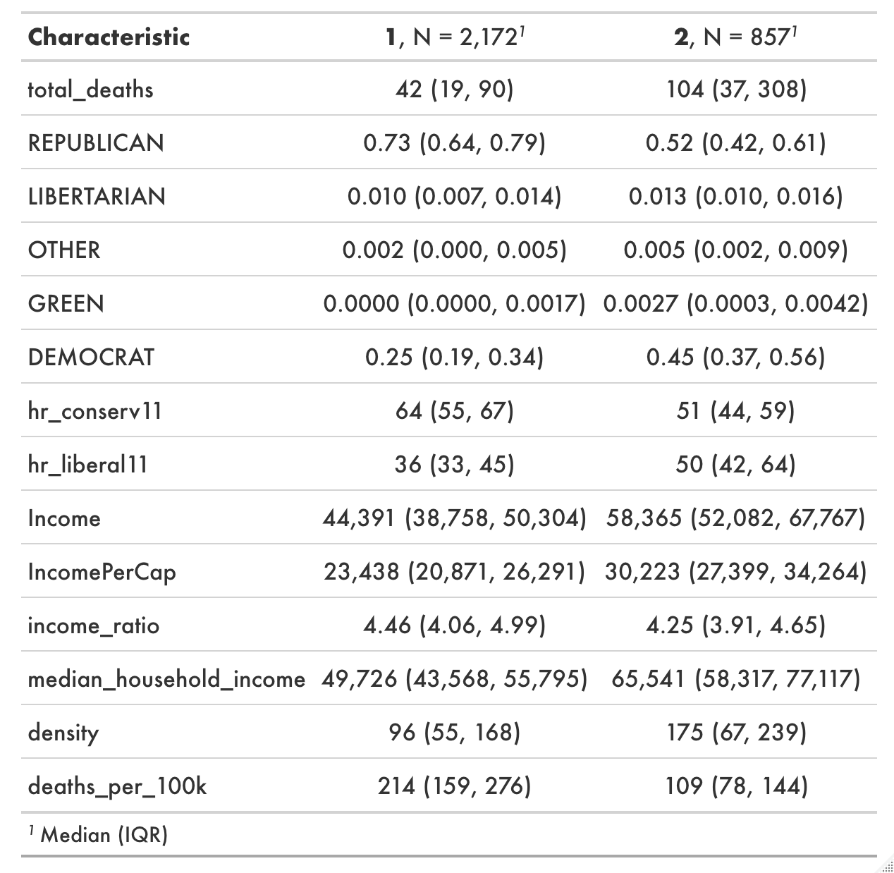

*Note.* This table includes the variables used for ADI / SDoH Economic Stability Clustering. See the Data Dictionary in the Appendix for variable descriptions and sources.

***Education Access & Quality***

Another one of the SDoH pillars is education access and quality. Higher education is often linked to healthier lifestyles and better paying careers. The interaction with the highest gain from the COVID-19 cases model consisted of temperature_lag_1mo (average temperature at the county level one month prior) as the parent variable and hs_or_more[9] (percent of population with high school education or higher) as the child variable.

Figure 35 groups counties into one of four buckets based on high school graduation rate and total cases for 2021. The high and low distinction is based on the median for those variables. Southern states (where the temperature is generally warmer) appear to have a lower high school graduation rate compared to the majority of the northern states. Table 11 includes a few extra variables such as population and density. Ultimately, it appears that colder areas with a strong high school graduation rate and a low population density have the fewest cases.

**Figure 35**

*2021 COVID-19 Cases by High School Graduation Rate*

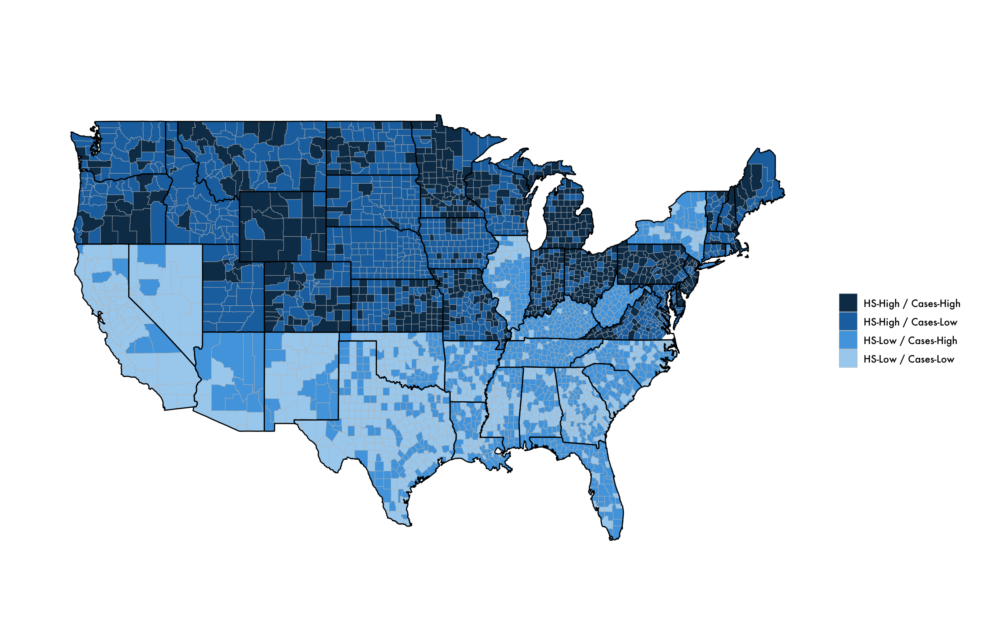

*Note.* This figure shows state-level high school graduation rates (*County Health Rankings*, 2021) and county-level COVID-19 cases (Johns Hopkins University, 2022). These features are bucketed relative to their median value.

**Table 11**

*Temperature, High School Graduation Rate, & COVID-19 Cases*

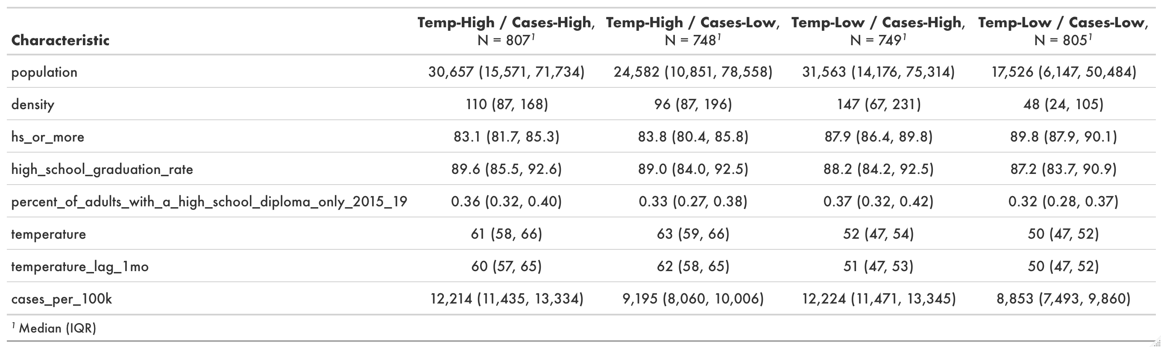

*Note.* This table shows high school graduation rates by temperature and COVID-19 case buckets. See the Data Dictionary in the Appendix for variable descriptions and sources.

***Health Care Access and Quality***

Health care access and quality is another one of the SDoH domains. One of the death model interactions with the strongest gain consisted of percent_low_birthweight as the parent variable and deaths_7dayavg_per100k as the child variable. Teen_birth_per1k was also included as another variable involving birth. Clustering was applied again to understand the importance of these feature interactions.

The silhouette chart in Figure 36 recommends splitting into 2 clusters. Based on the measures provided in Figure 37, each of the clusters are statistically significantly different. In Table 12, cluster 1 has higher teen births per 1,000, more births with a low birthweight, and more COVID-19 deaths per 100,000 with no overlap in the IQR.

**Figure 36**

*Silhouette Method – ADI / SDoH Health Care Access & Quality*

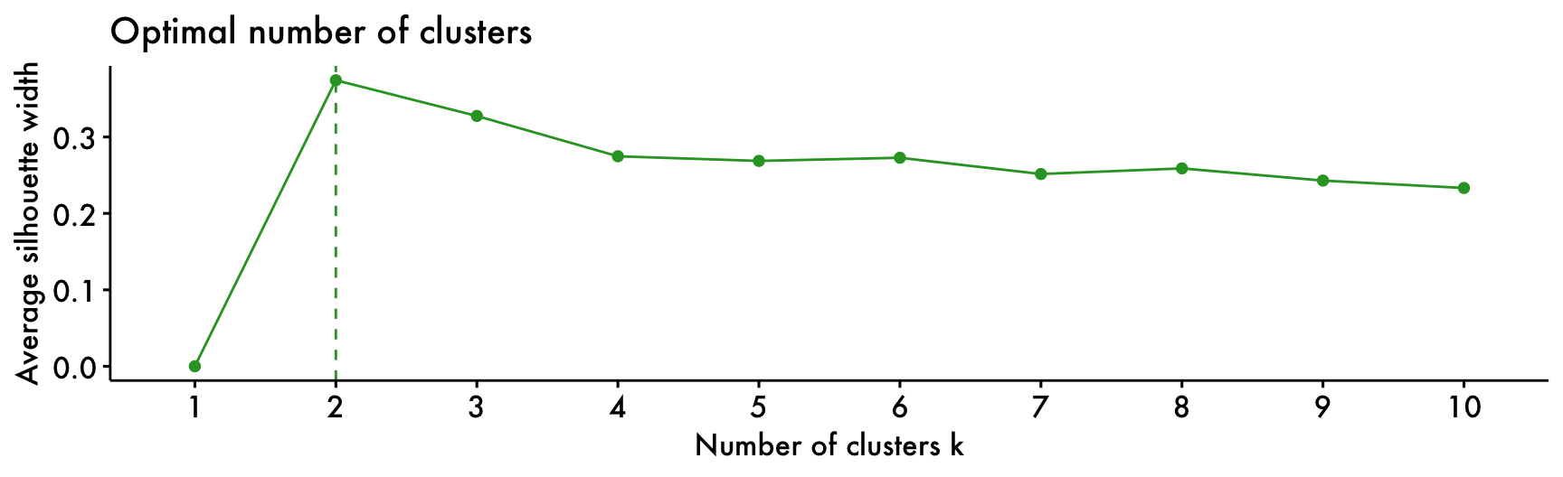

*Note.* This figure illustrates clustering performed on teen births, birthweight, population density, and COVID-19 incidence. Table 12 shows the specific variables included. See the Data Dictionary in the Appendix for variable descriptions and sources.

**Figure 37**

*ADI / SDoH Health Care Clustering*

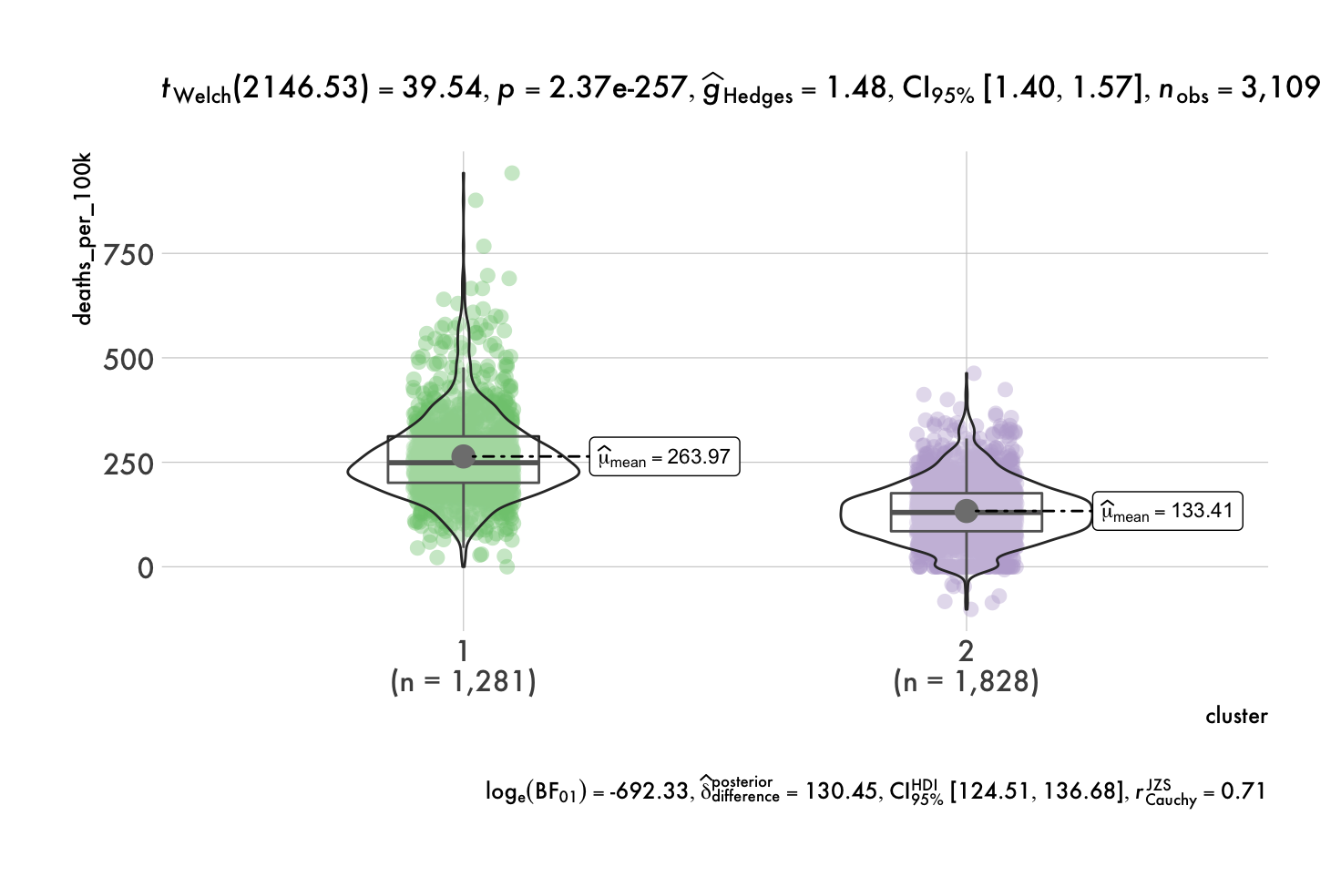

*Note.* This figure illustrates the statistically significant differences between clusters. Table 12 shows the specific variables included. See the Data Dictionary in the Appendix for variable descriptions and sources.

**Table 12**

*ADI/SDoH Health Care Summary Statistics*

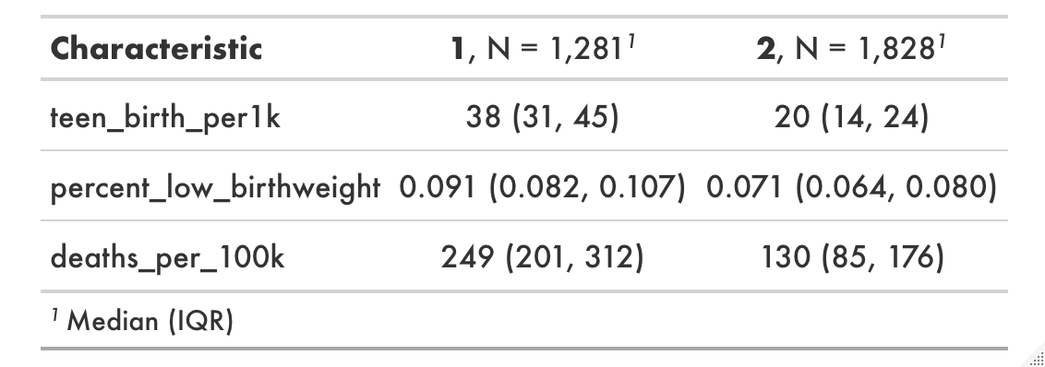

*Note.* This table shows population, density, teen births, birthweight, and COVID-19 incidence by cluster. See the Data Dictionary in the Appendix for variable descriptions and sources.

***Neighborhood and Built Environment***

One of the objectives of the SDoH neighborhood and built environment domain involves tobacco use. Cigarette tax and usage had multiple model interactions. Some of the variables in these interactions include month, adi, and government_response_index. As in prior clustering plots, Figures 38 and 39 highlight cohorts that are statistically significantly different. Table 13 shows that cluster 1 had the highest cases and deaths per 100,000 people. They also had the highest ADI, lowest government response, highest usage of cigarettes, and lowest cigarette taxes when looking at the median values. There is some overlap in the IQR however. Additionally, Figure 40 shows how cigarette taxes and usage relate to COVID-19 deaths by month. For most months, lower taxes are tied to more COVID-19 deaths. Across all months however, there are fewer deaths with less usage.

**Figure 38**

*ADI/SDoH Neighborhood Clustering – Deaths*

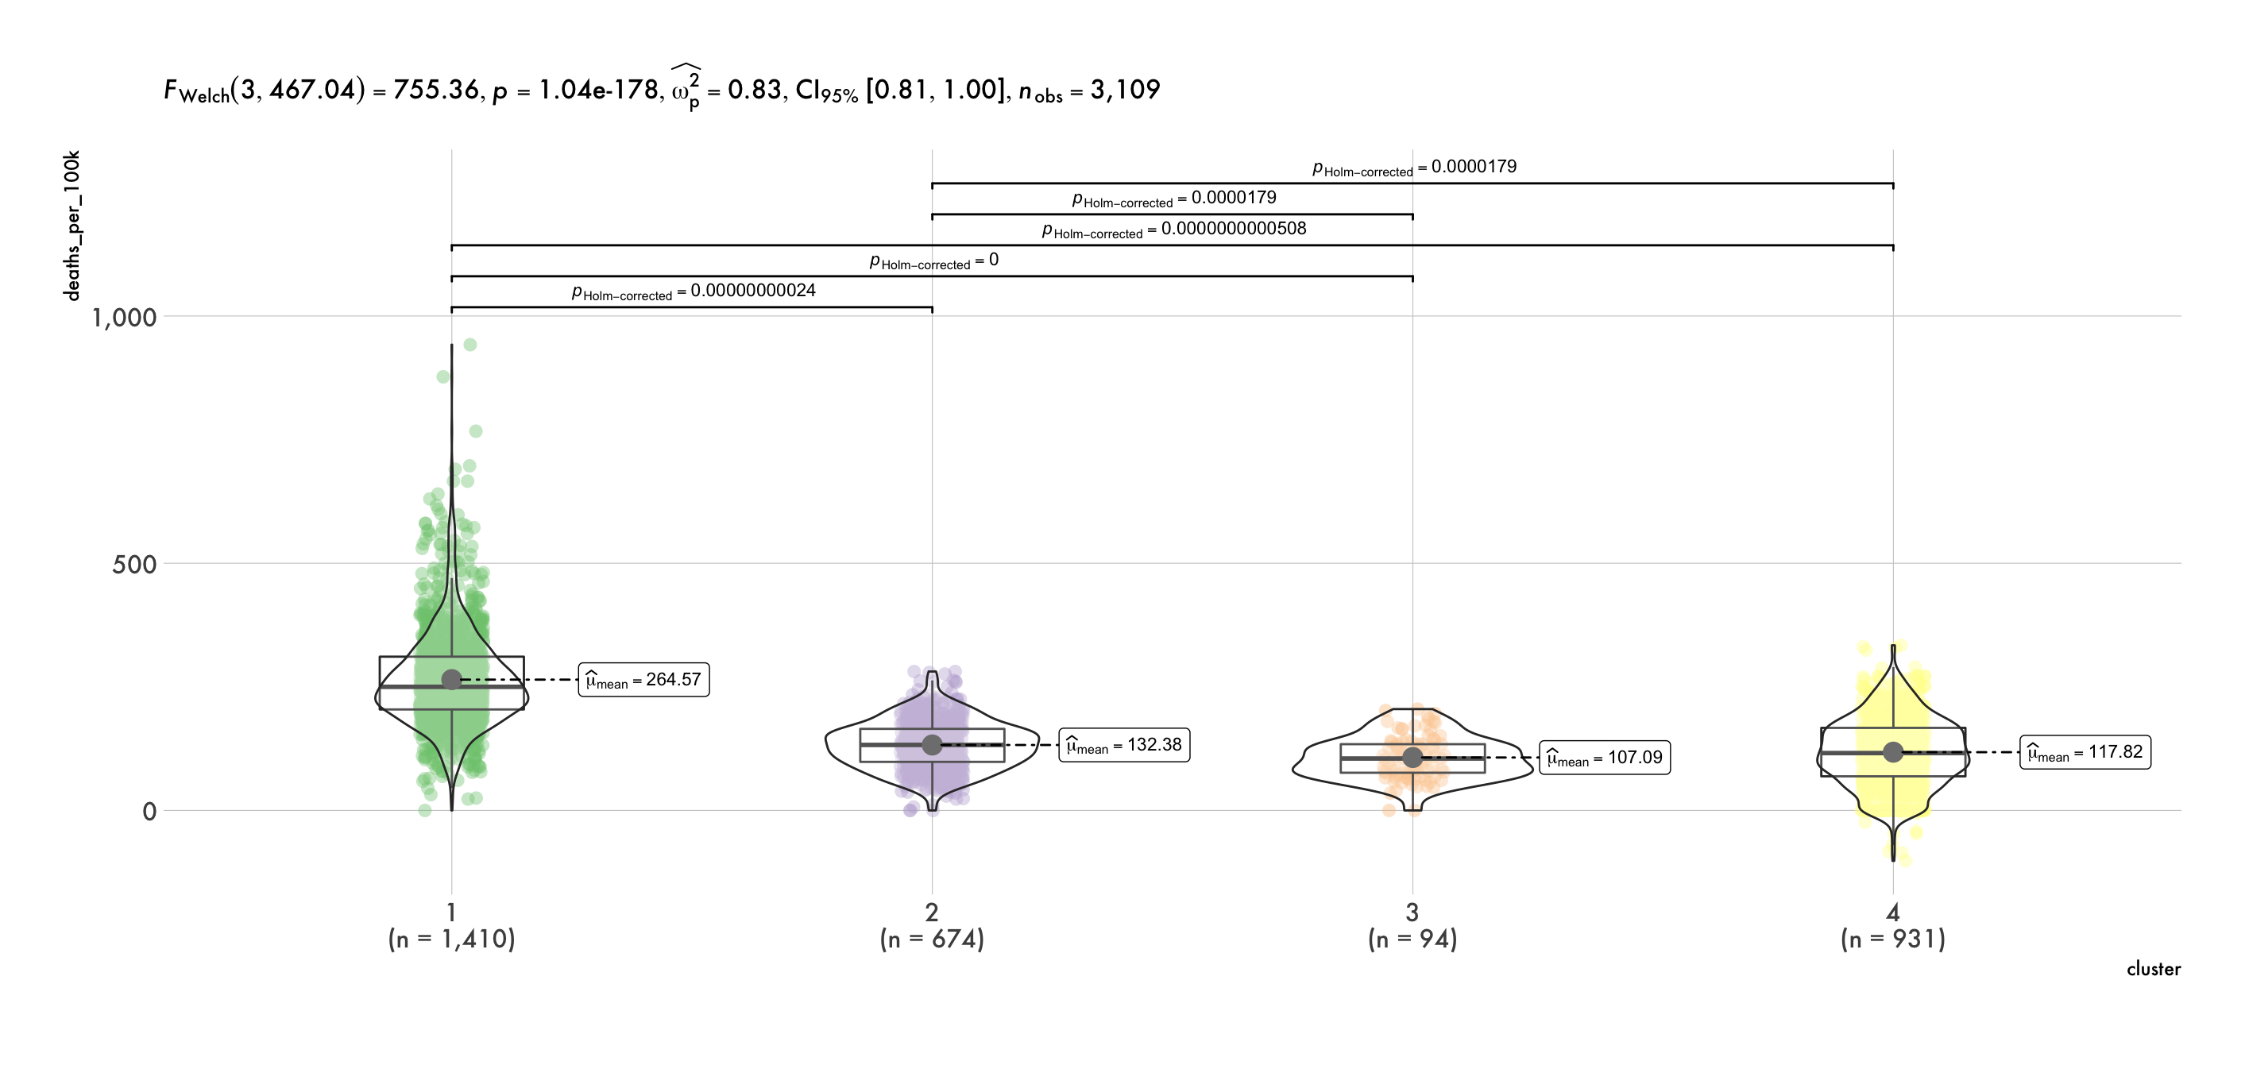

*Note.* This figure illustrates the statistically significant differences between clusters. Table 13 shows the specific variables included. See the Data Dictionary in the Appendix for variable descriptions and sources.

**Figure 39**

*ADI / SDoH Neighborhood Clustering – Cases*

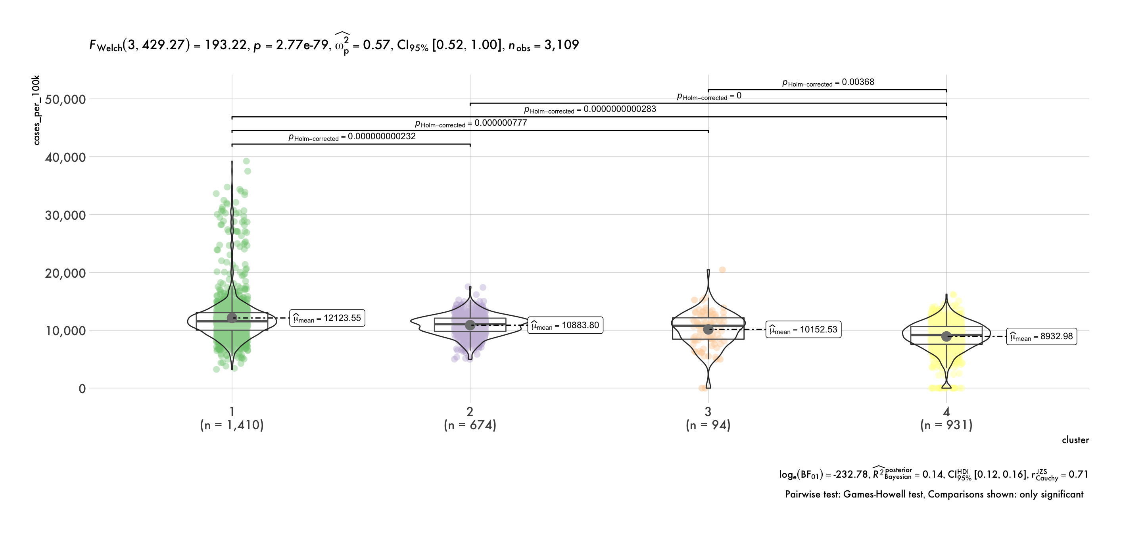

*Note.* This figure illustrates the statistically significant differences between clusters. Table 13 shows the specific variables included. See the Data Dictionary in the Appendix for variable descriptions and sources.

**Table 13**

*ADI / SDoH Neighborhood Summary Statistics*

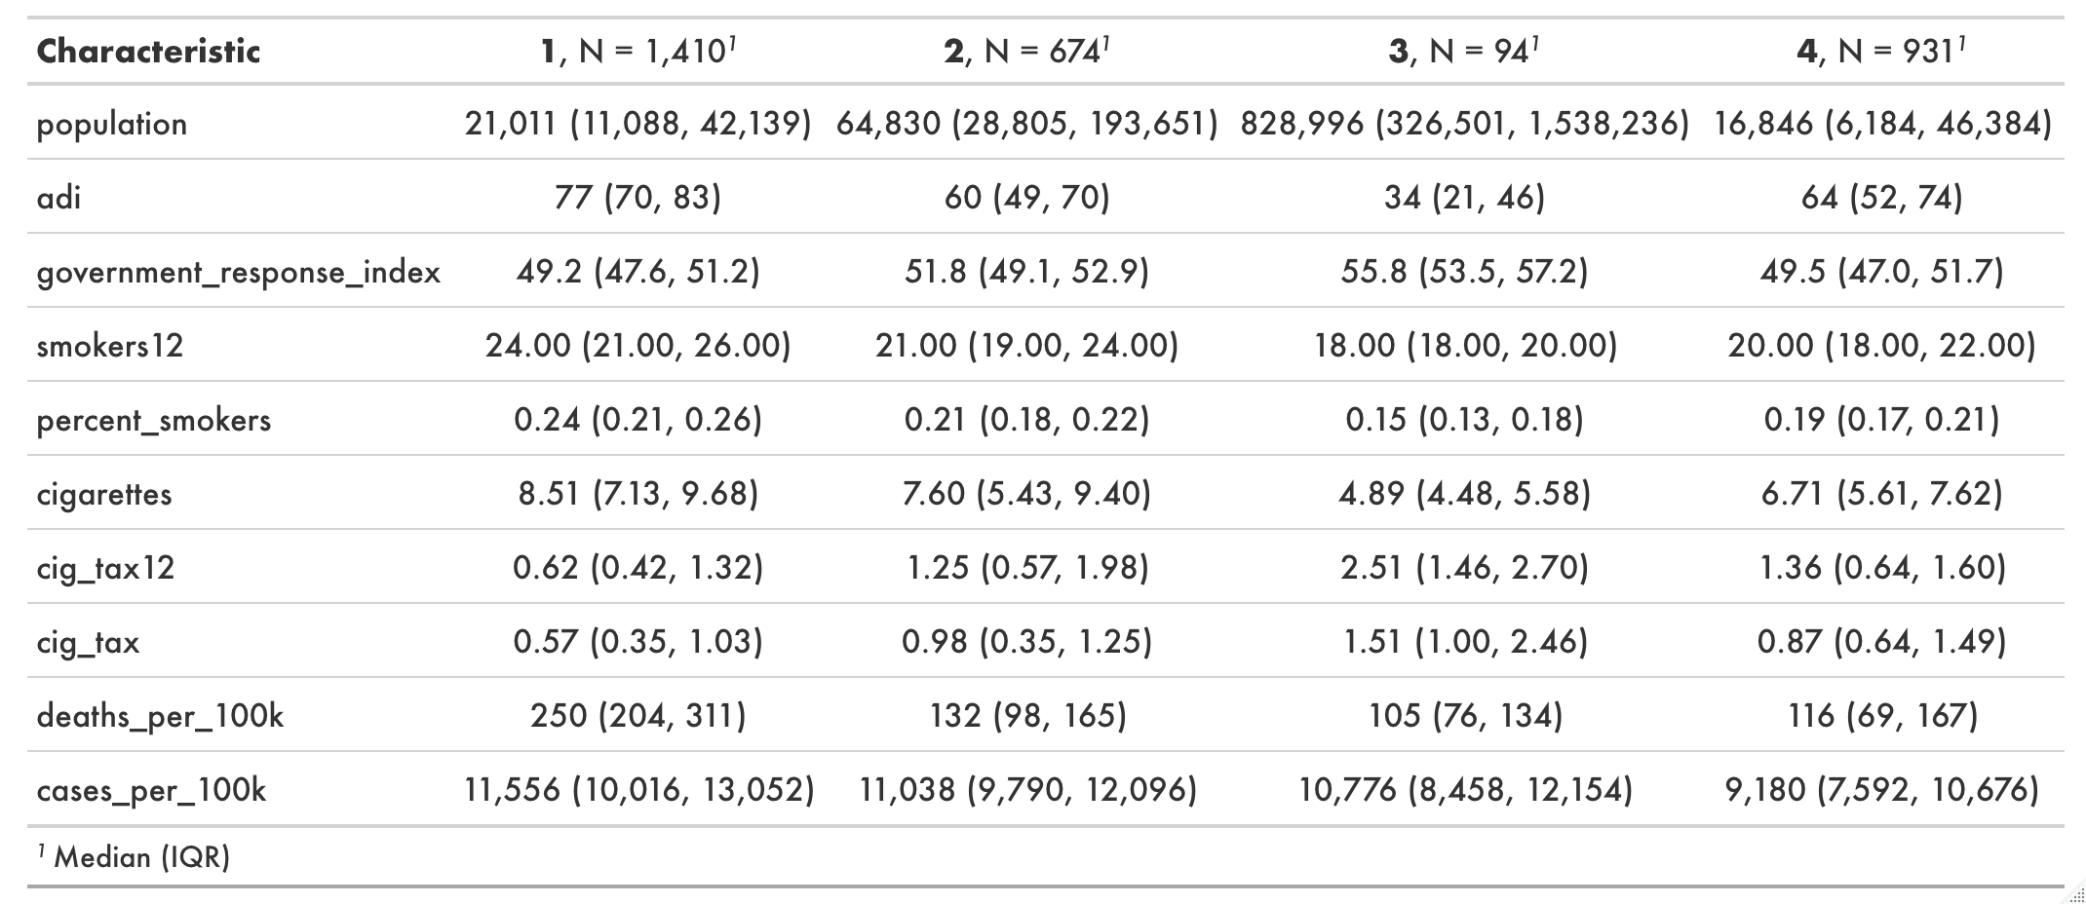

*Note.* This table shows population, ADI, government response, smoking prevalence, cigarette tax, and COVID-19 incidence by cluster. See the Data Dictionary in the Appendix for variable descriptions and sources.

**Figure 40**

*ADI / SDoH Neighborhood – COVID-19 Deaths & Cigarette Tax / Usage*

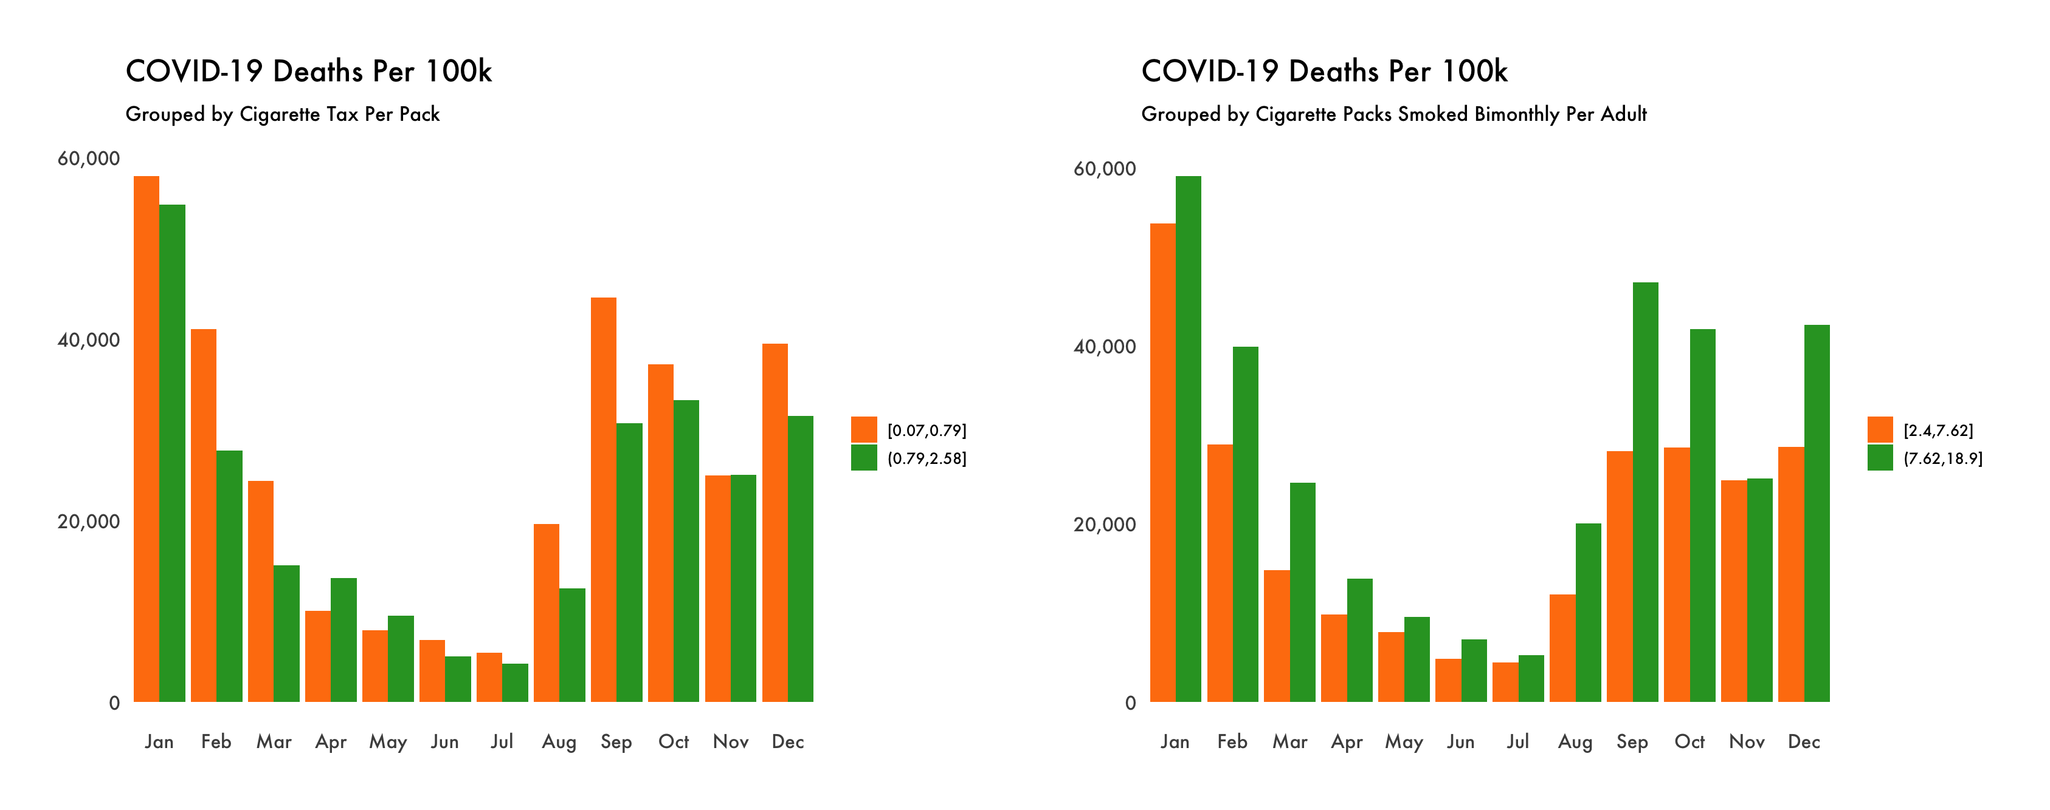

*Note.* This figure shows COVID-19 deaths (Johns Hopkins University, 2022) per month grouped by cigarette tax per pack and cigarettes smoked bimonthly per adult (Edwards et al., 2020).

***Social and Community Context***

One facet of the SDoH social and community context domain is nutrition and healthy eating. The dataset compiled contained a few variables relating to food insecurity and access. One interaction within the deaths model involved adi as the parent variable and percent_food_insecure as the child variable. Following the approaches done previously, the silhouette plot recommended three clusters. However, two clusters were chosen as the silhouette widths were relatively similar for two and three clusters. Additionally, fewer clusters improved explainability in this scenario. The measures shown in Figure 41 once again indicate statistical significance amongst the cohorts.

**Figure 41**

*ADI / SDoH Social Clustering*

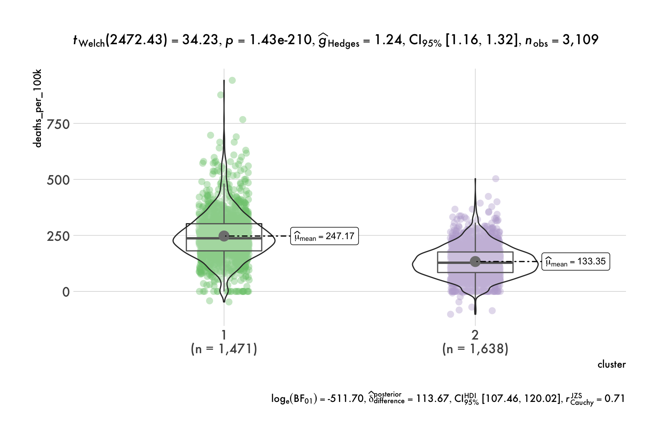

*Note.* This figure illustrates the statistically significant differences between clusters. Table 14 shows the specific variables included. See the Data Dictionary in the Appendix for variable descriptions and sources.

Table 14 indicates higher deaths per 100,000 people for counties with higher ADI values, lower food environment index scores (0 is worst, 10 is best), and higher percentages of food insecurity. The median value for percent_limited_access_to_healthy_foods was higher for cluster 1 as well. However, there is some overlap in the IQRs for that variable.

**Table 14**

*ADI / SDoH Social Summary Statistics*

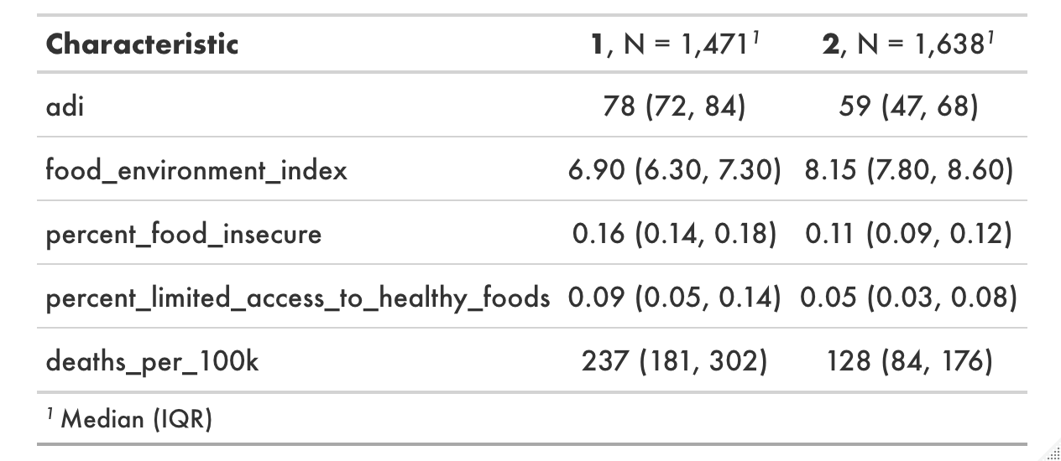

*Note.* This table shows adi, food-related variables, and COVID-19 deaths by cluster. See the Data Dictionary in the Appendix for variable descriptions and sources.

**Governmental Policy Measures / Mobility**

Lastly, this paper looked to evaluate policy measures designed to reduce the spread of COVID-19. Apple and Google mobility data assisted in understanding if people are first and foremost adhering to governmental restrictions and recommendations. After measuring the public response to these policies, the goal was then to determine if adherence had a statistically significant impact.

Figure 39 is a correlation plot amongst policy measures and mobility indices. The majority of the correlations are statistically significant. Based on this visual, it appears evident that governmental restrictions and recommendations do impact how mobile the public is. For example, the variable gathering_restrictions is negatively correlated with the variables that have ‘baseline’ as a suffix (Google mobility measures) or ‘apple’ as a prefix (residential_percent_change_from_baseline is the exception as it is logical that as mobility decreases, staying at home increases).

**Figure 42**

*Policy Measures & Mobility*

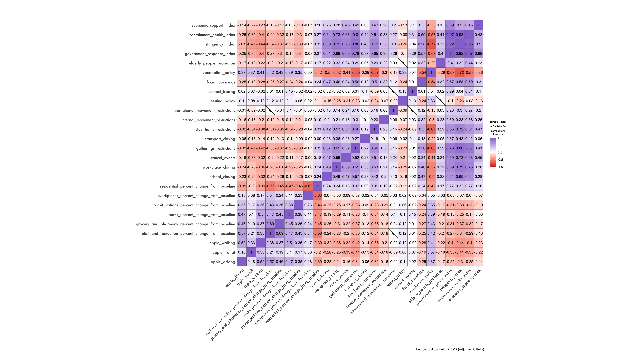

*Note.* This figure shows the correlation amongst government policies (Guidotti et al., 2020) and mobility (*Google* *COVID-19 Community Mobility Reports,* 2021 & *Apple Maps,* 2021) throughout 2021.

Given that people adjust their activity levels based on the decisions of public leaders, the next step was to determine which policy measures are most impactful. To do so, xgboost was utilized again to build models where mobility is the dependent y variable and policies are the independent x variables. Looking at the correlation plot above, apple_walking appears to have the strongest negative correlations, and residential_percent_change_from_baseline is the only one with predominantly positive correlations. Therefore, those two variables were chosen for modeling.

**Figure 43**

*Apple Walking Model - SHAP Values*

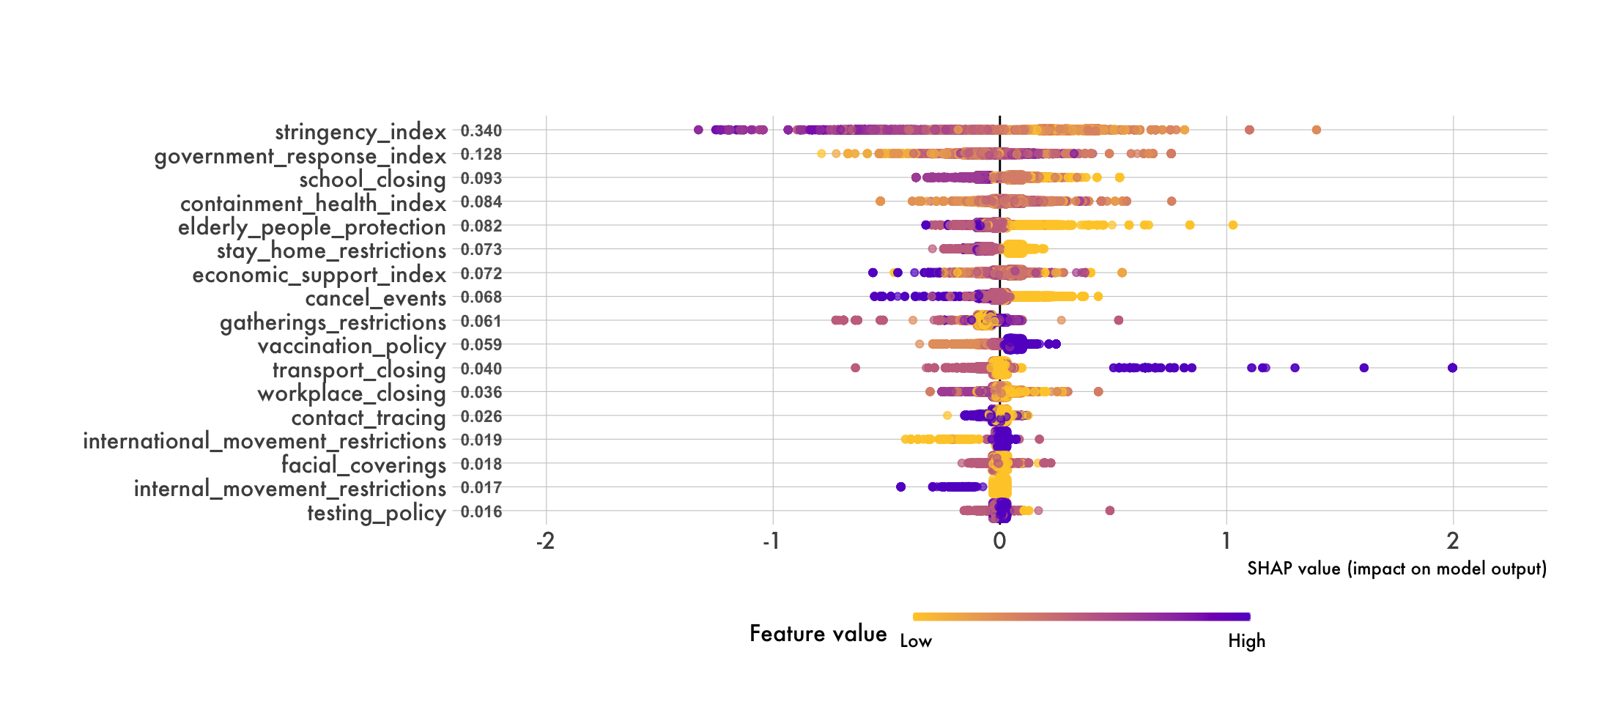

*Note.* This figure shows the SHAP values of 10,000 randomly selected observations for the Apple Walking model.

**Figure 44**

*Google Residential Model - SHAP Values*

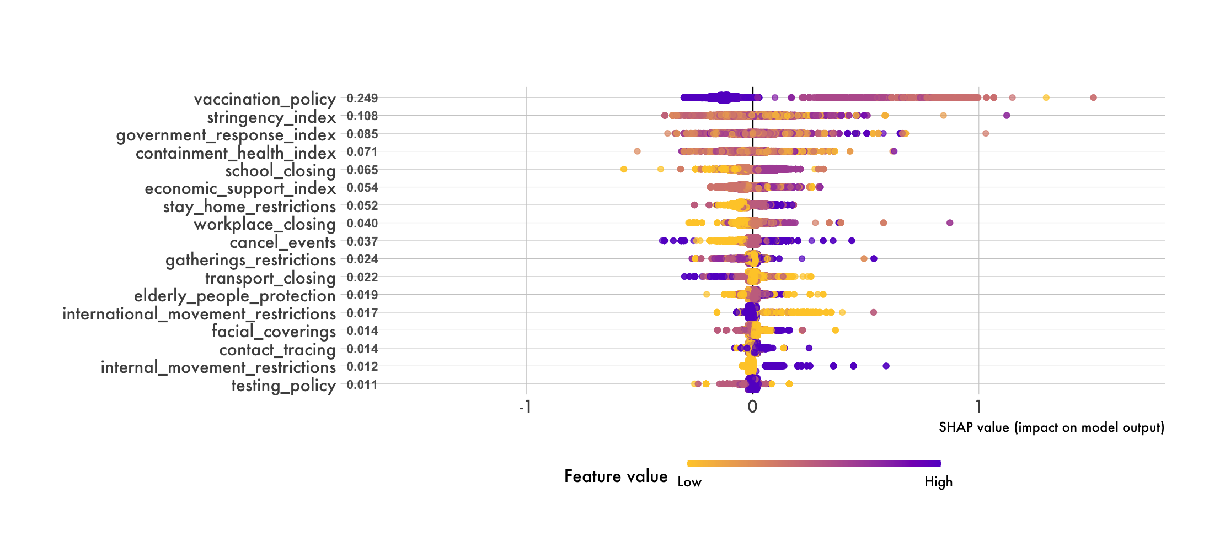

*Note.* This figure shows the SHAP values of 10,000 randomly selected observations for the Google Residential model.

Figures 43 & 44 contain Shapley values[10] for a random sample of the training dataset. Looking at these visuals above, the variables ending with ‘index’ have high importance in both models. Figure 45 below looks at the change in COVID-19 cases from the beginning to the end of the month by stringency_index specifically for January and December 2021. Those months were chosen as they had the highest number of cases. Spearman was chosen as the correlation method here as the assumption of normality does not hold. While, the p values in each plot indicate that the null hypothesis can be rejected, the Spearman correlation coefficients suggest weak monotonic relationships.

**Figure 45**

*Monthly Change in COVID-19 Cases by Stringency Index*

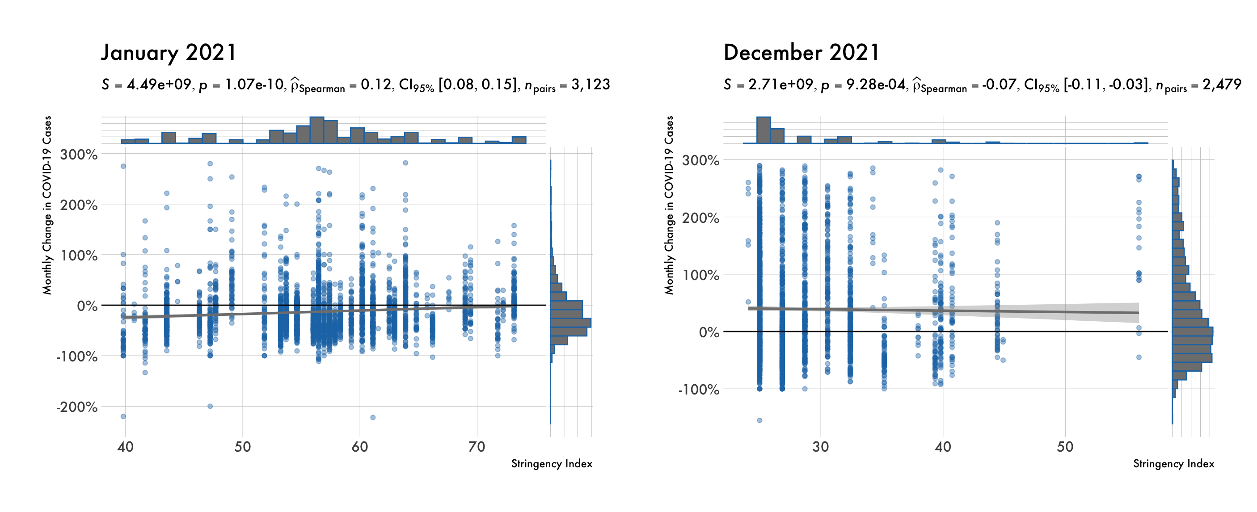

*Note.* This figure shows changes in COVID-19 cases (14-day moving average) (Johns Hopkins University, 2022) from the beginning to the end of a month correlate with how stringent a county’s policy measures are.

School_closing was another feature with a high variable importance score. This one appeared a bit more interesting as leadership decisions varied throughout the country. Table 15 shows the prominent policy measure[11] in place by month at the county level. Figure 46 is the change in cases (14-day moving average) per 100,000 people from the beginning to the end of the month for the second half of 2021. Outliers were removed using Tukey’s Fences[12]. July, August, and October are statistically insignificant amongst the school closing measures. November and December however seem to indicate that more restrictive measures are effective in reducing cases. September doesn’t definitively tell that story though as counties with no measures reported fewer cases per 100,000 people than counties falling under bucket 1.

**Table 15**

*School Closing Index by Month*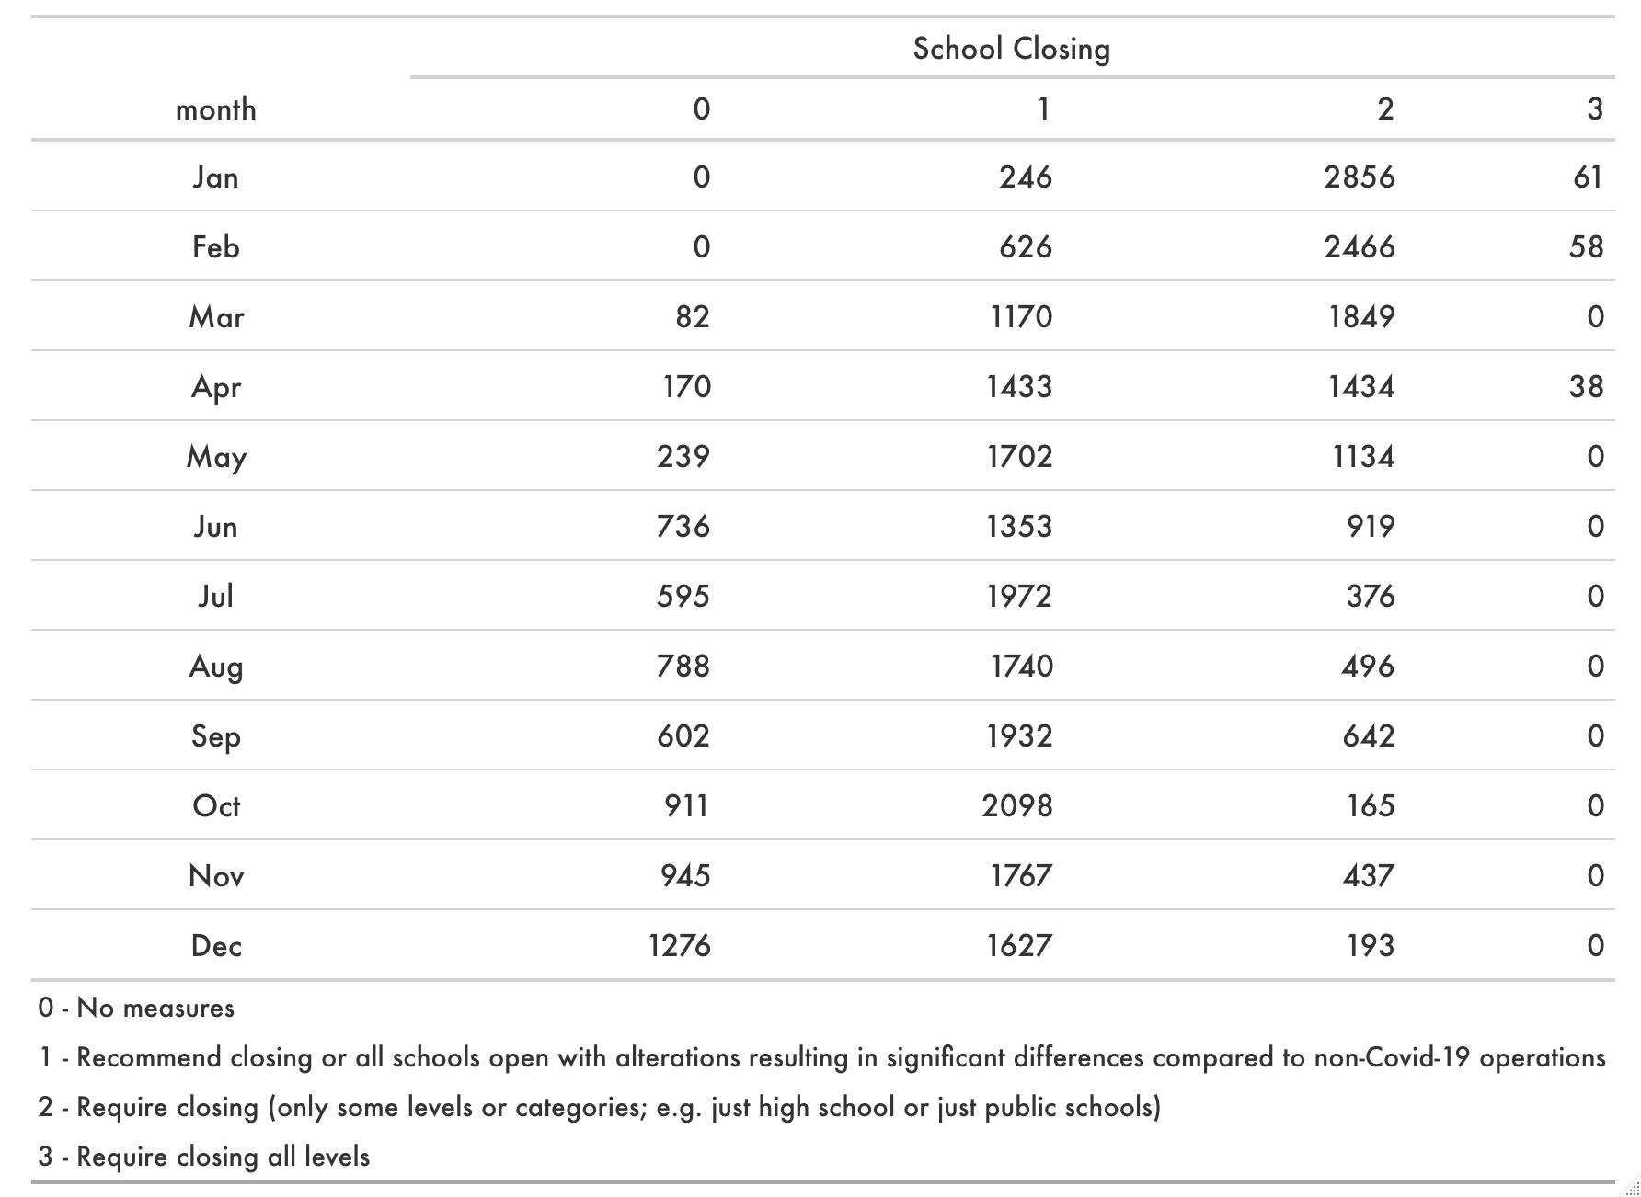

*Note.* This table shows the number of counties by school closing index (Guidotti et al., 2020).

**Figure 46**

*Monthly Change in COVID-19 Cases by School Closing Policy*

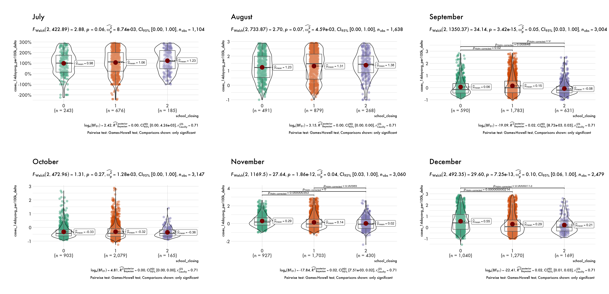

*Note.* This figure shows the change in COVID-19 cases (Johns Hopkins University, 2022) from the beginning to the end of the month by school closing policy (Guidotti et al., 2020).

Gathering_restrictions also had relatively high variable importance amongst the models. Based on Table 16 below, the first half of 2021 shows a bit more variety in restrictions by county. Therefore, those months were evaluated in Figure 47. Looking across each of the months and varying levels of restrictions, it doesn’t seem convincingly clear that gathering restrictions reducing confirmed cases of COVID. For example, buckets 0, 3, and 4 are relatively the same size in April. However, the differences between 0 and 3 are statistically insignificant, while the mean of bucket 0 compared to bucket 4 is lower with statistically significance.

**Table 16**

*Gathering Restrictions Index by Month*

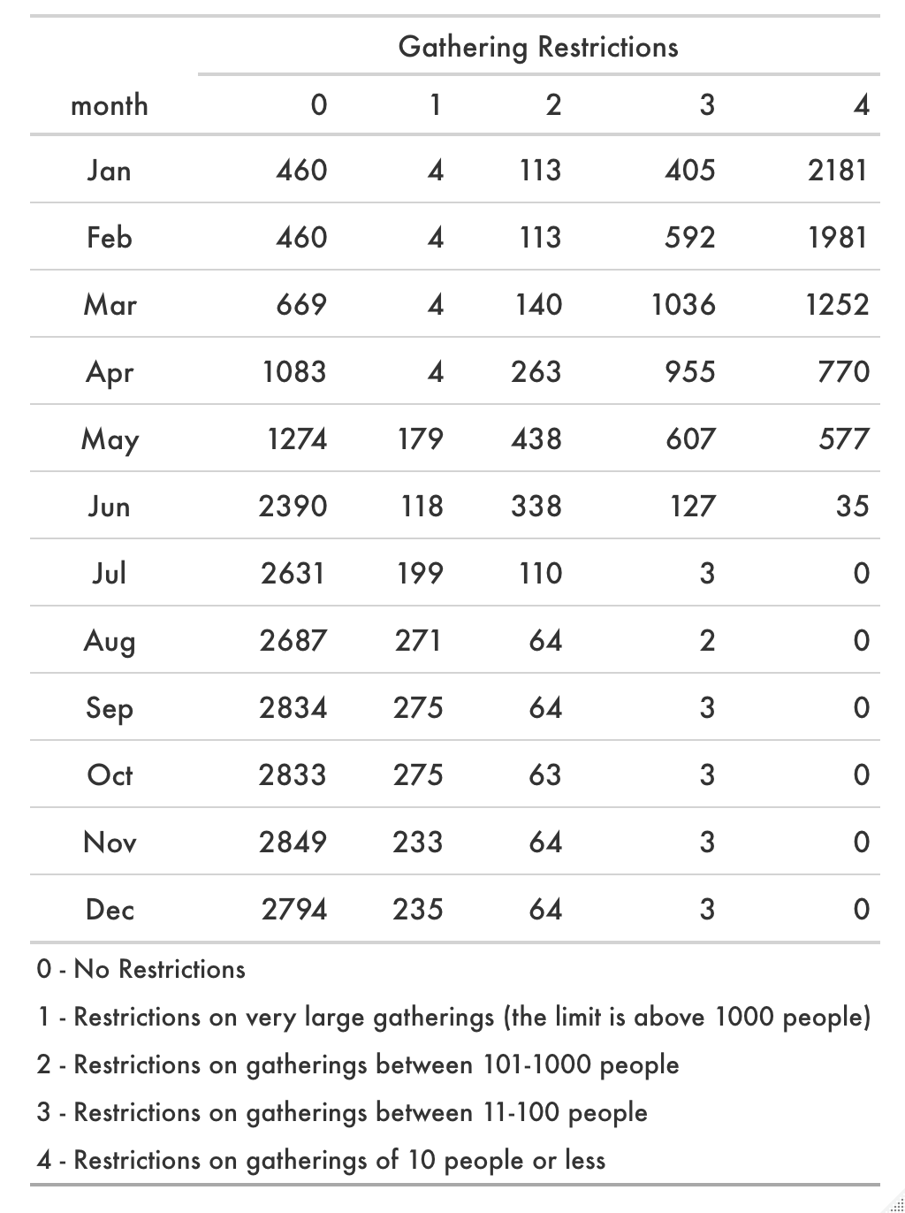

*Note.* This table shows the number of counties by restriction per month (Guidotti et al., 2020).

**Figure 47**

*Monthly Change in COVID-19 Cases by Gathering Restrictions*

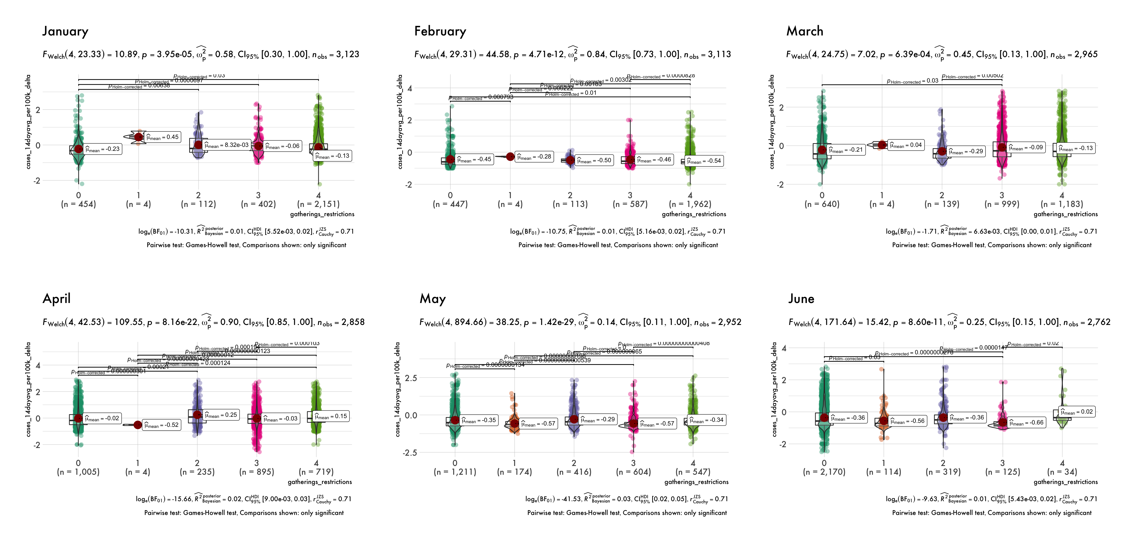

*Note.* This figure shows the change in COVID-19 cases (Johns Hopkins University, 2022) from the beginning to the end of the month by the level of gathering restrictions (Guidotti et al., 2020).

Lastly, Table 17 is bucketed by an aggregate level of restrictiveness. This was calculated by scaling each of the policy measures (as some range from 0 to 2, and others range from 0 up to 5) and summing them. Therefore, the [2,4] bucket would be considered the least restrictive, and the [7.33,11.2] bucket would be considered most restrictive. The values within the table represent the median (IQR) change from the beginning of the month to the end of the month. Cases, deaths, and mobility median values all seem to decline with more restrictive measures. However, there is some overlap amongst groups when comparing IQRs.

**Table 17**

*Monthly Change by Restrictiveness*

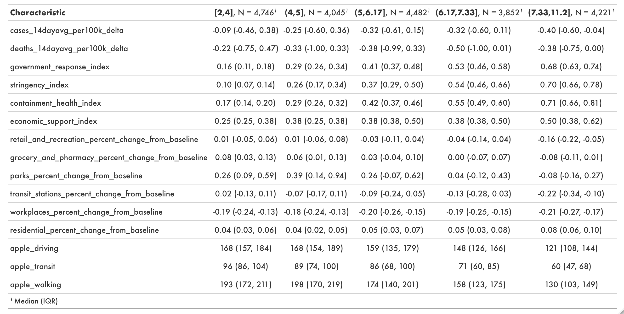

*Note.* This table shows COVID-19 incidence, policy measures, and mobility by cluster. See the Data Dictionary in the Appendix for variable descriptions and sources.

**Conclusion**

First, counties with greater prevalence of mental and physical health issues were also poorer on average. While cases per 100,000 were slightly higher, deaths per 100,000 were about 84% higher. Second, each of the SDoH domains were explored to identify addressable variables that are strongly correlated with COVID-19 incidence. Third, overall stringency regarding policy measures seemed to be tied to lower COVID-19 incidence. When looking at specific measures, however, the effectiveness was mixed.

**Summary**

**Introduction**

The goal of this case study was to explore features and interactions that may lead to increased COVID-19 incidence. Understanding the composition of different cohorts throughout the United States can assist various industries and organizations in managing the impact of COVID-19 and future similar crises. Neglecting to do so may lead to missed opportunities, misallocated resources, and preventable harm. Therefore, reasonable attempts made to understand how various segments are impacted by COVID-19 should prove to be a favorable endeavor.

**Findings**

Through the use of publicly available data, data science was applied to determine statistical significance amongst variables. Cohorts were clustered based on strong correlations or model interactions. Actionable items were discussed within each of the topics that may assist in reducing COVID-19 incidence.

**Conclusions by Research Questions**

Mental / physical health issues, poverty, and COVID-19 incidence showed strong correlations. Reviewing income equalities and equal opportunities in counties with greater health issues may help reduce COVID-19 incidence.

Within each of the five pillars of SDoH, correlations were observed with COVID-19 incidence. Some of the issues involved can be addressed at the community level such as cigarette usage and high school graduation rates. Other issues may not be easily addressable such as political affiliation and weather. Programs can’t be set up to change people’s beliefs or the climate.

Policy measures were effective at reducing mobility. While more stringent areas in general saw a decrease in COVID-19 incidence, looking at individual policies returned inconclusive results.

**Discussion**

The analysis performed appeared to line up with the literature review in each of the topics. Mental / physical health were strongly correlated with COVID-19 incidence. Higher deprivation indices (those is less fortunate areas) are more severely impacted by COVID-19. Government policy measures do impact mobility, however, reductions in mobility don’t reduce COVID-19 incidence with statistical significance.

**Suggestions for Future Research**

Mental and physical health are known to be positively correlated with COVID-19 incidence. Because broadly regulating these aspects of health is not feasible, and addressing them requires an understanding of underlying issues, this study highlighted features correlated with those variables with the goal of identifying areas of opportunity. Further research and action regarding issues such as child poverty, food insecurity, smoking, etc. may help improve mental and physical health, and thus lead to a reduction in COVID-19 incidence. Additionally, the spike in COVID-19 cases / deaths around September 2021 may benefit from a deeper analysis as those in counties with poorer mental and physical health scores were much more negatively impacted.

ADI is an aggregate value that attempts to quantify the overall socioeconomic disadvantage of a neighborhood. In order to identify actionable disadvantages, each domain within the SDoH was studied. Features such as teen birth rates, high school graduation rates, and government response indices were uncovered as having relatively strong correlations with COVID-19 incidence. These are items that neighborhood, county, and state level leaders should take into consideration when looking for ways to improve their socioeconomic status.

Overall, restrictive measures appeared to be effective in reducing COVID-19 cases. When drilling down to specific policies such as school closings and gathering restrictions, the results seemed less conclusive. There were often not statistically significant differences amongst counties indicating the effectiveness of a particular policy measure. Therefore, further research with a more controlled environment may be necessary for an objective conclusion to the effectiveness of specific governmental policies impacting mobility.

**Conclusion**

Understanding the demographic and socioeconomic features of a population is important for industries and organizations. This case study used those features to better understand how a variety of cohorts are more negatively impacted by COVID-19. The results from these analyses may be helpful in directing further research, practice, and policy measures to minimize COVID-19 incidence.

**References**

(2020). American Community Survey Data. United States Census Bureau. Downloaded from <https://www.census.gov/programs-surveys/acs/data.html> February 2, 2022.

(2021). County Health Rankings & Roadmaps: Building a Culture of Health, County by County. *County Health Rankings*. Downloaded from <https://www.countyhealthrankings.org/> November 5, 2021.

(2021). Economic Research Service. *U.S. Department of Agriculture*. Downloaded from <https://www.ers.usda.gov/data-products/county-level-data-sets/download-data/> November 4, 2021.

(2021). Mental Health. *Centers for Disease Control and Prevention*. <https://www.cdc.gov/mentalhealth/learn/index.htm>

(2021). Mobility Trends Report. *Apple Maps*. Downloaded from <https://covid19.apple.com/mobility> January 3, 2022.

(2021). See how your community is moving around differently due to COVID-19. *Google* *COVID-19 Community Mobility Reports*. Downloaded from <https://www.google.com/covid19/mobility/> January 2, 2022.

(2022). COVID-19 Vaccinations in the United States,County. *Centers for Disease Control and Prevention.* Downloaded from <https://data.cdc.gov/Vaccinations/COVID-19-Vaccinations-in-the-United-States-County/8xkx-amqh> January 19, 2022.

Alyammahi, S., Abdin, S., Alhamad, D., Elgendy, S., Altell, A., Omar, H. (2021). The dynamic association between COVID-19 and chronic disorders: An updated insight into prevalence, mechanisms and therapeutic modalities. *Infection, Genetics and Evolution*. <https://doi.org/10.1016/j.meegid.2020.104647>

Anthem. (2021). Protect Your Mental Health and Well-Being During COVID-19. WELL-BEING AND COMMUNITY. <https://www.anthem.com/coronavirus/blog/protect-your-mental-health-and-well-being/>

Boserup, B., McKenney, M., Elkbuli, A. (2020). Disproportionate Impact of COVID-19 Pandemic on Racial and Ethnic Minorities. *The American Surgeon*. 86(12):1615-1622. <https://doi.org/10.1177/0003134820973356>

Brownlee, J. (2016). Feature Importance and Feature Selection With XGBoost in Python. Machine Learning Mastery. <https://machinelearningmastery.com/feature-importance-and-feature-selection-with-xgboost-in-python/>

C3.ai, Inc. (2022). Shapley Values. <https://c3.ai/glossary/data-science/shapley-values/>

Choisy, M. (2018). SIR models in R. *RPubs*. <https://rpubs.com/choisy/sir>

CVS Health. (2021). The 2021 Health Care Insights Study. <https://www.cvshealth.com/sites/default/files/cvs-health-health-care-insights-study-2021-report-executive-summary.pdf>

Dong, E., Du, H., Gardner, L. (2020). An interactive web-based dashboard to track COVID-19 in real time. *Lancet Inf Dis*. 20(5):533-534. doi: <https://doi.org/10.1016/S1473-3099(20)30120-1>

Edwards, B., Pollock, P. (2020). Datasets and Functions Featured in Pollock and Edwards, an R Companion to Essentials of Political Analysis, Second Edition. <https://cran.r-project.org/web/packages/poliscidata/poliscidata.pdf>

Godman, H. (2021). Harvard study: Healthy diet associated with lower COVID-19 risk and severity. *Harvard Health Publishing*. <https://www.health.harvard.edu/staying-healthy/harvard-study-healthy-diet-associated-with-lower-covid-19-risk-and-severity>

Gottumukkala, R., Katragadda, S., Bhupatiraju, R., Kamal, A., Raghavan, V., Chu, H., Kolluru, R., Ashkar, Z. (2021). Exploring the relationship between mobility and COVID−19 infection rates for the second peak in the United States using phase-wise association. *BMC Public Health*. <https://doi.org/10.1186/s12889-021-11657-0>

Guidotti, E., Ardia, D. (2020). COVID-19 Data Hub. *Journal of Open Source Software*, 5(51), 2376. <https://doi.org/10.21105/joss.02376>

Gurung, H. (2022). Decision Trees and XGBOOST Algorithms. <https://github.com/Hem7513/Decision-Trees-and-XGBoost-Algorithm-Documentation>

Healthy People 2030. U.S. Department of Health and Human Services. *Office of Disease Prevention and Health Promotion*. Retrieved February 17, 2022 from <https://health.gov/healthypeople/objectives-and-data/social-determinants-health>

IBM. (2021). Bayesian One Sample Inference: Normal. *SPSS Statistics*. <https://www.ibm.com/docs/en/spss-statistics/SaaS?topic=statistics-bayesian-one-sample-inference-normal>

IBM Cloud Education. (2021). Underfitting: Learn how to avoid underfitting, so that you can generalize data outside of your model accurately. *IBM Cloud Learn Hub*. <https://www.ibm.com/cloud/learn/underfitting#:~:text=Underfitting%20vs.%20Overfitting%20Put%20simply%2C%20overfittingis%20the%20opposite,resulting%20in%20high%20error%20rates%20on%20test%20data>

Jacobsen, G., Jacobsen, K. (2020). Statewide COVID-19 Stay-at-Home Orders and Population Mobility in the United States. World Medical & Health Policy. <https://doi-org.libweb.uwlax.edu/10.1002/wmh3.350>

Johns Hopkins University (2022). COVID-19 data. Downloaded from <https://raw.githubusercontent.com/govex/COVID-19/master/data_tables/testing_data/time_series_covid19_US.csv> February 1, 2022.

Kandola, A. (2021). How do COVID-19 symptoms progress? *Medical News Today*. <https://www.medicalnewstoday.com/articles/progression-of-covid-19-symptoms>

Kind, A.J.H., Buckingham, W. (2018). Making Neighborhood Disadvantage Metrics Accessible: The Neighborhood Atlas. *New England Journal of Medicine*. 378: 2456-2458. DOI: 10.1056/NEJMp1802313. PMCID: PMC6051533. AND University of Wisconsin School of Medicine Public Health. 2019 Area Deprivation Index v3.1. Downloaded from <https://www.neighborhoodatlas.medicine.wisc.edu/> November 20, 2021.

Kitchen, C., Hatef, E., Chang, H., Weiner, J., Kharrazi, H. (2021). Assessing the association between area deprivation index on COVID-19 prevalence: a contrast between rural and urban U.S. jurisdictions. *AIMS Public Health.* 8(3):519-530. <https://doi.org/10.3934/publichealth.2021042>

Lewis, N., Friedrichs, M., Wagstaff, S., et al. (2020). Disparities in COVID-19 Incidence, Hospitalizations, and Testing, by Area-Level Deprivation – Utah, March 3–July 9, 2020. Morbidity and Mortality Weekly Report 69(38):1369–1373. <http://dx.doi.org/10.15585/mmwr.mm6938a4>

Lu, X., Lin, Z. (2021). COVID-19, Economic Impact, Mental Health, and Coping Behaviors: A Conceptual Framework and Future Research Directions. *Front. Psychol.* 12:759974. <https://doi.org/10.3389/fpsyg.2021.759974>

McNeely, C., Schintler, L., Stabile, B. (2020). Social Determinants and COVID-19 Disparities: Differential Pandemic Effects and Dynamics. *World Medical & Health Policy*. <https://doi-org.libweb.uwlax.edu/10.1002/wmh3.370>

MIT Election Data and Science Lab. (2021). County Presidential Election Returns 2000-2020. <https://doi.org/10.7910/DVN/VOQCHQ>

Modius Health. (2019). Health & Wealth- Is There A Correlation Between The Two? <https://us.modiushealth.com/blogs/news/health-wealth-is-there-a-correlation-between-the-two>

National Oceanic and Atmospheric Administration. (2022). Climate at a Glance. National Centers for Environmental Information. Downloaded from <https://www.ncdc.noaa.gov/cag/county/mapping> February 4, 2022.

Nunez, A., Sreeganga, S., Ramaprasad, A. (2021). Access to Healthcare during COVID-19. International Journal of Environmental Research and Public Health. 18(6). <https://doi.org/10.3390/ijerph18062980>

Panchal, N., Kamal, R., Cox, C., Garfield, R. (2021). The Implications of COVID-19 for Mental Health and Substance Use. *Kaiser Family Foundation*. <https://www.kff.org/coronavirus-covid-19/issue-brief/the-implications-of-covid-19-for-mental-health-and-substance-use/>

Radecic, D. (2021). Complete Guide to Gradient Boosting and XGBoost in R. Appsilon. <https://appsilon.com/r-xgboost/>

Ramachandran, A. (2020). Google Mobility Data. *Understand how people are moving due to COVID.* Downloaded from <https://www.kaggle.com/aiswaryaramachandran/google-mobility-data?select=2020_US_Region_Mobility_Report.csv> November 2, 2021.

Soetewey, A. (2020). The complete guide to clustering analysis: k-means and hierarchical clustering by hand and in R. Stats and R. <https://statsandr.com/blog/clustering-analysis-k-means-and-hierarchical-clustering-by-hand-and-in-r/>

Szumilas, M. (2010). Explaining Odds Ratios. J Can Acad Child Adolesc Psychiatry, 19(3): 227–229. <https://www.ncbi.nlm.nih.gov/pmc/articles/PMC2938757/>

Tello, M. (2021). Does exercise help protect against severe COVID-19? *Harvard Health Publishing*. <https://www.health.harvard.edu/blog/does-exercise-help-protect-against-severe-covid-19-202106092475>

Wang, Q., Xu, R., Volkow, N. (2020). Increased risk of COVID-19 infection and mortality in people with mental disorders: analysis from electronic health records in the United States. *World Psychiatry*. <https://doi-org.libweb.uwlax.edu/10.1002/wps.20806>

Zajacova, A., Lawrence, E. (2018). The Relationship Between Education and Health: Reducing Disparities Through a Contextual Approach. Annual Review of Public Health, 39: 273-289. <https://doi.org/10.1146/annurev-publhealth-031816-044628>

**Appendix**

**Data Dictionary**



**Model Pairs**



**Model Interactions**



**R Programming Code**

[DS785.Rmd](https://github.com/flachboard/DS785Capstone/blob/main/DS785.Rmd)

**R Session Information**

Operating System: macOS Monterey 12.2.1

R version 4.1.2 (2021-11-01) –- “Bird Hippie”

Platform: x86_64-apple-darwin17.0 (64-bit)

RStudio 2021.09.1 Build 372

Packages: base, arrow 7.0.0, bayestestR 0.11.5, caret 6.0-90, choroplethr 3.7.0, choroplethrMaps 1.0.1, cluster 2.1.2, correlation 0.7.1, corrplot 0.92, corrr 0.4.3, covidcast 0.4.2, DALEX 2.3.0, data.table 1.14.2, deSolve 1.30, downloadthis 0.2.1, EIX 1.2.0, embed 0.1.5, factoextra 1.0.7, FactoMineR 2.4, farff 1.1.1, flexdashboard 0.5.2, forecast 8.15, formattable 0.2.1, ggalluvial 0.12.3, GGally 2.1.2, ggcharts 0.2.1, ggcorrplot 0.1.3, ggExtra 0.9, ggforce 0.3.3, ggridges 0.5.3, ggside 0.2.0, ggstatsplot 0.9.1, ggtext 0.1.1, grid 4.1.2, gridExtra 2.3, gt 0.3.1, gtable 0.3.0, gtsummary 1.5.0, heatmaply 1.3.0, hrbrthemes 0.8.0, janitor 2.1.0, latticeExtra 0.6-29, lubridate 1.8.0, maptools 1.1-2, Metrics 0.1.4, NbClust 3.0, OpenML 1.10, openxlsx 4.2.4, outliers 0.14, plotly 4.10.0, poliscidata 2.3.0, prophet 1.0, psych 2.1.9, randomForest 4.6-14, ranger 0.13.1, RcppRoll 0.3.0, see 0.6.9, sf 1.0-4, SHAPforxgboost 0.1.1, shapper 0.1.3, shapr 0.2.0, shinydashboard 0.7.2, skimr 2.1.3, tabnet 0.3.0, tidycensus 1.1, tidymodels 0.1.4, tidyverse 1.3.1, timetk 2.6.2, tmap 3.3-2, tmaptools 3.1-1, xgboost 1.5.0.2, xlsx 0.6.5, xts 0.12.1, zipcodeR 0.3.3, zoo 1.8-9

1. Data Collection and Data Analysis are covered in more detail in the Methodology section.
2. Odds ratios are used to compare the relative odds of the occurrence of the outcome of interest given exposure to the variable of interest (Szumilas, M., 2010).
3. Note that comparisons are not statistically significantly different between seniors and adults for bipolar disorder and depression.
4. Medical comorbidities include cancers, cardiovascular diseases, type 2 diabetes, obesity, chronic kidney diseases, chronic obstructive pulmonary disease, asthma, and substance use disorders.
5. Purity scores refer to the probability of a variable being correctly classified when randomly chosen.
6. Student’s t-test and Welch’s t-test assume a normal distribution. However, Student’s t-test also assumes equal variance while Welch’s t-test does not.
7. Interquartile Range = Upper Quartile (75th Percentile) – Lower Quartile (25th Percentile) = Q3 – Q1
8. See ModelPairs.xlsb and ModelInteractions.xlsb files in Appendix
9. Hs_or_more is a state-level variable
10. SHAP, which stands for Shapley Additive exPlanations, is an interpretability method based on Shapley values and was introduced by Lundberg and Lee (2017) to explain individual predictions of any machine learning model (C3.ai, Inc., 2022).
11. The prominent policy measure was calculated as the mode policy measure by month.
12. [where $Q_{1}$ and $Q_{3}$ are the lower and upper quartiles respectively & $k$ = some nonnegative constant (popular choice is 1.5).